**WEEK 2 — Working With Git & GitHub**

**📌 Question (Simple Form)**

**Create a local project folder, initialize it with Git, commit the files, connect it to a GitHub remote repository, and push the project to GitHub.  
Then execute basic Git commands to manage the repository.**

**📌 Execution Steps**

**# STEP 1: Create and enter project folder**

**cd “myprojectpath”**

**# STEP 3: Initialize Git repository**

**git init**

**# STEP 4: Add files to staging area**

**git add .**

**# STEP 5: Commit files with a message**

**git commit -m "Initial commit"**

**# STEP 6: Connect to GitHub repository**

**git remote add origin https://github.com/<your-username>/<repo-name>.git**

**# STEP 7: Rename default branch to main**

**git branch -M main**

**# STEP 8: Push project to GitHub**

**git push -u origin main**

**Optional Helpful Commands**

**git status**

**git log --oneline**

**git pull origin main**

**git clone <URL>**

**📌 Expected Output**

**After successful execution:**

**✔ Terminal messages confirming:**

* **Repository initialized (Initialized empty Git repository)**
* **Files added (1 file changed)**
* **Commit created ([main (root-commit) abc123] Initial commit)**
* **Remote added successfully**
* **Push upload progress (showing file transfer and branch creation)**

**✔ On GitHub:**

* **myproject repository will appear.**
* **readme.txt file will be visible.**
* **Commit history will show the message: "Initial commit"**
* **Default branch will be main**

1. **Git Commands:**

* **git version : The command git version is used to check the version of git.**

**git --version**

* **git config: Configures Git settings. Commonly used to set up user information**

**git config --global user.name "Your Name"**

**git config --global user.email "youremail@example.com"**

* **git config --list: Displays all the Git configurations for the current user.**

1. **Repository Management**

* **git init: Initializes a new Git repository in the current directory**

**git init**

* **git clone: Creates a copy of an existing Git repository from a remote source (e.g., GitHub) to your local machine**

**git clone** [**https://github.com/username/repository.git**](https://github.com/username/repository.git)

* **git remote –v : To see the remote repository that is connected to your local repository**

**git remote –v**

* **git remote add : To add a new remote repository to your local repository**

**git remote add origin** [**https://github.com/username/repository.git**](https://github.com/username/repository.git)

* **Pushing Changes to Remote: To push your local commits to a remote repository:**

**git push <remote_name> <branch_name>**

**git push origin main**

* **Pulling Updates from Remote: To pull the latest changes from the remote repository and merge them into your local branch**

**git pull <remote_name> <branch_name>**

**git pull origin main**

* **git remote remove: To remove a remote repository from your local configuration:**

**git remote remove <remote_name>**

**git remote remove origin**

* **Renaming a Remote: to rename an existing remote:**

**git remote rename <old_name> <new_name>**

**git remote rename origin upstream**

* **Fetching Updates from Remote: To fetch updates from the remote repository but not merge them into your local branch**

**git fetch <remote_name>**

* **Changing Remote URL : To change the URL of a remote (e.g., after changing the remote repository address):**

**git remote set-url <remote_name> <new_url>**

**git remote set-url origin** [**https://github.com/username/new-repository.git**](https://github.com/username/new-repository.git)

* **Viewing the Remote Repository’s Information: to see detailed information about a remote repository**

**git remote show <remote_name>**

**git remote show origin**

**3. Staging and Committing**

* **git status: Shows the status of changes in your working directory and staging area. It tells you which files are untracked, modified, or ready to be committed.**

**git status**

* **git add: Adds changes in the working directory to the staging area.**

**git add filename.txt # Adds a specific file**

**git add . # Adds all changes in the directory**

* **git commit: Commits the staged changes to the repository with a descriptive message. The -m option allows you to include a commit message.**

**git commit -m "Commit message describing changes"**

**4. Branching and Merging**

* **git branch: Lists all branches or creates a new branch**

**git branch # Lists all branches or**

**git branch -a # Lists all branches**

**git branch branch-name # Creates a new branch**

**git branch -d <branch_name> # Deletes a branch**

***Use -D to force-delete if it hasn't been merged.***

* **Listing All Remote Branches : To you want to list all branches on the remote repository**

**git branch –r**

* **git checkout: Switches to a different branch**

**git checkout branch-name # Switches to an existing branch**

**git checkout -b new-branch # Creates and switches to a new branch**

* **Pruning Deleted Remotes : If a branch was deleted on the remote but still shows up locally.**

**git remote prune origin**

**When someone deletes a branch on the remote, your local Git doesn’t automatically remove the corresponding remote-tracking branch (like origin/old-feature).**

**git remote prune origin removes these outdated references.**

* **Fetching a Specific Remote Branch: To fetch a specific branch from a remote.**

**git fetch <remote_name> <branch_name>**

**git fetch origin feature-branch**

* **Setting the Upstream Branch for Pushing : When pushing for the first time and want to set the remote branch you are pushing to:**

**git push --set-upstream <remote_name> <branch_name>**

**git push --set-upstream origin feature-branch**

* **git merge: Merges the specified branch into the current branch. This command integrates the changes from the feature branch into the main branch.**

**git checkout main # Switch to the main branch**

**git merge branch-name # Merge branch-name into main**

* **Rebasing a Local Branch onto a Remote Branch: If you want to rebase your local branch onto a remote branch (this can be useful to keep your history linear)**

**git fetch <remote_name>**

**git rebase <remote_name>/<branch_name>**

**Example:**

**git fetch origin**

**git rebase origin/main**

* 1. **Undoing Changes**
* **git reset : Removes the specified file from the staging area but leaves the working directory unchanged. git reset --hard can also reset the working directory and staging area to the last commit.**

**git reset <file>:**

* **git revert: Creates a new commit that undoes the changes from a specified commit, leaving the history intact.**

**git revert <commit>:**

* 1. **Viewing History**
* **git log: Shows a history of commits in the repository, including commit hashes, messages, and timestamps. Use git log --oneline for a more concise view.**

**git log:**

* **git diff: Displays differences between various commits, the working directory, and the staging area. git diff without arguments shows changes not yet staged.**

**git diff:**

* **git show: Shows the details of a specific commit, including the changes made and the commit message.**

**git show <commit>**

* 1. **To undo the changes made to file before staging it.**
* **git restore filename**
  1. **To correct committed with the wrong message**
* **git commit --amend -m "Corrected commit message"**

**9. Recovering deleted branches**

* **git reflog**
* **git checkout -b feature-ui <commit_hash>**

**10. To download the latest changes from the remote without merging**

* **git fetch origin**

**11. To remove accidentally committed sensitive file from Git history.**

* **git filter-branch --force --index-filter \**
* **"git rm --cached --ignore-unmatch secrets.txt" \**
* **--prune-empty --tag-name-filter cat -- --all**

**12. To merge changes from another branch**

**First switch to branch where changes are to applied and then merge another-branch**

* **git checkout previous-branch**
* **git merge another-branch**

**13. To resolve a merge conflict manually**

**You tried to merge two branches and Git reported a conflict in x.js. Then for conflict resolution do:**

1. **Open x.js and resolve/remove the conflict markers (<<<<<<<, =======, >>>>>>>)**
2. **After resolving:**

* **git add app.js**
* **git commit # If Git didn’t auto-create a merge commit**

**14. The .gitignore**

**The .gitignore file is used to tell Git which files or directories to ignore in your project. It's a useful way to avoid committing unnecessary files like log files, build outputs, and IDE configurations.**

* 1. **Create a .gitignore File**

**In the root directory of your Git project, create a file called .gitignore**

**touch .gitignore**

* 1. **Add Rules to .gitignore**

**Inside the .gitignore file, you add patterns for the files and directories you want Git to ignore. Each pattern should be written on a new line.**

**Here are some common examples:**

* **Ignore all .log files: *.log**
* **Ignore a specific file: secret_file.txt**
* **Ignore all files in a temp/ directory: temp/**
* **Ignore all files except important_file.txt inside a folder:**

**folder/\***

**!folder/important_file.txt**

* **Ignore files with a specific extension: *.bak**

**15. To see who changed a particular line in a file**

* **git blame script.py**

**16. Git stash**

**# You modified files A and B, but not committed them.**

**git stash # saves changes and reverts to clean state**

**git switch another-branch**

**# do something else...**

**git switch main**

**git stash apply # brings back your changes**

**17. To check branch is merge**

* **git branch –merged**

**If branch not merged then displays its name**

**18. To Delete multiple local branches at once**

* **git branch –d branc1 branch2 branch3**

**✅ What Week 3 Really Wants You To Do**

**It has three goals:**

1. **Create a separate branch (collaboration style).**
2. **Make changes and push them to GitHub (like a team).**
3. **Create a merge conflict and resolve it.**
4. **(Optional) create a patch file.**

**You can complete ALL of Week 3 with just ONE file and TWO branches.**

**git checkout -b feature-collab**

**git checkout -b feature-collab**

**👉 creates a new branch called feature-collab and switches to it.**

**You should see something like:**

**sh**

**Copy code**

**Switched to a new branch 'feature-collab'**

**✅ Step A3: Edit the file in this branch**

**We will edit readme.txt.**

**Option 1 (using Notepad – easy for exam):**

**In File Explorer, open myproject folder.**

**Double-click readme.txt.**

**At the end of the file, add a new line:**

**text**

**Copy code**

**This line is from feature-collab branch.**

**Press Ctrl + S to save.**

**Close Notepad.**

**✅ Step A4: Stage and commit changes**

**Back in Git Bash (still in feature-collab):**

**sh**

**Copy code**

**git add readme.txt**

**git commit -m "Update readme from feature-collab branch"**

**git add readme.txt → tells Git: “I want to include this file in the next commit.”**

**git commit -m "..." → saves a new version (commit) with that message.**

**You’ll see something like:**

**sh**

**Copy code**

**[feature-collab 1234abc] Update readme from feature-collab branch**

**1 file changed, 1 insertion(+)**

**✅ Step A5: Push this branch to GitHub**

**sh**

**Copy code**

**git push origin feature-collab**

**This uploads the feature-collab branch to GitHub.**

**Git may print a URL like:**

**text**

**Copy code**

**remote: Create a pull request for 'feature-collab' on GitHub by visiting:**

**https://github.com/yourusername/myproject/pull/1**

**✅ Step A6: Create a Pull Request in GitHub (simulating collaboration)**

**Open your browser → Go to github.com.**

**Click your repo → myproject.**

**On top, you will see a yellow bar saying “Compare & pull request” or a green button saying “Compare & pull request”.**

**Click “Compare & pull request”.**

**On the next page, click “Create pull request”.**

**(No need to write long description, just default is fine.)**

**This shows you know a collaborative workflow: branch → PR.**

**You can either merge it now or use it later. For conflict demo, we’ll create our conflict locally now.**

**PART B – Create and Resolve a Merge Conflict (Very Important)**

**Goal:**

**Change the same file in two branches in different ways, then merge and resolve.**

**We will use readme.txt again.**

**✅ Step B1: Go back to main branch**

**In Git Bash:**

**sh**

**Copy code**

**git checkout main**

**You should see:**

**text**

**Copy code**

**Switched to branch 'main'**

**Your branch is up to date with 'origin/main'.**

**✅ Step B2: Make a conflicting change on main branch**

**Open readme.txt again in Notepad.**

**At the end of the file, add this line:**

**text**

**Copy code**

**This line is from main branch (will conflict).**

**Save (Ctrl + S) and close.**

**✅ Step B3: Commit this change on main**

**In Git Bash:**

**sh**

**Copy code**

**git add readme.txt**

**git commit -m "Update readme from main branch"**

**git push origin main**

**Now:**

**main has one version of the line.**

**feature-collab has a different line.**

**Time to merge and cause conflict.**

**✅ Step B4: Try merging feature-collab into main**

**Make sure you are still on main:**

**sh**

**Copy code**

**git status**

**If it shows (main), good.**

**Now run:**

**sh**

**Copy code**

**git merge feature-collab**

**You will likely get a merge conflict message:**

**text**

**Copy code**

**Auto-merging readme.txt**

**CONFLICT (content): Merge conflict in readme.txt**

**Automatic merge failed; fix conflicts and commit the result.**

**This is expected and exactly what examiners LOVE to see.**

**✅ Step B5: Open file and view conflict markers**

**Open readme.txt in Notepad again.**

**You will see something like this near the bottom:**

**text**

**Copy code**

**This line is from main branch (will conflict).**

**<<<<<<< HEAD**

**This line is from main branch (will conflict).**

**=======**

**This line is from feature-collab branch.**

**>>>>>>> feature-collab**

**The structure is:**

**<<<<<<< HEAD → your current branch’s version (main).**

**======= → separator.**

**>>>>>>> feature-collab → other branch’s version.**

**✅ Step B6: Manually resolve the conflict**

**You must:**

**Decide final content → you can combine both.**

**Remove the conflict markers (<<<<<<<, =======, >>>>>>>).**

**Example resolution:**

**Change that entire conflicting section to:**

**text**

**Copy code**

**This line is from main branch and feature-collab branch (resolved).**

**And ensure there are NO <<<<<<<, =======, or >>>>>>> left.**

**Then:**

**Save the file (Ctrl + S)**

**Close Notepad.**

**✅ Step B7: Mark conflict as resolved and commit**

**Back in Git Bash:**

**sh**

**Copy code**

**git add readme.txt**

**git commit -m "Resolved merge conflict between main and feature-collab"**

**git push origin main**

**Now:**

**The conflict is resolved.**

**main branch has the final combined line.**

**GitHub will also show merge commit if you refresh.**

**PART C – Create a Patch File (Simple Version)**

**Now we’ll show patch creation from current changes.**

**✅ Step C1: Create patch from diff**

**From inside myproject (any branch is okay, main is fine):**

**sh**

**Copy code**

**git diff > changes.patch**

**This creates a file called changes.patch in your project folder.**

**OR, if you want patch from last commit:**

**sh**

**Copy code**

**git format-patch -1 HEAD**

**WEEK 4 — Maven Build Execution**

**📌 What this Question is Asking (Simple)**

**Create a Maven project, understand the Maven folder structure, add a dependency in pom.xml, build the project using Maven commands, and verify the generated output (JAR/WAR and BUILD SUCCESS).**

**In short:  
👉 Create Maven Project → Add Dependency → Build → Run → Confirm Output**

**Step 1 — Open Eclipse IDE**

* Click **Start Menu → Eclipse IDE**
* Click **Launch** when the workspace screen appears.

📷 *Screenshot suggestion:* Eclipse open screen.

**✅ Step 2 — Open Package Explorer (if not visible)**

Top menu →

Window → Show View → Package Explorer

📷 Screenshot if required.

**✅ Step 3 — Create New Maven Project**

Top menu:

File → New → Project...

In the window:

Expand "Maven"

Select "Maven Project"

Click Next

📷 Screenshot.

**✅ Step 4 — Keep Default Workspace Settings**

* Leave **“Use default workspace location”** checked.
* Click **Next**

📷 Screenshot.

**✅ Step 5 — Select Maven Archetype**

Scroll to find:

org.apache.maven.archetypes → maven-archetype-quickstart

Version may be **1.4 or 1.5 (any is fine)**.

Click **Next**

📷 Screenshot.

**✅ Step 6 — Enter Project Details**

Fill:

Group ID: com.example

Artifact ID: mymavenproject

Version: leave default

Package: auto-generated (OK)

Click **Finish**

📷 Screenshot.

**⚠️ Step 7 — Console Confirmation (Important)**

Eclipse may ask inside Console:

Confirm properties configuration:

Y:

➡ Type **Y** and press **ENTER**.

📷 Screenshot.

Wait 10–30 seconds until project appears.

**✅ Step 8 — Verify Project Structure**

In Package Explorer you must see:

mymavenproject

├─ src/main/java

├─ src/test/java

└─ pom.xml

📷 Screenshot.

**✅ Step 9 — Build the Project (Maven Clean)**

Right-click **project folder → Run As → Maven clean**

Console should show:

[INFO] BUILD SUCCESS

📷 Screenshot.

**✅ Step 10 — Run Maven Install**

Right-click project →

Run As → Maven install

Expected output in console:

[INFO] BUILD SUCCESS

📷 Screenshot.

**✅ Step 11 — Verify Output Folder**

Expand:

target/

You should see:

mymavenproject-0.0.1-SNAPSHOT.jar

📷 Screenshot.

**✅ Step 12 — Run the Application**

Go to:

src/main/java → App.java

Right-click **App.java → Run As → Java Application**

Console output:

Hello World!

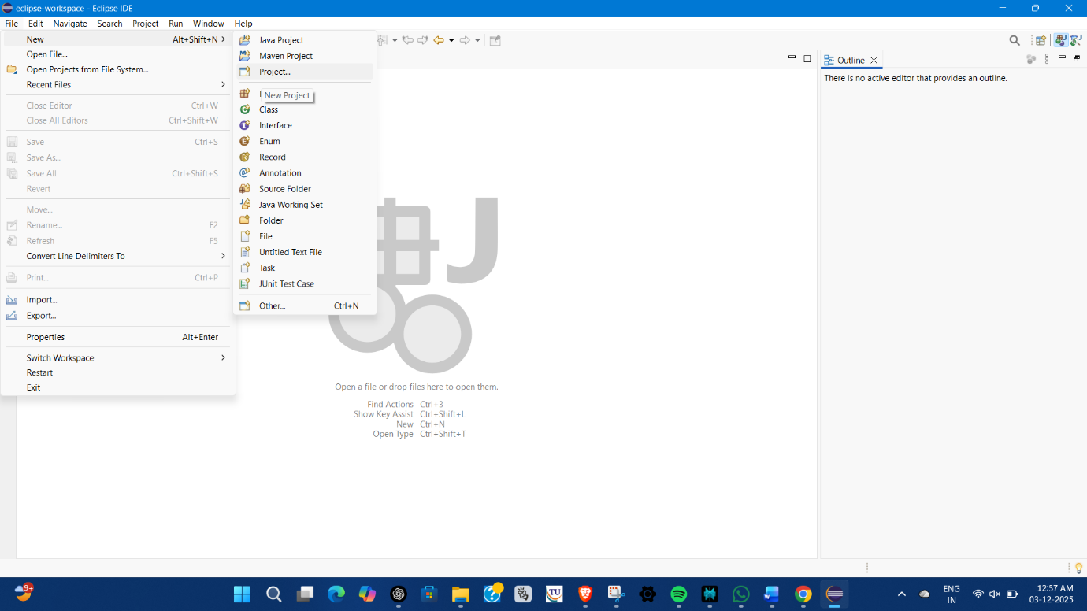

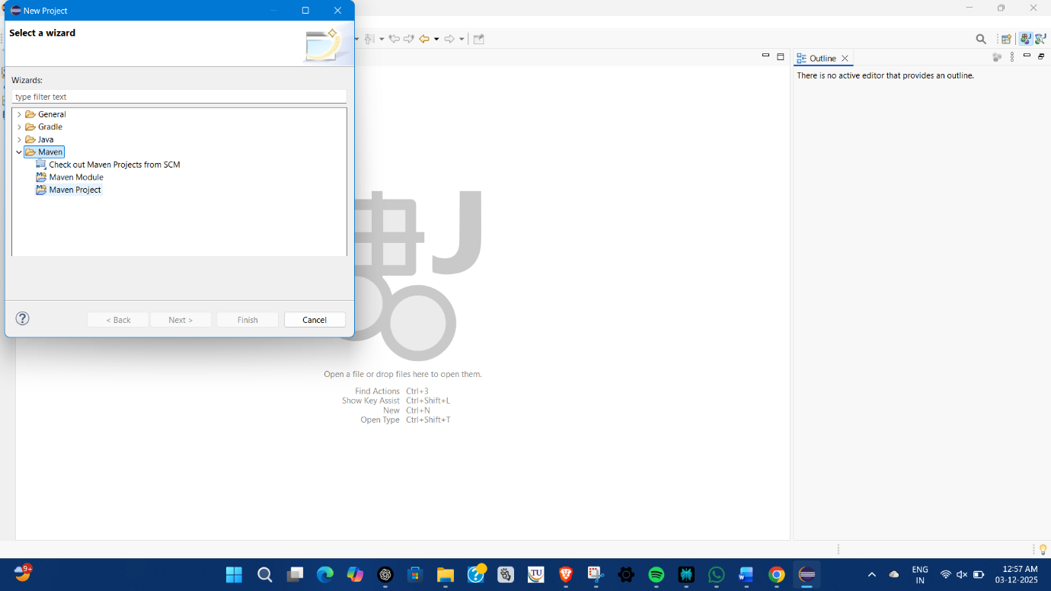

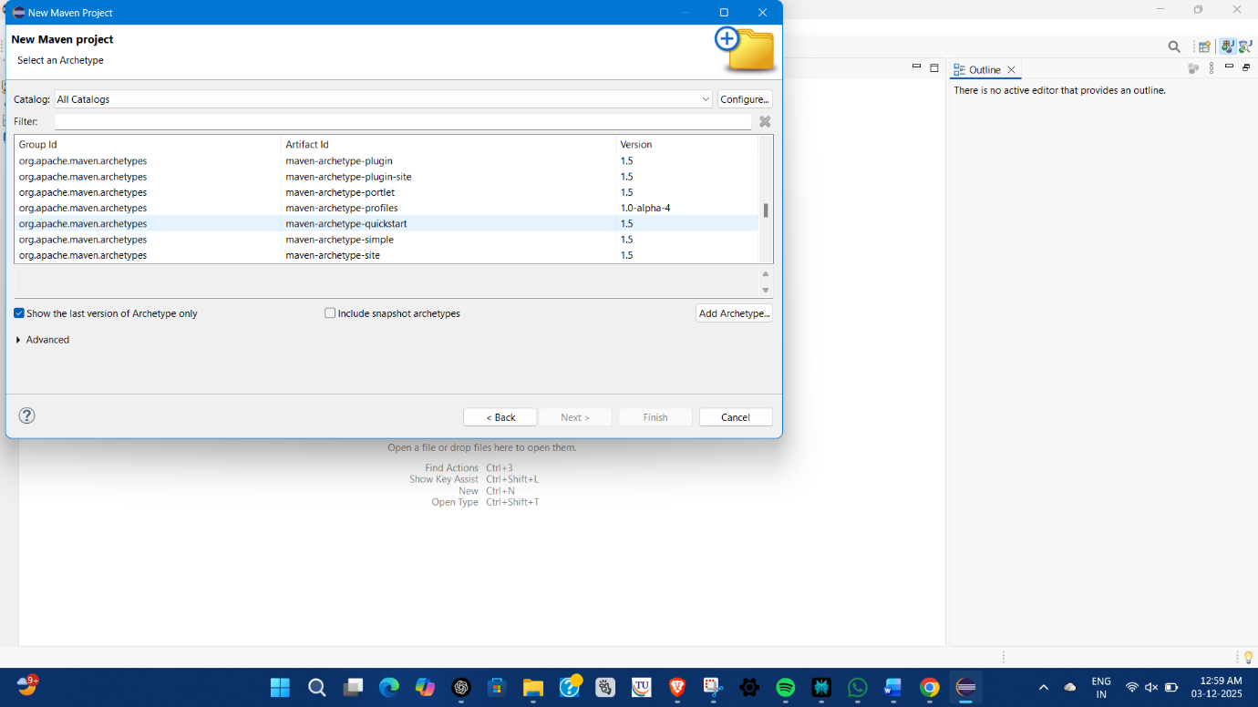

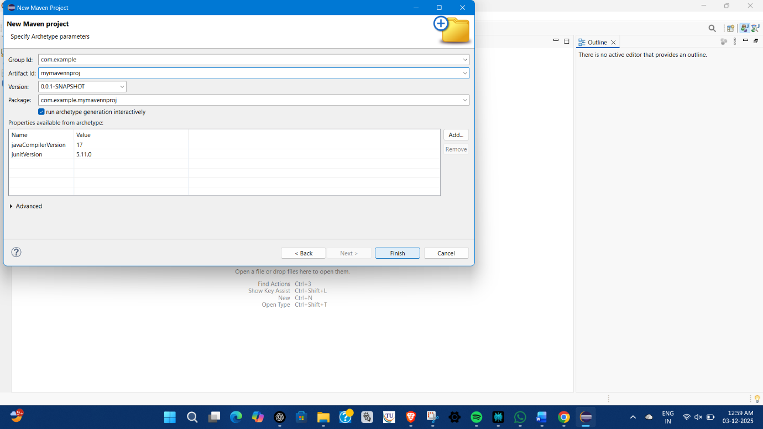

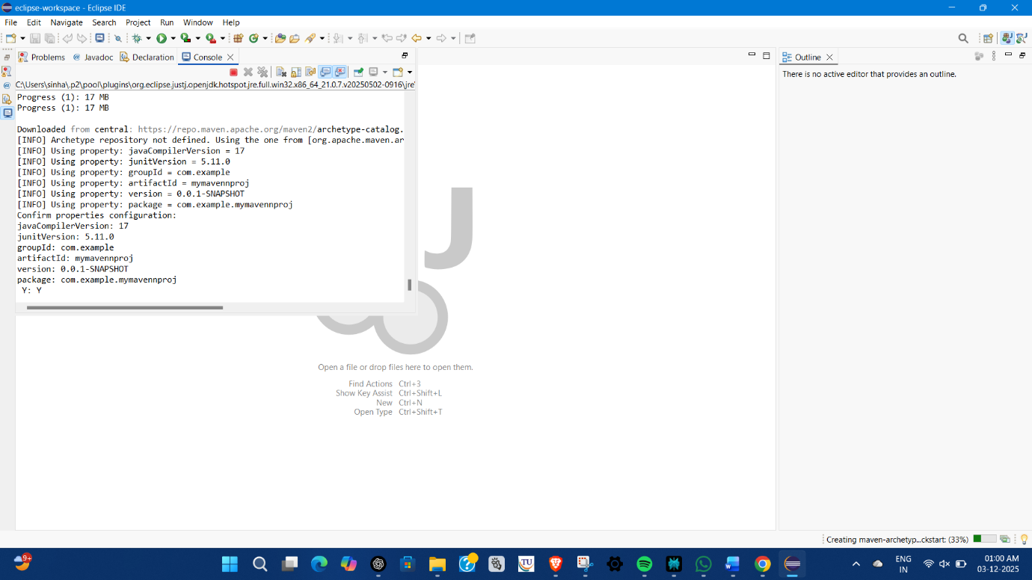

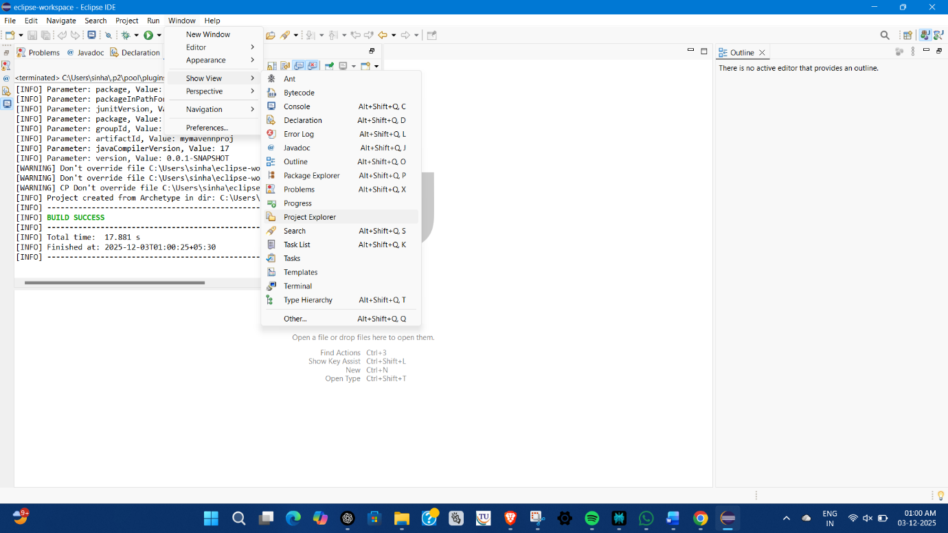

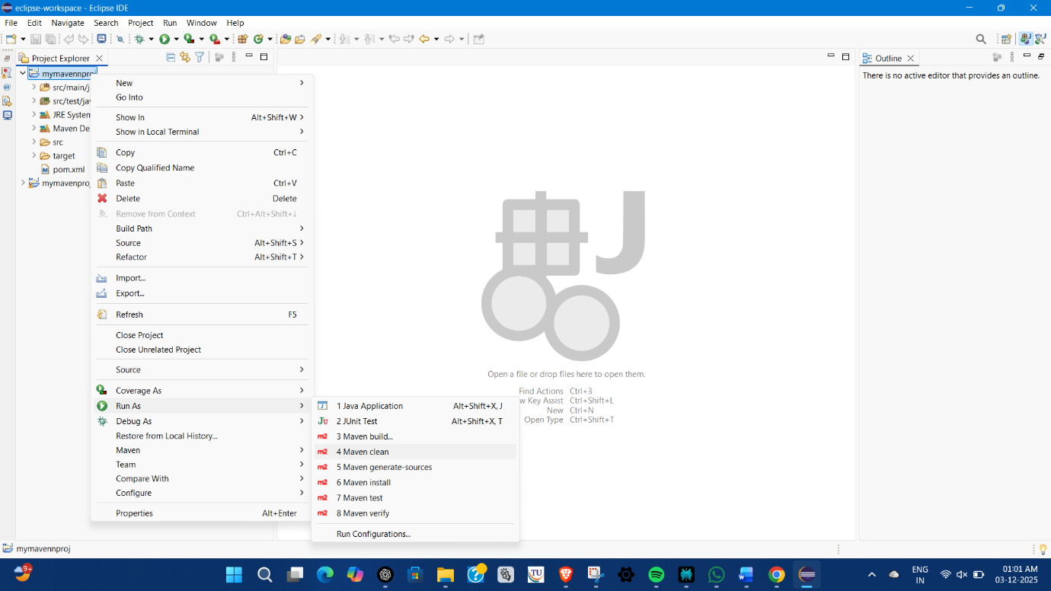

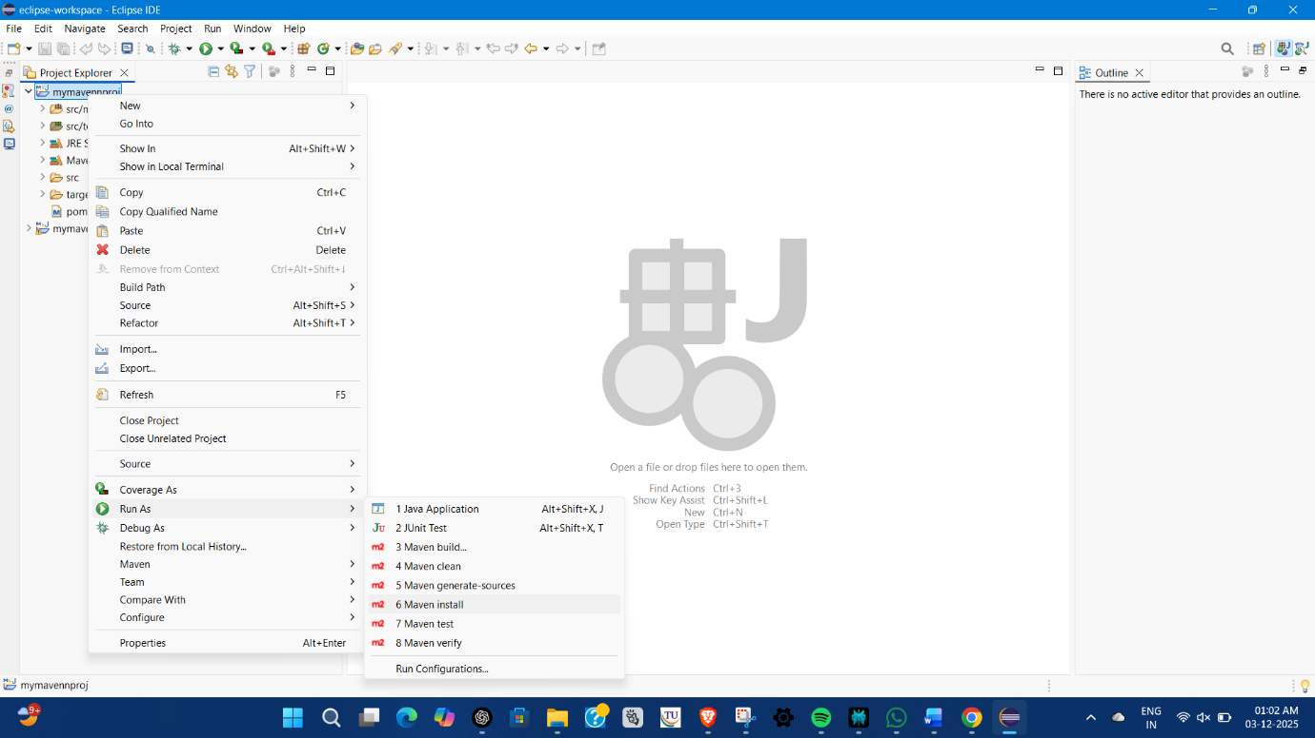

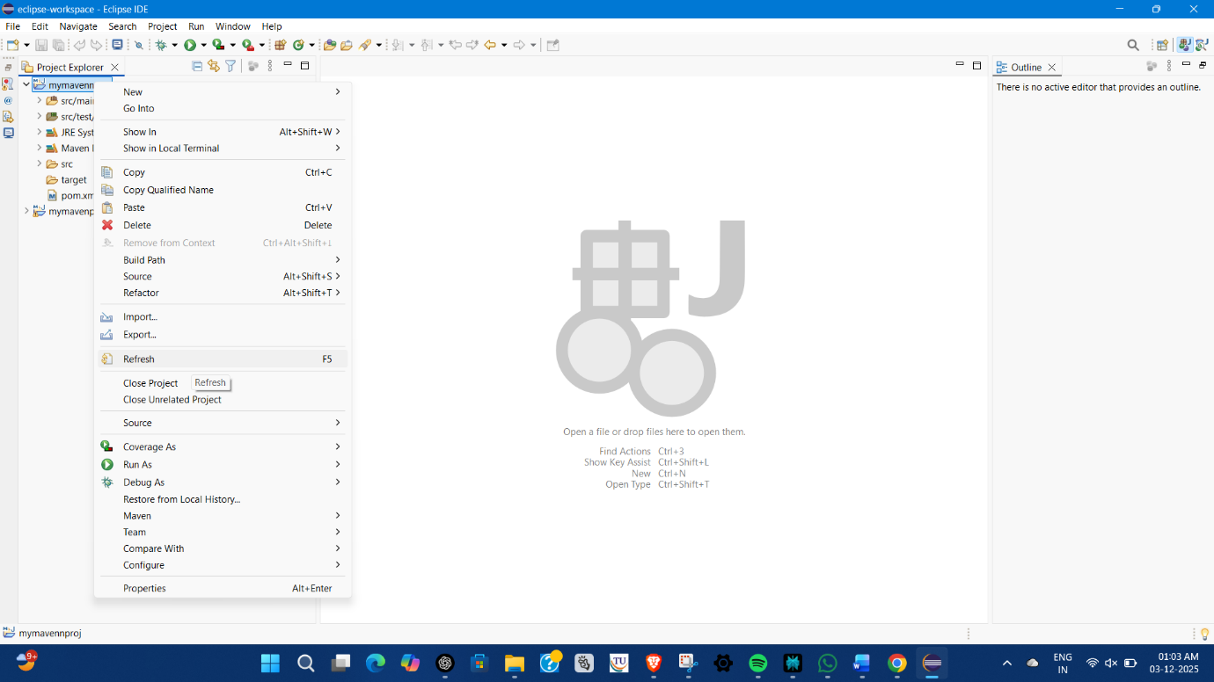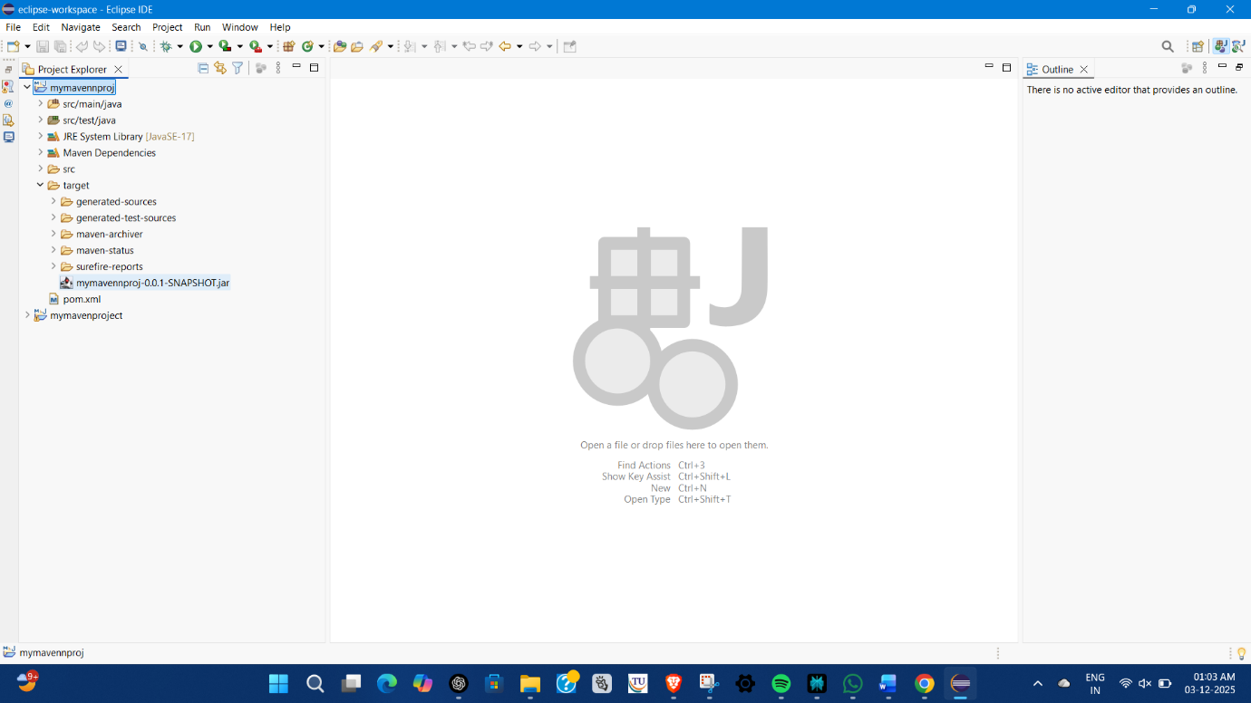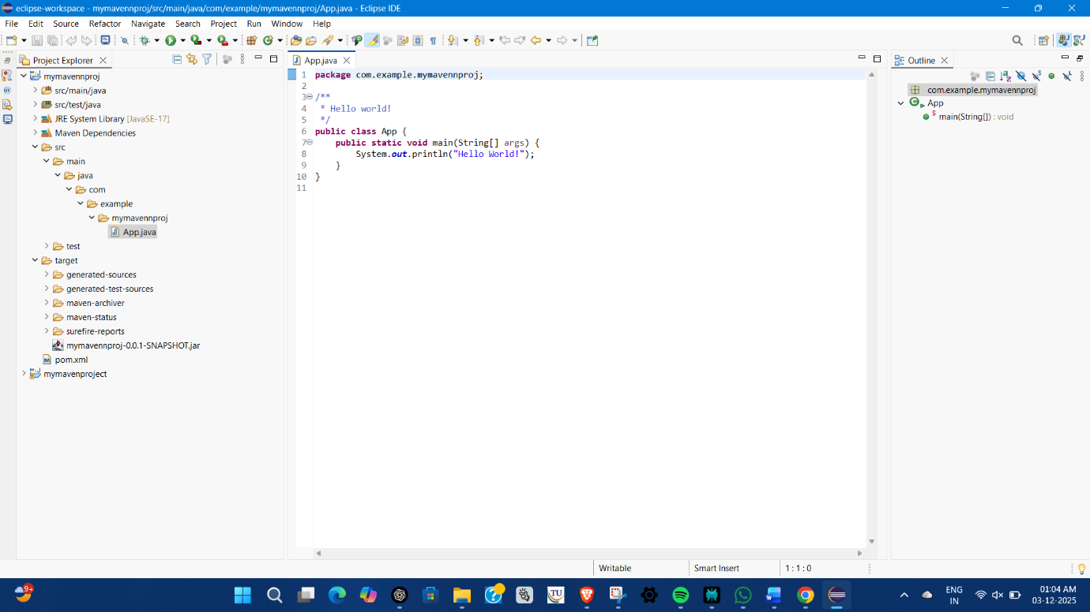

**Week -5   
Docker   
What the Question is Asking (The Briefing)**

**The lab is a guided exercise designed to teach you the core concepts and commands of Docker, a tool that helps package applications into portable, isolated environments called containers.**

**The entire lab is broken down into two main parts:**

**Part 1: Basic Container Management**

**This section teaches you the fundamental commands for managing pre-built applications (specifically, a Redis database server) using Docker. You will learn how to:**

1. **Pull a pre-made application image (redis) from the internet.**
2. **Run that image as a live, isolated container.**
3. **Inspect the running container.**
4. **Interact with the application inside the container (using redis-cli).**
5. **Stop, Start, and Remove the container and the image.**

**Part 2: Custom Image Creation and Sharing**

**This section moves beyond pre-built images and teaches you the software engineering workflow for creating and sharing your own custom application image. You will learn how to:**

1. **Write a Dockerfile, which is a simple text file containing instructions to build your custom image.**
2. **Build a new image from your Dockerfile.**
3. **Commit changes to a running container to create a new image snapshot.**
4. **Log in to Docker Hub (a public repository for Docker images).**
5. **Push your custom image to Docker Hub so others can use it.**
6. **Pull and Run your custom image to verify the sharing process.**
7. **Clean up all containers and images.**

**⭐ WEEK 5 — Docker Execution (Simple Required Version)**

**1️⃣ What the Question Is Asking (Simple English)**

**The week-5 experiment wants you to:**

**Install Docker, pull an image, run a container, inspect it, stop it, restart it, and remove it.**

**Basically:  
👉 Work with a Docker image and container using commands.**

**Nothing more is required for execution marks.**

**2️⃣ Step-by-Step Execution (Do These & Screenshot)**

**Before starting: Make sure Docker Desktop is running.  
When it says: Docker Engine running, then continue.**

**Step 1 — Open Command Prompt / Git Bash**

**Right-click anywhere → Open Git Bash here  
OR search: cmd → open**

**📷 Take a screenshot of empty terminal (optional).**

**Step 2 — Pull Redis Image**

**Type:**

**docker pull redis**

**📷 Screenshot output.**

**Expected messages:**

**Pulling from library/redis**

**Downloading...**

**Download complete**

**Status: Downloaded newer image for redis:latest**

**Step 3 — Run a Redis Container**

**docker run --name my-redis -d redis**

**Flags explained:**

* **--name my-redis → give container name**
* **-d → run in background**

**📷 Screenshot output: a long container ID string.**

**Step 4 — Check Running Containers**

**docker ps**

**📷 Screenshot the output.**

**Expected:**

**CONTAINER ID NAME IMAGE STATUS PORTS ...**

**xxxxx my-redis redis Up ...**

**Step 5 — Enter Redis CLI (Run Inside Container)**

**docker exec -it my-redis redis-cli**

**This opens a prompt like:**

**127.0.0.1:6379>**

**Now run:**

**SET name "Alice"**

**GET name**

**Expected:**

**OK**

**"Alice"**

**📷 Screenshot.**

**Exit Redis shell:**

**exit**

**Step 6 — Stop the Running Container**

**docker stop my-redis**

**📷 Screenshot:**

**my-redis**

**Step 7 — Start the Container Again**

**docker start my-redis**

**📷 Screenshot.**

**Step 8 — Remove the Container**

**First stop if still running:**

**docker stop my-redis**

**Then remove:**

**docker rm my-redis**

**📷 Screenshot:**

**my-redis**

**Step 9 — Remove the Redis Image (Optional)**

**docker rmi redis**

**⭐ WEEK 5 — PART 2**

**Create a Custom Docker Image Using Dockerfile and Run It**

**📌 What this task is asking:**

**Create a folder → write a Dockerfile → build a custom image → run a container → verify → stop → remove container + image.**

**Just like Part-1, but now you are building your own image, not pulling one.**

**✅ STEP-BY-STEP EXECUTION (with screenshot points)**

**STEP 1 — Create a Folder**

**Create a folder anywhere, example:**

**C:\DockerProjects\RedisCustom**

**📷 Screenshot folder.**

**STEP 2 — Open Git Bash inside that folder**

**Right-click inside the folder → select:**

**Open Git Bash Here**

**📷 Screenshot empty terminal.**

**STEP 3 — Create a Dockerfile**

**In Git Bash type:**

**touch Dockerfile**

**OR manually create a file named:**

**Dockerfile (⚠ No extension)**

**📷 Screenshot showing the file in the folder.**

**STEP 4 — Edit Dockerfile**

**Open the Dockerfile and add:**

**FROM redis:latest**

**CMD ["redis-server"]**

**📷 Screenshot of the contents.**

**STEP 5 — Build the Custom Image**

**In Git Bash run:**

**docker build -t redisnew .**

**Meaning:**

* **docker build → build an image**
* **-t redisnew → give the image a name**
* **. → use current folder (where Dockerfile is)**

**📷 Screenshot where it shows:**

**Successfully built ...**

**Successfully tagged redisnew:latest**

**STEP 6 — Run a Container from Your Custom Image**

**docker run --name myredisnew -d redisnew**

**📷 Screenshot showing the long container ID.**

**STEP 7 — Check Running Containers**

**docker ps**

**Expected output:**

**CONTAINER ID IMAGE STATUS NAMES**

**xxxxx redisnew Up... myredisnew**

**📷 Screenshot.**

**STEP 8 — Connect and Test Redis**

**docker exec -it myredisnew redis-cli**

**Inside CLI run:**

**SET user "Docker"**

**GET user**

**Expected output:**

**OK**

**"Docker"**

**📷 Screenshot.**

**Exit CLI:**

**exit**

**STEP 9 — Stop the Container**

**docker stop myredisnew**

**Expected:**

**myredisnew**

**📷 Screenshot.**

**STEP 10 — Remove the Container**

**docker rm myredisnew**

**📷 Screenshot.**

**STEP 11 — Remove the Custom Image**

**docker rmi redisnew**

**⭐ WEEK 6 — Docker Compose (Execution Steps Document Version)**

**📌 1️⃣ What the Question Is Asking**

**Create a docker-compose.yml file that starts multiple containers (WordPress + MySQL), run it using Docker Compose, verify containers running, and then stop them.**

**🧱 2️⃣ Step-by-Step Execution (Follow & Screenshot Each Step)**

**STEP 1 — Create a Folder**

**Example:**

**C:\DockerProjects\ComposeTest**

**📷 Screenshot folder.**

**STEP 2 — Open Git Bash in that folder**

**Right-click → Open Git Bash here**

**📷 Screenshot empty terminal.**

**STEP 3 — Create the docker-compose.yml File**

**Type:**

**touch docker-compose.yml**

**📷 Screenshot.**

**Now open the file and paste the following:**

**version: '3.8'**

**services:**

**wordpress:**

**image: wordpress:latest**

**ports:**

**- "8080:80"**

**environment:**

**WORDPRESS_DB_HOST: db:3306**

**WORDPRESS_DB_USER: wordpress**

**WORDPRESS_DB_PASSWORD: wordpress**

**WORDPRESS_DB_NAME: wordpress**

**depends_on:**

**- db**

**db:**

**image: mysql:5.7**

**environment:**

**MYSQL_ROOT_PASSWORD: rootpassword**

**MYSQL_DATABASE: wordpress**

**MYSQL_USER: wordpress**

**MYSQL_PASSWORD: wordpress**

**📷 Screenshot of content.**

**STEP 4 — Run Docker Compose**

**Command:**

**docker compose up -d**

**(or if older version: docker-compose up -d)**

**📷 Screenshot output → should show:**

**Creating network...**

**Pulling wordpress...**

**Pulling mysql...**

**Creating compose-test_db_1 ...**

**Creating compose-test_wordpress_1 ...**

**Done.**

**STEP 5 — Verify Running Containers**

**Run:**

**docker ps**

**Expected output:**

**CONTAINER ID NAME IMAGE**

**xxxxx compose-test_wordpress_1 wordpress**

**xxxxx compose-test_db_1 mysql:5.7**

**📷 Screenshot.**

**STEP 6 — Test in Browser (Optional but Good)**

**Open browser → type:**

**http://localhost:8080**

**You should see:**

**➡ WordPress installation screen**

**📷 Screenshot (IF loading — takes ~1–2 mins)**

**If not loading — STILL OK, this part is optional.**

**STEP 7 — Stop All Containers**

**Command:**

**docker compose down**

**📷 Screenshot expected:**

**Stopping compose-test_wordpress_1 ... done**

**Stopping compose-test_db_1 ... done**

**Removing containers...**

**Removing network...**

**STEP 8 — Confirm Stopped**

**Run:**

**docker ps**

**It should show no running WordPress/MySQL containers.**

**📷 Screenshot.**

**Something on your PC is already using port 8080  
(examples: Tomcat, another container, Java web app, IntelliJ server, Postman mock server, etc.)**

**So WordPress container cannot start because it needs port 8080 from your compose file.**

**✅ Fix: Change the port in the docker-compose.yml file**

**You only need to edit ONE line:**

**Find:**

**- "8080:80"**

**Change it to a free port, like:**

**- "8085:80"**

**or**

**- "8090:80"**

**So final section becomes:**

**wordpress:**

**image: wordpress:latest**

**ports:**

**- "8085:80"**

**✅ After editing the file, run these commands:**

**Step 1 (stop earlier attempt):**

**docker compose down**

**Step 2 (start with corrected port):**

**docker compose up -d**

**🧪 Verify:**

**Run:**

**docker ps**

**You should now see:**

**dockerproj1-wordpress-1 Up (0.0.0.0:8085->80)**

**dockerproj1-db-1 Up**

**📌 That means both containers are running correctly.**

**🌍 Test in Browser:**

**Open:**

**http://localhost:8085**

**✅ WEEK-7 — Maven Build, Dependency Management & Execution**

**🔹 Objective**

**To enhance a Maven project by adding external dependencies, updating configuration, rebuilding using Maven lifecycle commands, and executing the updated project.**

**🔹 Step-by-Step Execution**

**📌 Step 1 — Open Maven Project in Eclipse**

**Open your previously created Maven project.**

**Expected structure:**

**mymavenproject**

**├─ src/main/java**

**├─ src/test/java**

**└─ pom.xml**

**📌 Step 2 — Modify pom.xml (Add Dependency + Compiler Plugin)**

**Open pom.xml → bottom tab → select pom.xml (code view).**

**Replace everything with this final version:**

**<project xmlns="http://maven.apache.org/POM/4.0.0" xmlns:xsi="http://www.w3.org/2001/XMLSchema-instance"**

**xsi:schemaLocation="http://maven.apache.org/POM/4.0.0 http://maven.apache.org/xsd/maven-4.0.0.xsd">**

**<modelVersion>4.0.0</modelVersion>**

**<groupId>com.example</groupId>**

**<artifactId>mymavenproject</artifactId>**

**<version>0.0.1-SNAPSHOT</version>**

**<packaging>jar</packaging>**

**<name>mymavenproject</name>**

**<properties>**

**<project.build.sourceEncoding>UTF-8</project.build.sourceEncoding>**

**</properties>**

**<dependencies>**

**<!-- Default JUnit Dependency -->**

**<dependency>**

**<groupId>junit</groupId>**

**<artifactId>junit</artifactId>**

**<version>3.8.1</version>**

**<scope>test</scope>**

**</dependency>**

**<!-- Week 7 Added Dependency -->**

**<dependency>**

**<groupId>com.google.code.gson</groupId>**

**<artifactId>gson</artifactId>**

**<version>2.10</version>**

**</dependency>**

**</dependencies>**

**<!-- Compiler plugin configuration -->**

**<build>**

**<plugins>**

**<plugin>**

**<groupId>org.apache.maven.plugins</groupId>**

**<artifactId>maven-compiler-plugin</artifactId>**

**<version>3.11.0</version>**

**<configuration>**

**<source>17</source>**

**<target>17</target>**

**</configuration>**

**</plugin>**

**</plugins>**

**</build>**

**</project>**

**📌 Press CTRL + S to save.**

**📌 Step 3 — Update Maven Project**

**Right-click project →**

**Maven → Update Project → OK**

**Expected: Eclipse downloads Gson dependency.**

**📌 Step 4 — Modify App.java to Use Dependency**

**Open:**

**src/main/java/com/example/mymavenproject/App.java**

**Replace code with:**

**package com.example.mymavenproject;**

**import com.google.gson.Gson;**

**public class App {**

**public static void main(String[] args) {**

**Gson gson = new Gson();**

**String json = gson.toJson("Hello Week 7!");**

**System.out.println("Converted to JSON: " + json);**

**}**

**}**

**Save file.**

**📌 Step 5 — Run Maven Clean and Install**

**Right-click project →**

**✔ Run As → Maven Clean  
✔ Run As → Maven Install**

**Expected console output:**

**[INFO] BUILD SUCCESS**

**📌 Step 6 — Verify target Folder**

**Inside project:**

**target/**

**├─ classes/**

**└─ mymavenproject-0.0.1-SNAPSHOT.jar**

**(Refresh if not showing)**

**📌 Step 7 — Run the Application**

**Right-click:**

**App.java → Run As → Java Application**

**Expected output:**

**Converted to JSON: "Hello Week 7!"**

**🎉 This confirms the dependency worked and project executed correctly.**

**✅ What to change so Week-7 looks different**

**Just modify the program to use Gson dependency (the one we added).**

**Right now your App.java prints:**

**Hello World!**

**We’ll update it to use Gson, so it shows:**

**Converted to JSON: {"message":"Hello Week 7!"}**

**That way the teacher will understand:**

* **You added dependency ✔**
* **You used it in code ✔**
* **You rebuilt project ✔**
* **Output is different from Week-4 ✔**

**This makes Week-7 valid and unique.**

**✏ Step to Update App.java**

**Open:**

**src/main/java/com/example/mymavenproject/App.java**

**Replace its code with:**

**package com.example.mymavenproject;**

**import com.google.gson.Gson;**

**public class App {**

**public static void main(String[] args) {**

**Gson gson = new Gson();**

**String json = gson.toJson("Hello Week 7!");**

**System.out.println("Converted to JSON: " + json);**

**}**

**}**

**🚀 Now Build Again**

**Right-click project → Run As → Maven Clean**

**Then → Maven Install**

**Console must show:**

**[INFO] BUILD SUCCESS**

**▶ Run Program**

**Right-click App.java → Run As → Java Application**

**Expected output:**

**Converted to JSON: "Hello Week 7!"**

**Now Week-7 output is clearly different from Week-4.**

**Week 8: Jenkins Automation**

1. Hands-on practice on manual creation of Jenkins pipeline using Maven projects from Github
2. Create the job and build the pipeline for maven-java and maven-web project.
3. Questions on Jenkins
4. Upload the Screenshots.
5. **Steps for MavenJava Automation:**

Maven Java Automation Steps:

**Step 1: Open Jenkins (localhost:8080)**

├── Click on "New Item" (left side menu  
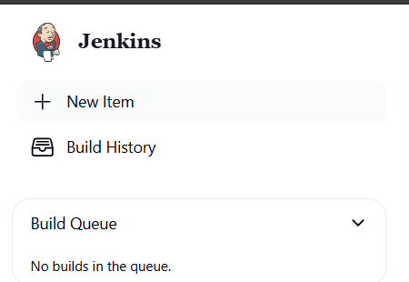

**Step 2: Create Freestyle Project (e.g., MavenJava_Build)**

├── Enter project name (e.g., MavenJava_Build)

├── Click "OK"  
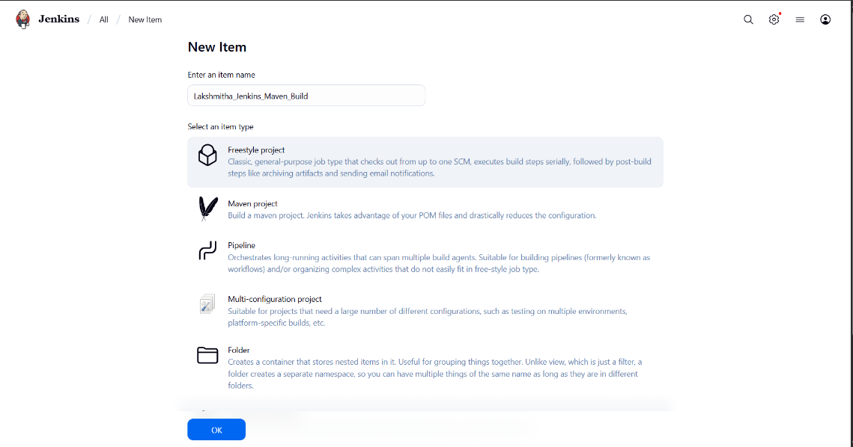

**└── Configure the project:**

├── **Description**: "Java Build demo"

├── **Source Code Management**:

└── Git repository URL: [GitMavenJava repo URL]

├── **Branches to build**: */Main or */master

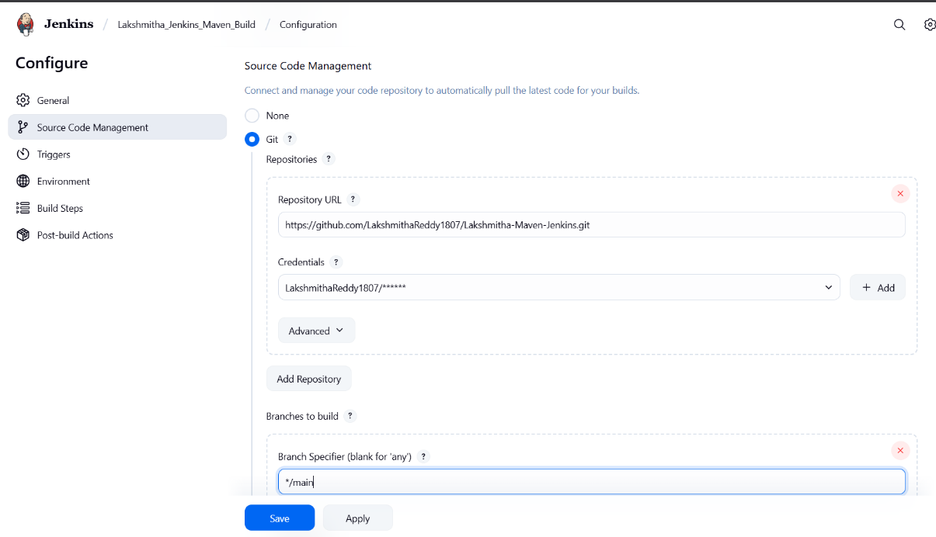

└── **Build Steps**:

├── **Add Build Step** -> "Invoke top-level Maven targets"

└── Maven version: MAVEN_HOME

└── Goals: clean

├── **Add Build Step** -> "Invoke top-level Maven targets"

└── Maven version: MAVEN_HOME

└── Goals: install

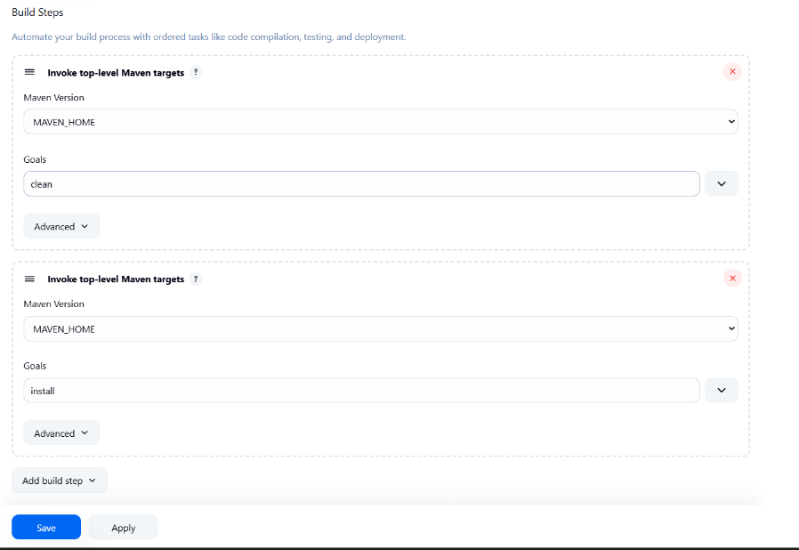

└── **Post-build Actions**:

├── Add Post Build Action -> "Archive the artifacts"

└── Files to archive: **/*

├── Add Post Build Action -> "Build other projects"

└── Projects to build: MavenJava_Test

└── Trigger: Only if build is stable

└── Apply and Save

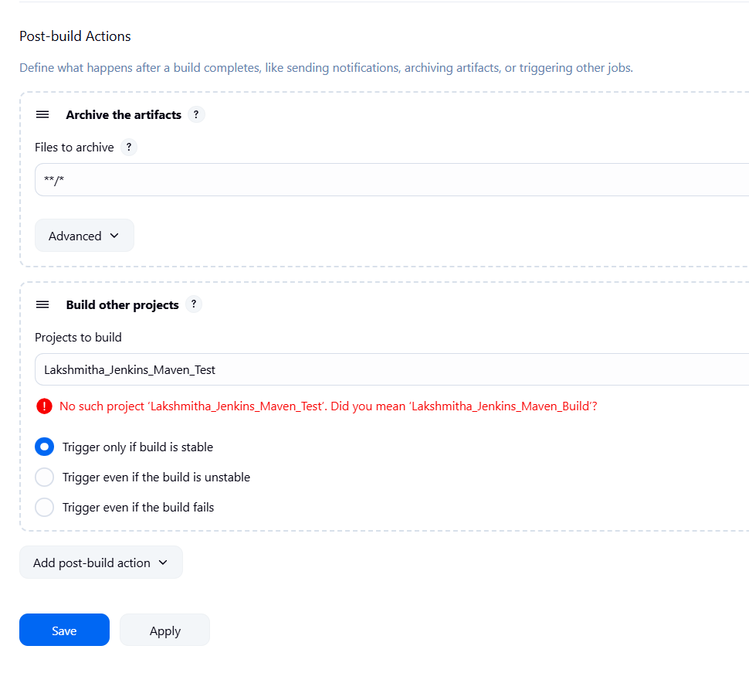

└── **Step 3: Create Freestyle Project (e.g., MavenJava_Test)**

├── Enter project name (e.g., MavenJava_Test)

├── Click "OK"

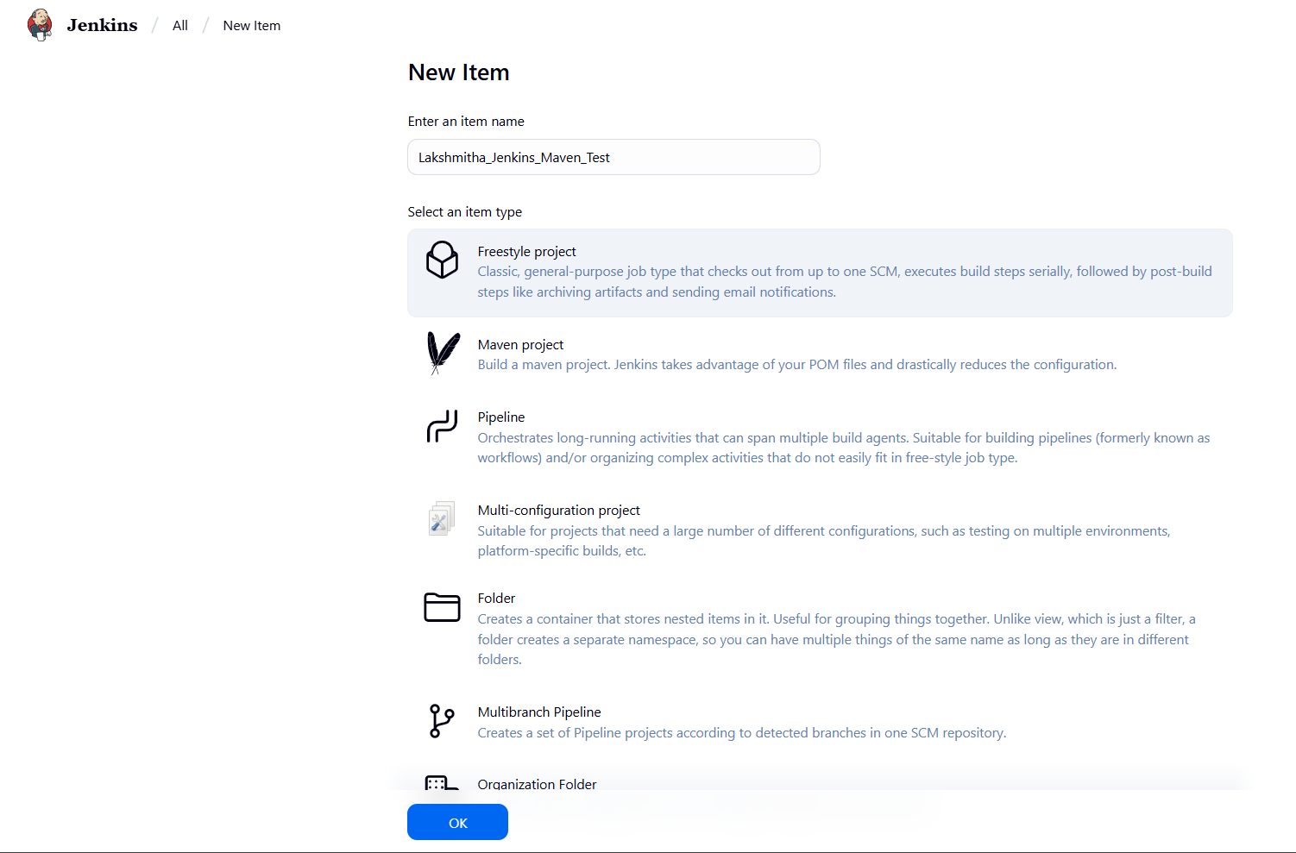

**└── Configure the project**:

├── **Description**: "Test demo"

**├── Build Environment**:

└── Check: "Delete the workspace before build starts"

├── **Add Build Step** -> "Copy artifacts from another project"

└── Project name: MavenJava_Build

└── Build: Stable build only **//** tick at this

└── Artifacts to copy: **/*

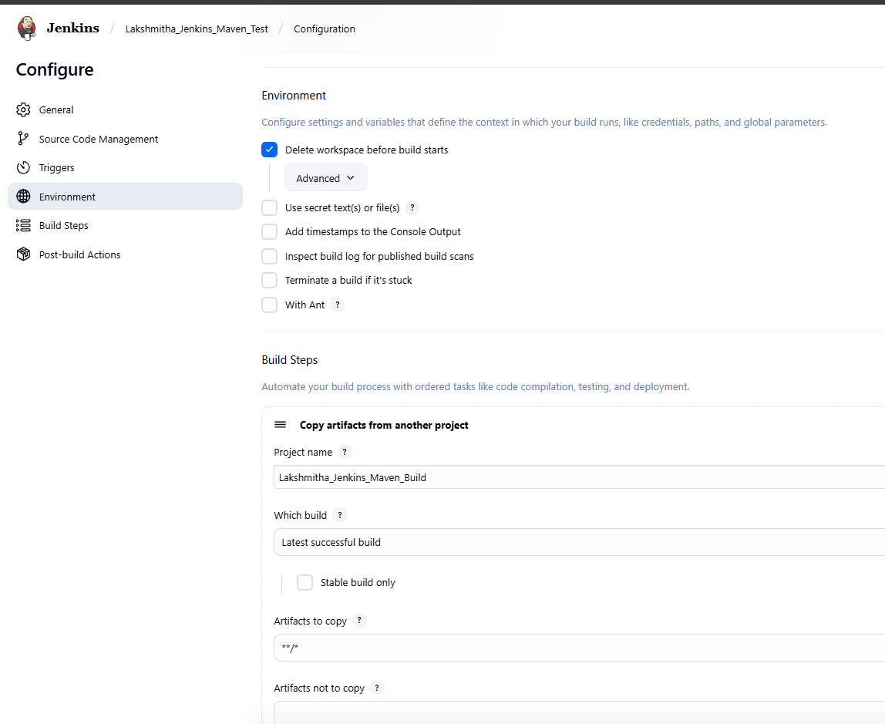

├── **Add Build Step** -> "Invoke top-level Maven targets"

└── Maven version: MAVEN_HOME

└── Goals: test

└── Post-build Actions:

├── **Add Post Build Action** -> "Archive the artifacts"

└── Files to archive: **/*

└── Apply and Save

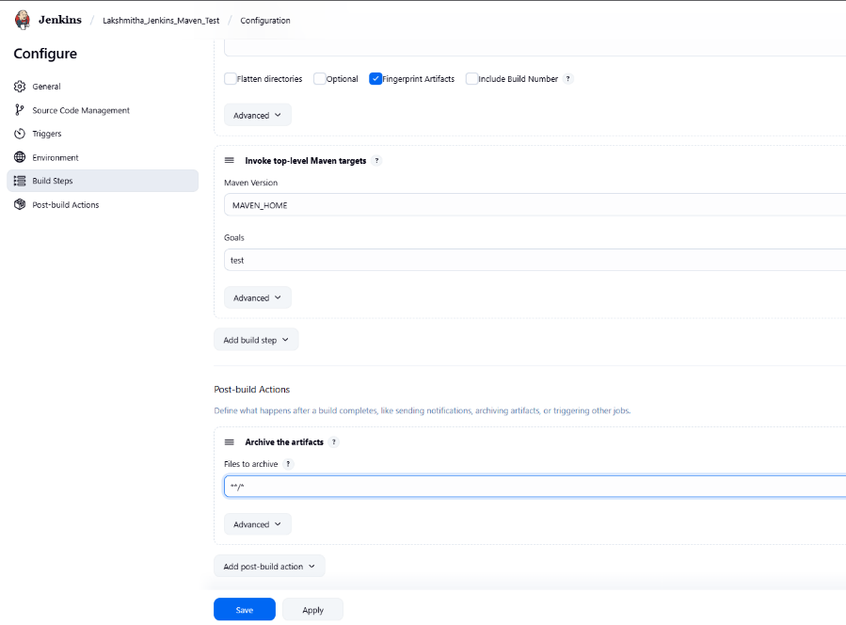

└── **Step 4**: Create Pipeline View for Maven Java project

├── Click "+" beside "All" on the dashboard

├── Enter name: MavenJava_Pipeline

├── **Select "Build pipeline view" // tick here**

**|--- create**

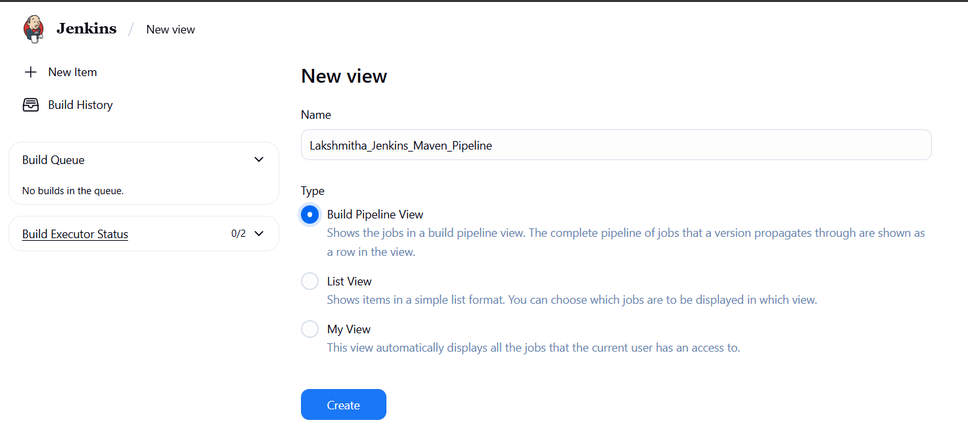

**└── Pipeline Flow**:

**├── Layout**: Based on upstream/downstream relationship

├── Initial job: MavenJava_Build

└── Apply and Save OK

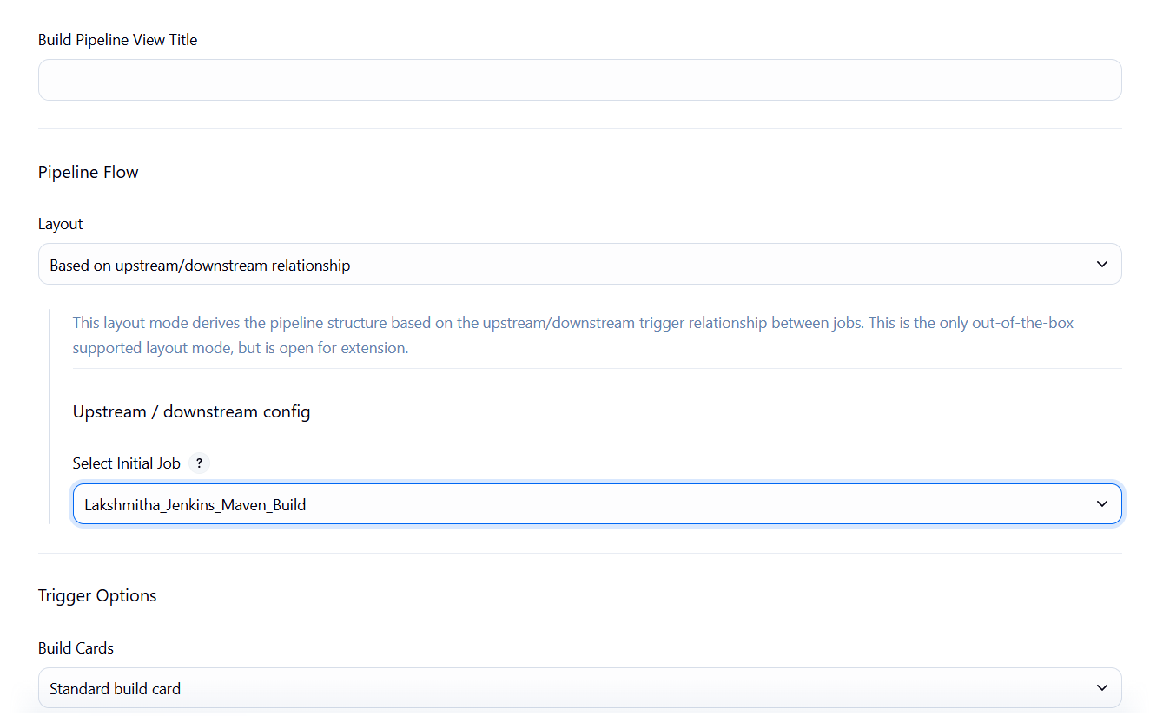

└── **Step 5**: Run the Pipeline and Check Output

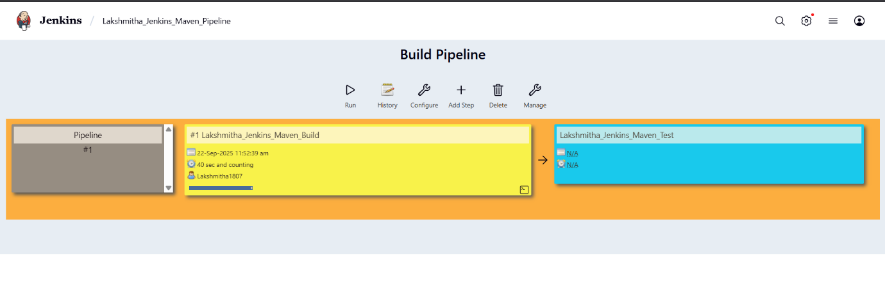

├── Click on the trigger to run the pipeline

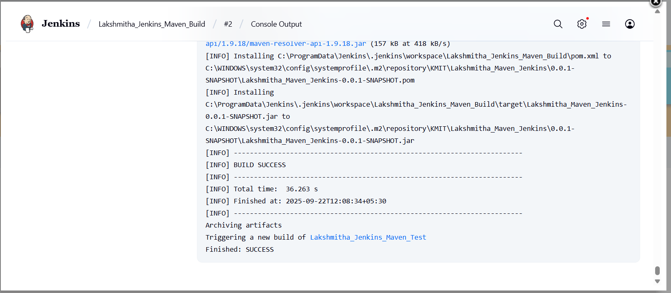

├── click on the small black box to open the console to check if the build is success

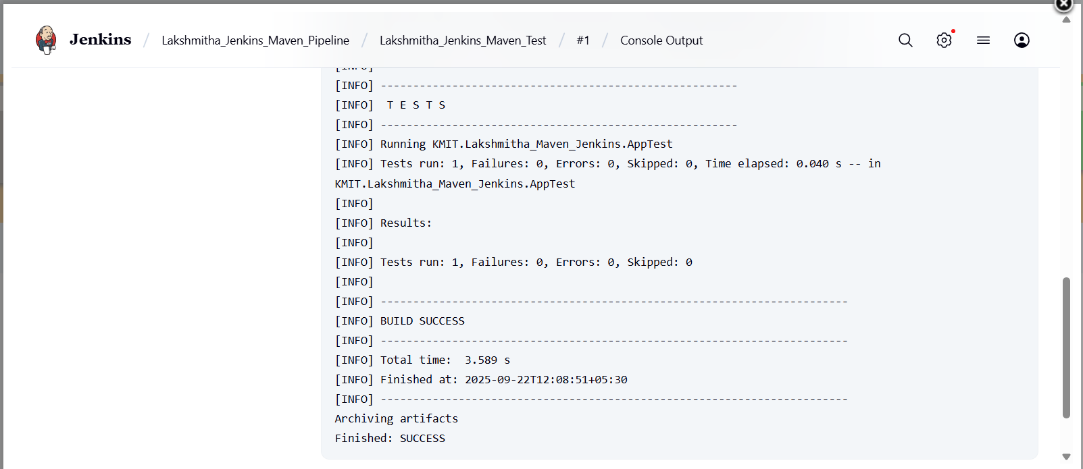

Note :

1. If build is success and the test project is also automatically triggered with name

“MavenJava_Test”

1. The pipeline is successful if it is in green color as shown ->check the console of the test project
2. The test project is successful and all the artifacts are archived successfully

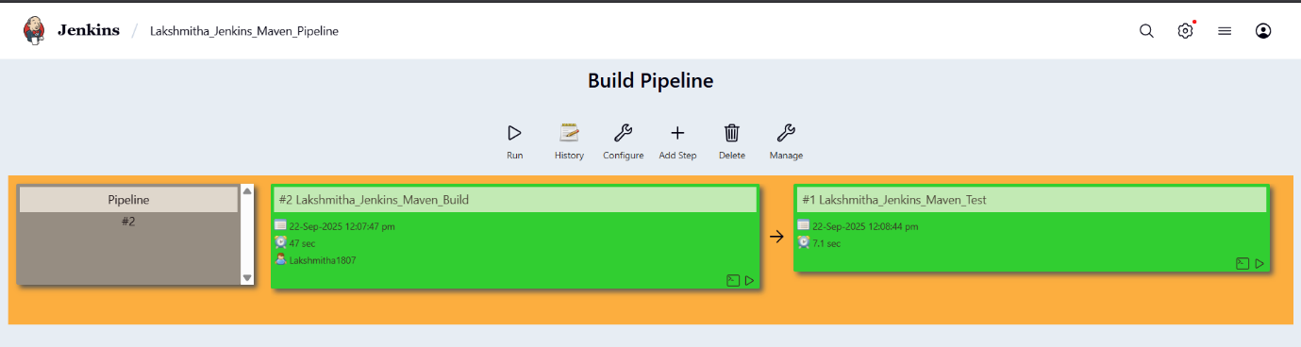

**II. Maven Web Automation Steps:**

└── **Step 1:** Open Jenkins (localhost:8080)

├── Click on "New Item" (left side menu)

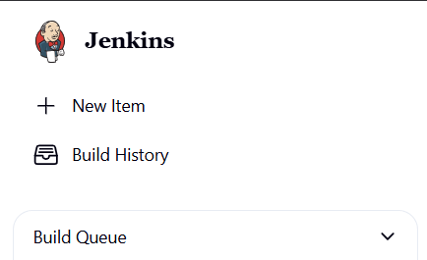

└── **Step 2**: Create Freestyle Project (e.g., MavenWeb_Build)

├── Enter project name (e.g., MavenWeb_Build)

├── Click "OK"

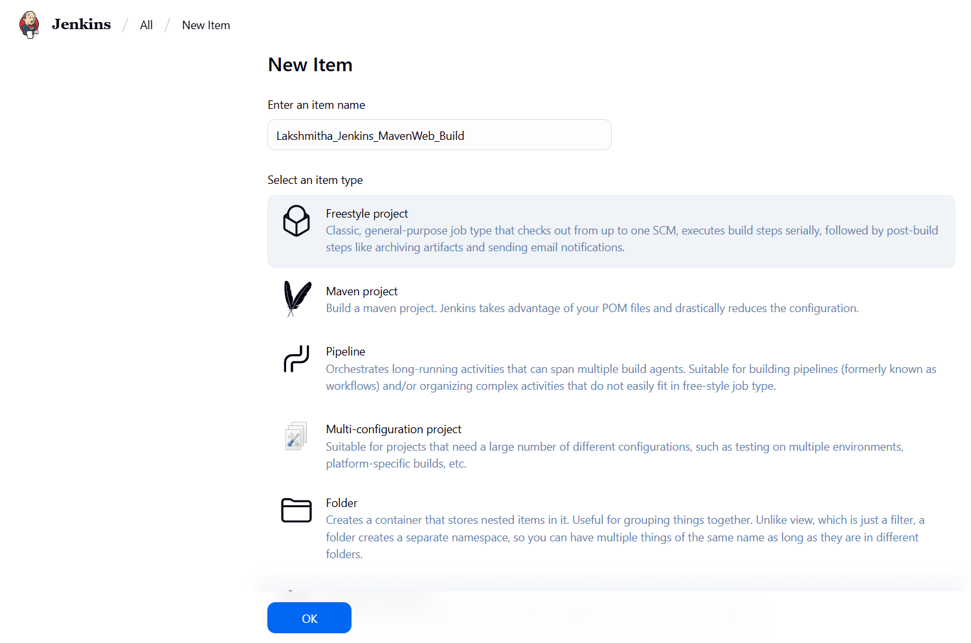

└── **Configure the project**:

├── **Description**: "Web Build demo"

├── **Source Code Management:**

└── Git repository URL: [GitMavenWeb repo URL]

├── *Branches to build*: */Main or master

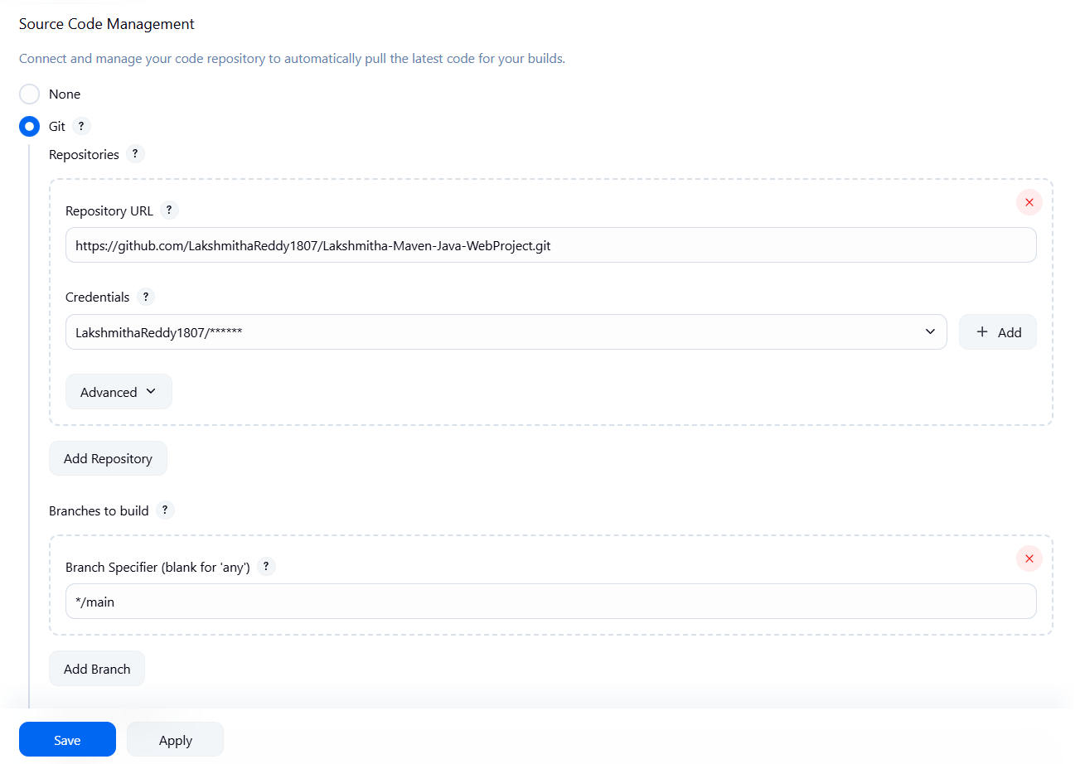

└── **Build Steps**:

├── **Add Build Step** -> "Invoke top-level Maven targets"

└── Maven version: MAVEN_HOME

└── Goals: clean

├── **Add Build Step** -> "Invoke top-level Maven targets"

└── Maven version: MAVEN_HOME

└── Goals: install

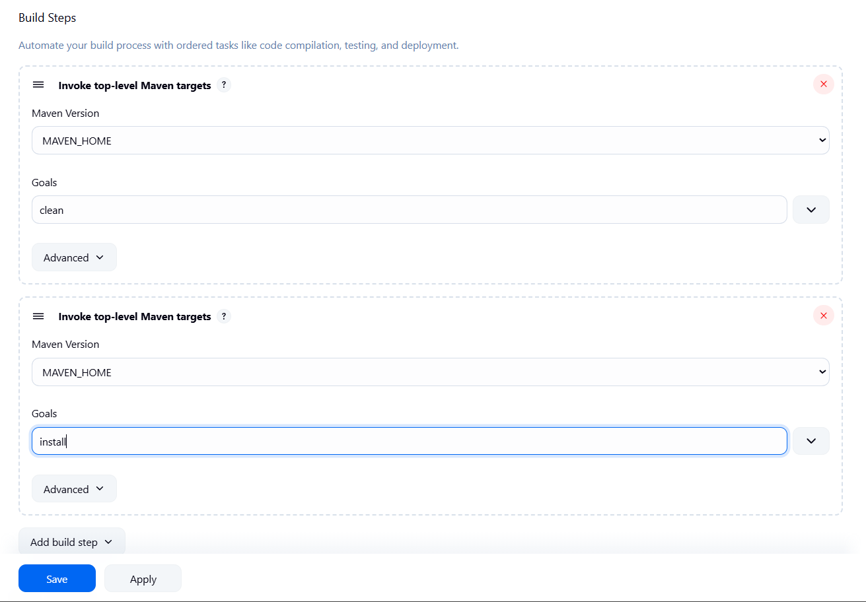

└── **Post-build Actions**:

├── **Add Post Build Action** -> "Archive the artifacts"

└── Files to archive: **/*

├── **Add Post Build Action** -> "Build other projects"

└── Projects to build: MavenWeb_Test

└── Trigger: Only if build is stable

└── Apply and Save

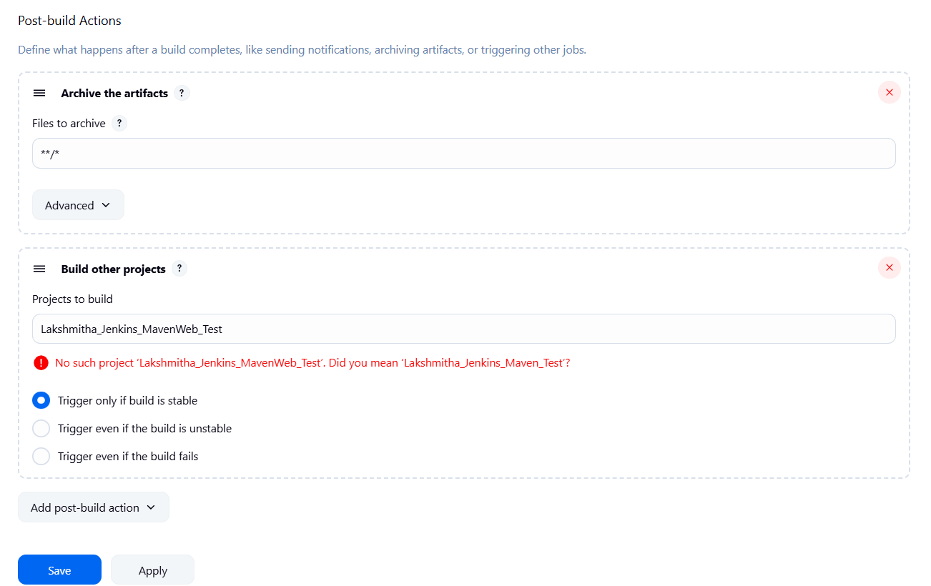

**└── Step 3**: Create Freestyle Project (e.g., MavenWeb_Test)

├── Enter project name (e.g., MavenWeb_Test)

├── Click "OK"

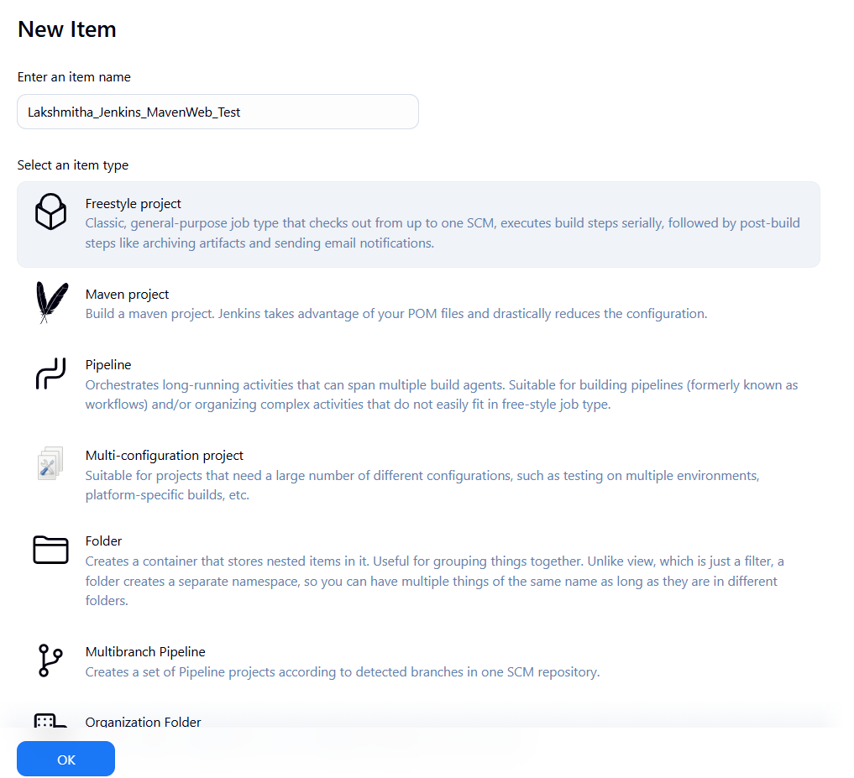

└── **Configure the project:**

├── **Description:** "Test demo"

├── **Build Environment**:

└── Check: "Delete the workspace before build starts"

├── **Add Build Step** -> "Copy artifacts from another project"

└── Project name: MavenWeb_Build

└── Build: Stable build only

└── Artifacts to copy: **/*

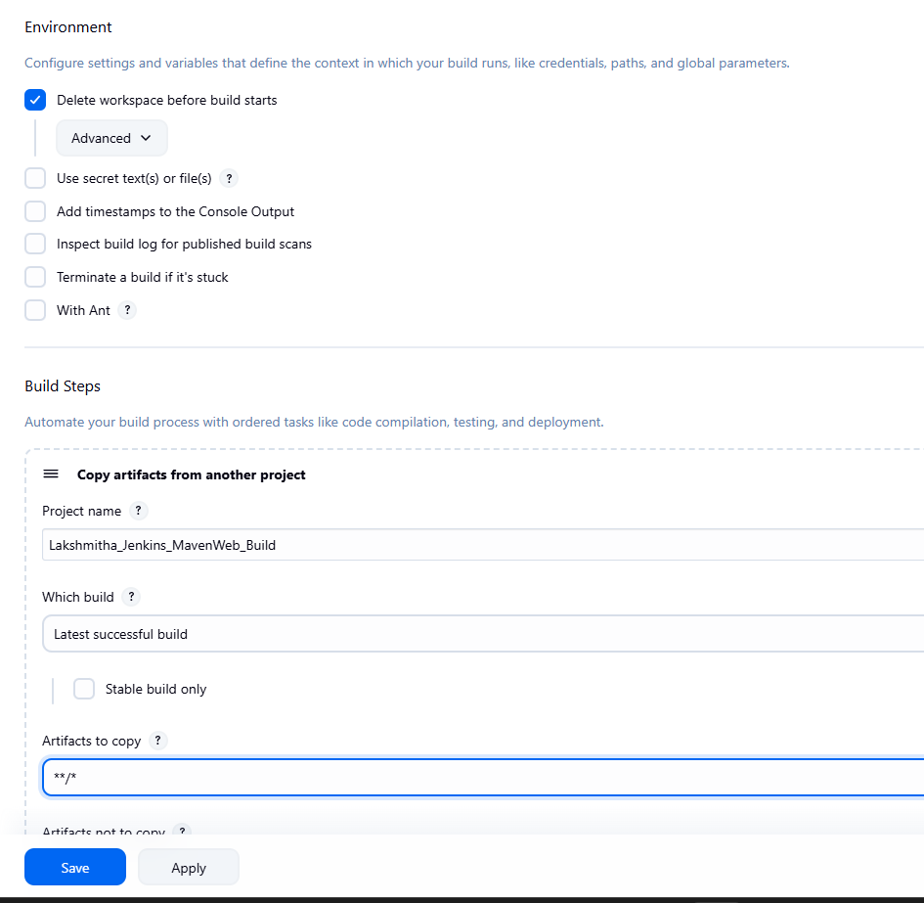

├── **Add Build Step** -> "Invoke top-level Maven targets"

└── Maven version: MAVEN_HOME

└── Goals: test

└── **Post-build Actions**:

├── **Add Post Build Action** -> "Archive the artifacts"

└── Files to archive: **/*

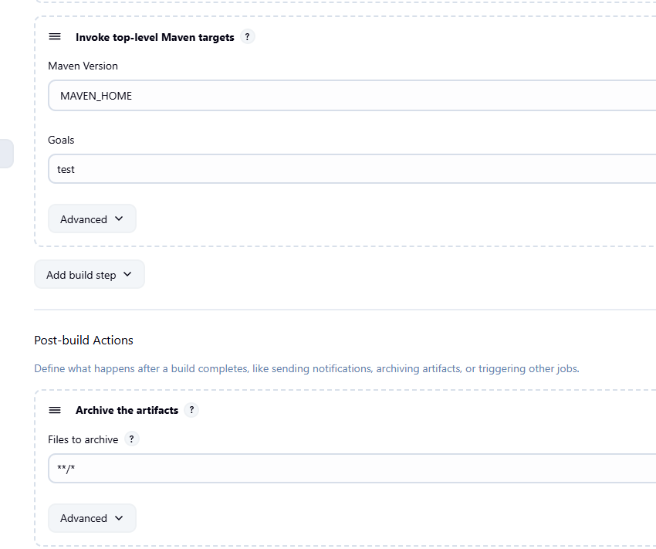

├── **Add Post Build Action** -> "Build other projects"

└── Projects to build: MavenWeb_Deploy

└── Apply and Save

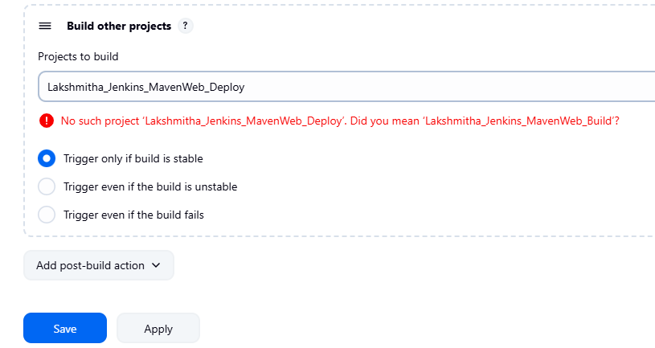

└── **Step 4**: Create Freestyle Project (e.g., MavenWeb_Deploy)

├── Enter project name (e.g., MavenWeb_Deploy)

├── Click "OK"

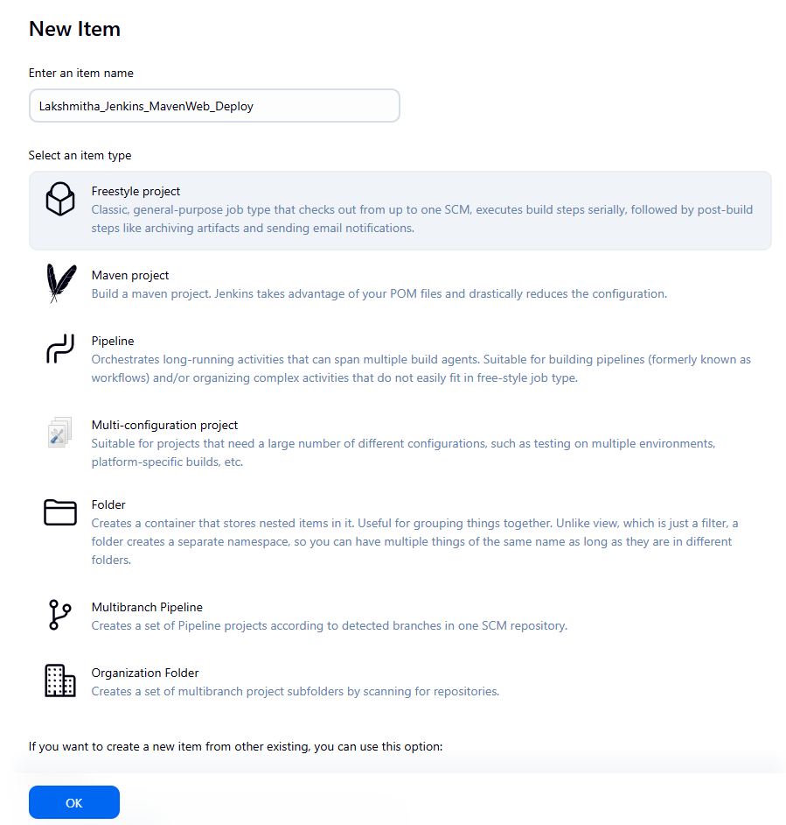

└── **Configure the projec**t:

├── **Description**: "Web Code Deployment"

├── **Build Environment**:

└── Check: "Delete the workspace before build starts"

├── **Add Build Step** -> "Copy artifacts from another project"

└── Project name: MavenWeb_Test

└── Build: Stable build only

└── Artifacts to copy: **/*

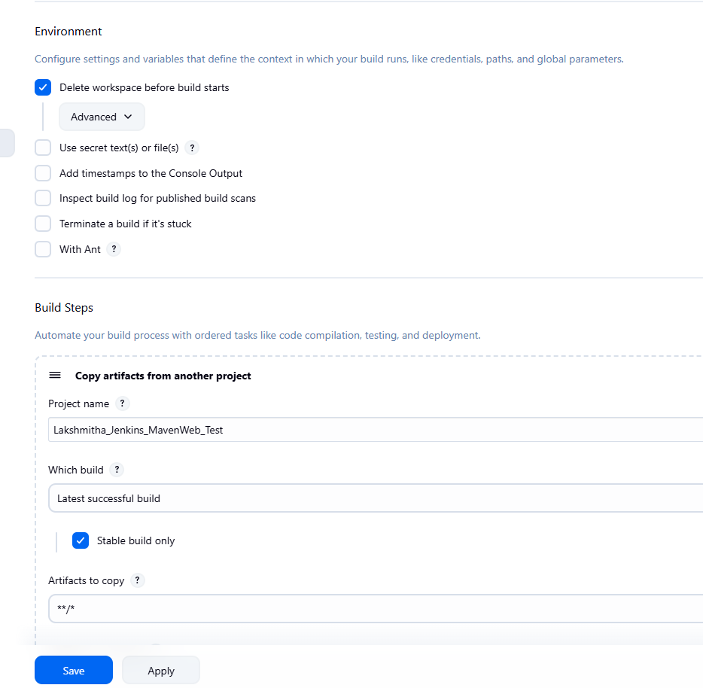

└── **Post-build Actions**:

├── **Add Post Build Action** -> "Deploy WAR/EAR to a container"

└── WAR/EAR File: **/*.war

└── Context path: Webpath

└── Add container -> Tomcat 9.x remote

└── Credentials: Username: admin, Password: 1234

── Tomcat URL: https://localhost:8085/

└── Apply and Save

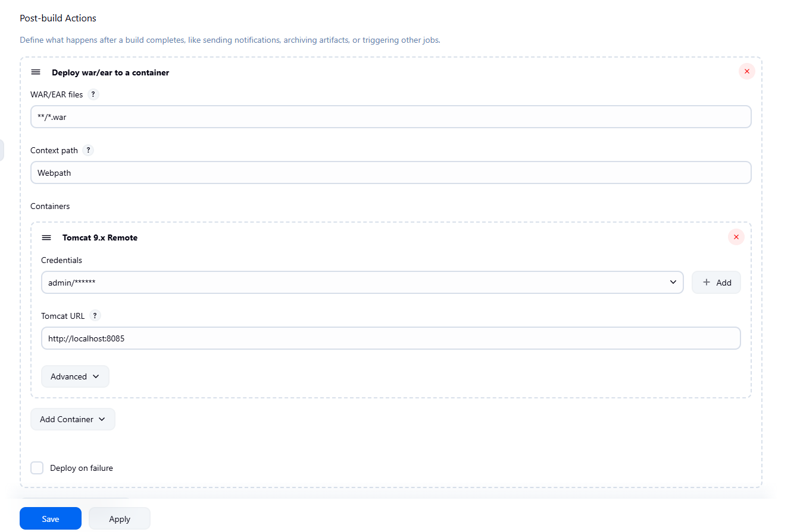

└── **Step 5**: Create Pipeline View for MavenWeb

├── Click "+" beside "All" on the dashboard

├── Enter name: MavenWeb_Pipeline

├── **Select "Build pipeline view"**

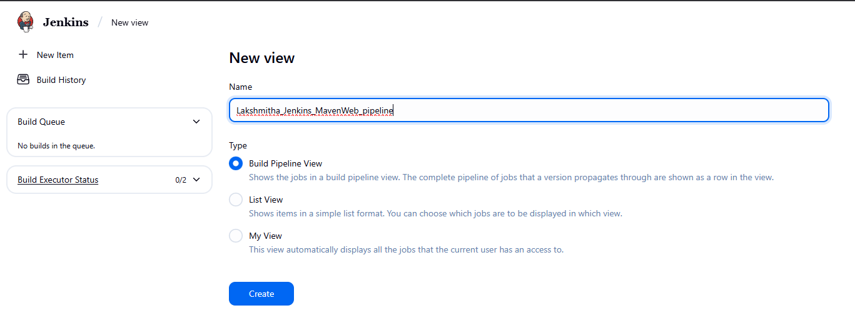

**└── Pipeline Flow**:

**├── Layout**: Based on upstream/downstream relationship

├── Initial job: MavenWeb_Build

└── Apply and Save

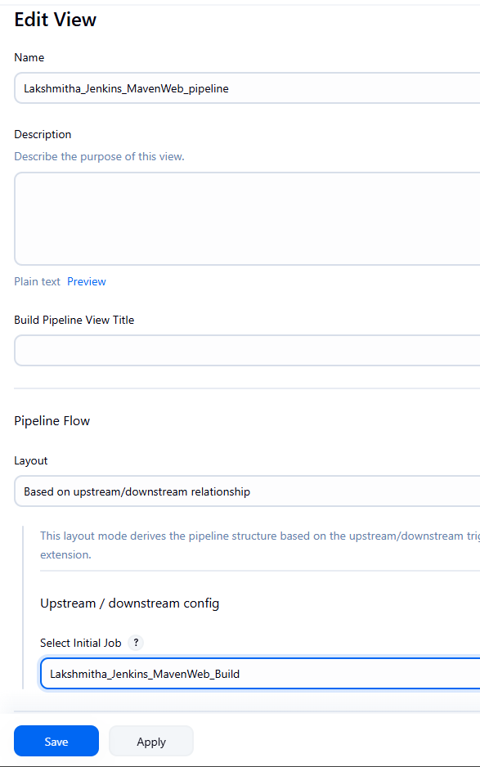

└── **Step 6**: Run the Pipeline and Check Output

├── Click on the trigger **“RUN”** to run the pipeline

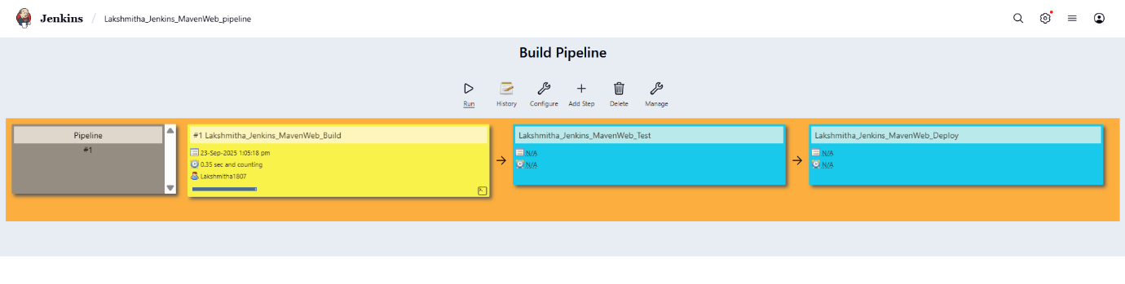

Note:

1. After Click on Run -> click on the small black box to open the console to check if the build is success
2. Now we see all the build has success if it appears in green color

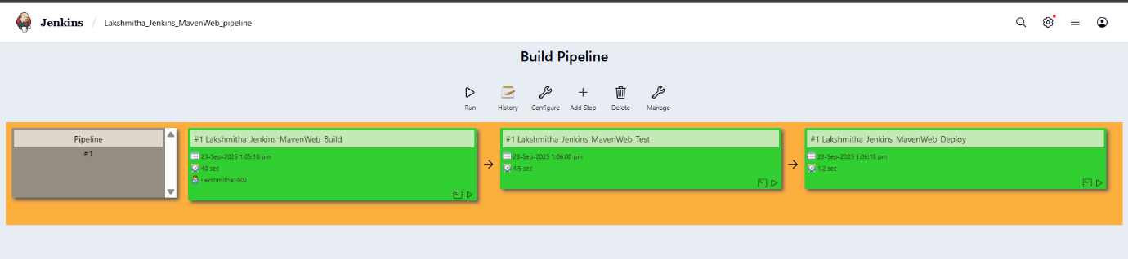o

├── Open Tomcat homepage in another tab

├── Click on the "/webpath" option under the manager app

Note:

1. It ask for user credentials for login ,provide the credentials of tomcat.
2. It provide the page with out project name which is highlighted.
3. After clicking on our project we can see output.

**Week 9: Pipeline Creation using script**

1. Evaluation of Jenkins pipeline.
2. **WORKING ON BUILD TRIGGERS FOR LAST JENKINS PIPILINE**
3. Hands-on practice on creation of scripted Jenkins pipeline.
4. Take the screenshots for above task

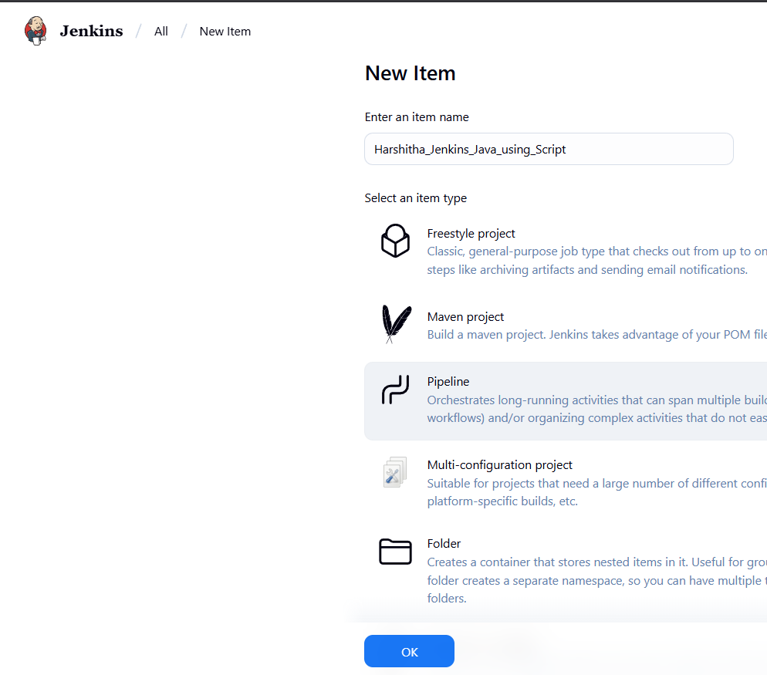

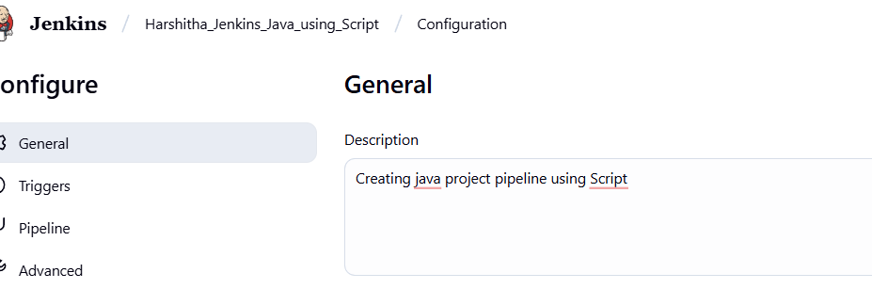

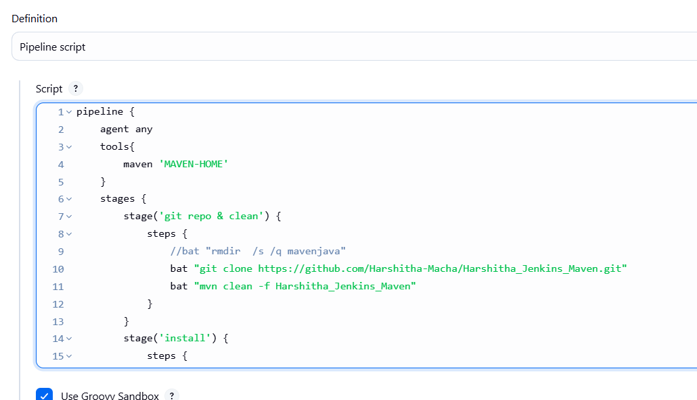

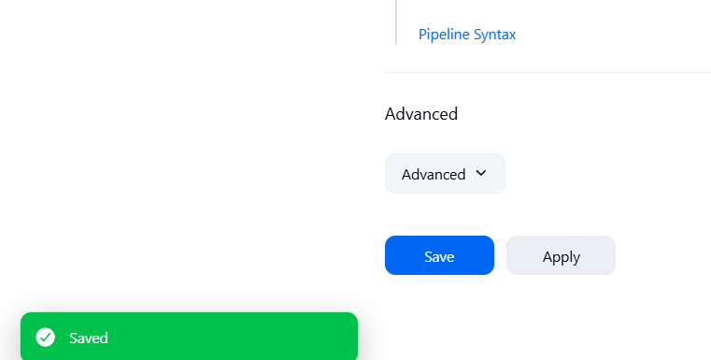

Procedure

**General :**

Description :- provide the description of the project

Build triggers: here we can provide with build triggers of you choice

**Advance project option**:

Definition:

Choose pipeline script

CODE:

pipeline {

agent any

tools{

jdk 'JAVA_HOME'

maven 'MAVEN_HOME'

}

stages {

stage('git repo & clean') {

steps {

bat "rmdir /s /q Harshitha_Jenkins_Maven || exit 0"

bat "git clone https://github.com/Harshitha-Macha/Harshitha_Jenkins_Maven.git"

bat "mvn clean -f Harshitha_Jenkins_Maven/pom.xml"

}

}

stage('install') {

steps {

bat "mvn install -f Harshitha_Jenkins_Maven/pom.xml"

}

}

stage('test') {

steps {

bat "mvn test -f Harshitha_Jenkins_Maven/pom.xml"

}

}

stage('package') {

steps {

bat "mvn package -f Harshitha_Jenkins_Maven/pom.xml"

}

}

}

}

Apply and save

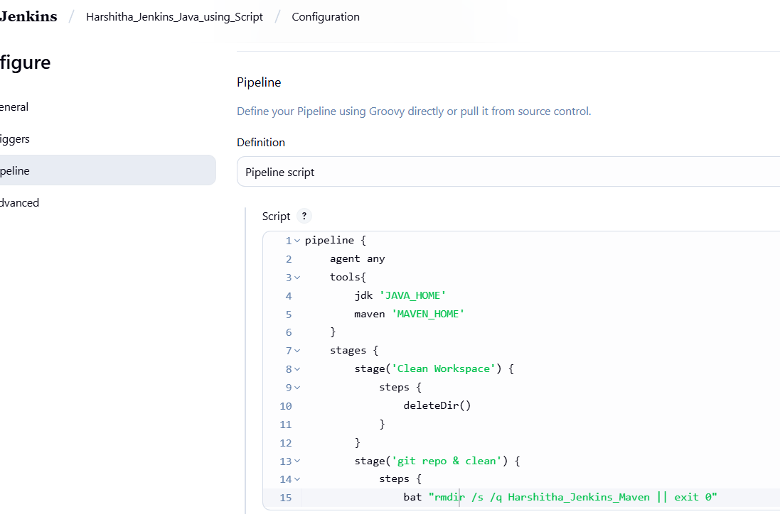

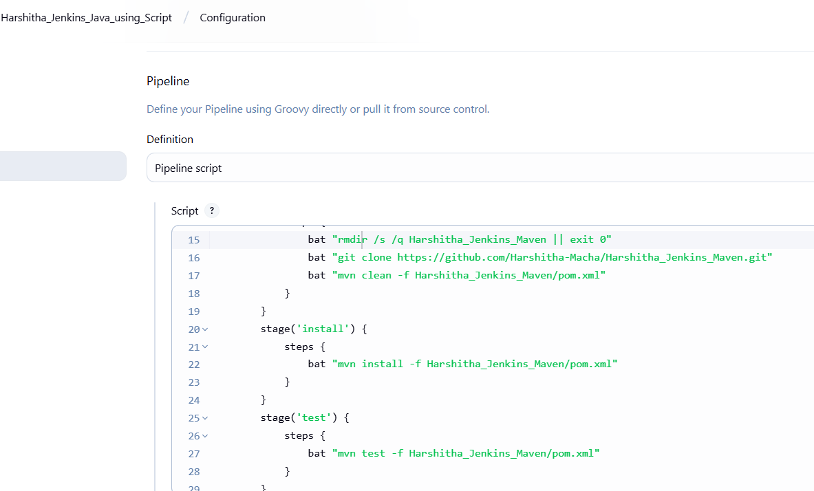

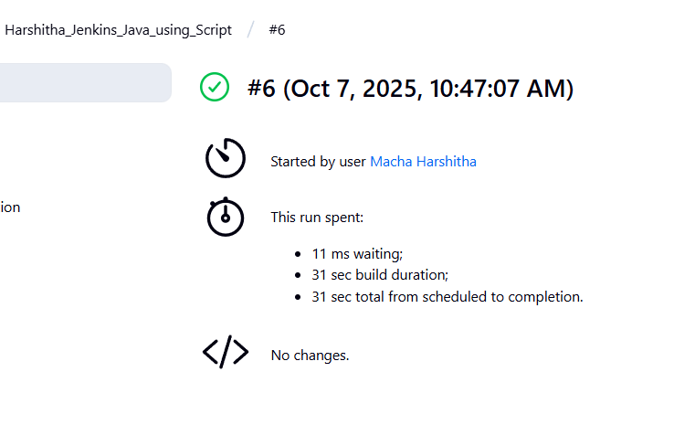

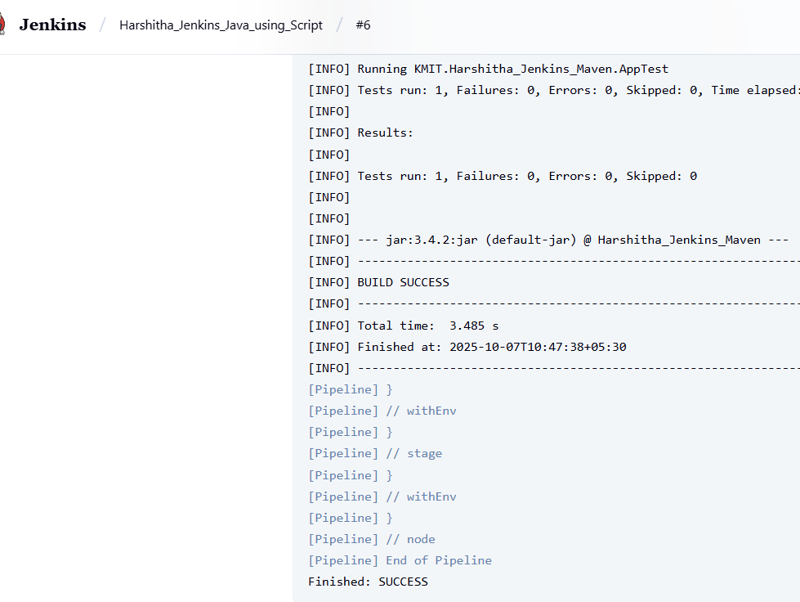

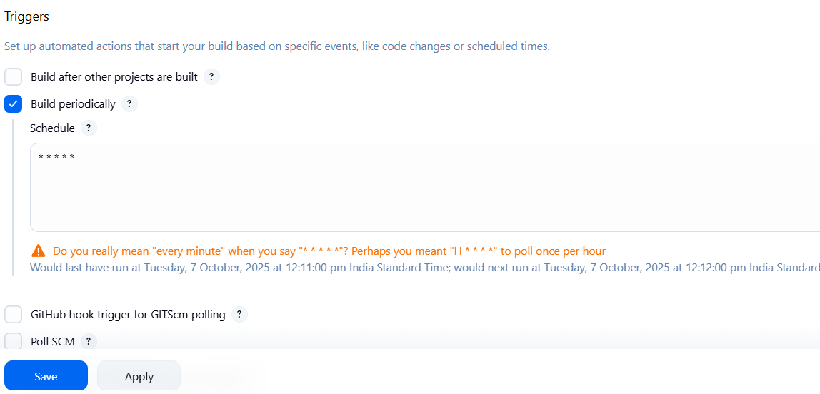

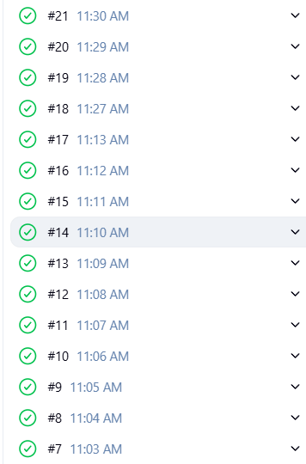

**Generic code:**

**pipeline {**

**agent any**

**tools {**

**maven 'MAVEN_HOME'**

**}**

**stages {**

**stage('Clone Repo') {**

**steps {**

**bat "git clone YOUR_GITHUB_REPO_LINK"**

**}**

**}**

**stage('Clean') {**

**steps {**

**bat "mvn clean -f YOUR_PROJECT_FOLDER_NAME"**

**}**

**}**

**stage('Install') {**

**steps {**

**bat "mvn install -f YOUR_PROJECT_FOLDER_NAME"**

**}**

**}**

**stage('Test') {**

**steps {**

**bat "mvn test -f YOUR_PROJECT_FOLDER_NAME"**

**}**

**}**

**stage('Package') {**

**steps {**

**bat "mvn package -f YOUR_PROJECT_FOLDER_NAME"**

**}**

**}**

**}**

**}**

**2nd ver:**

**pipeline {**

**agent any**

**tools{**

**jdk 'JAVA_HOME'**

**maven 'MAVEN_HOME'**

**}**

**stages {**

**stage('git repo & clean') {**

**steps {**

**bat "rmdir /s /q mymavenproject || exit 0"**

**bat "git clone https://github.com/vanisinha/mymavenproject.git"**

**bat "mvn clean -f mymavenproject/pom.xml"**

**}**

**}**

**stage('install') {**

**steps {**

**bat "mvn install -f mymavenproject/pom.xml"**

**}**

**}**

**stage('test') {**

**steps {**

**bat "mvn test -f mymavenproject/pom.xml"**

**}**

**}**

**stage('package') {**

**steps {**

**bat "mvn package -f mymavenproject/pom.xml"**

**}**

**}**

**}**

**}**

**LAB ACTION PLAN FOR WEEK 10**

Working with minikube and Nagios

1. Hands-on practice of creating, running and scaling pods in minikube.

2. Running Nginx server on specified port number by explaining the Nginx monitoring tool

3. Running Nagios server and Understanding the Monitoring tool using Docker.

4. AWS-free Trier account Creation steps

5. Upload the screenshots for the tasks

Kubernetes:

Kubernetes is a tool that automates how we run and manage applications inside the container.

Dockers will only run containers, if in any case the container fails/stopped/killed, the docker will not help us, here is where Kubernetes plays an important role, Kubernetes cluster will be responsible in creating a new container and managing various containers.

POD: In Kubernetes, a Pod is the smallest deployable unit that you can create and manage.

Minikube:

Minikube creates a VM on your local machine and deploys a simple Kubernetes cluster with one node. It's a lightweight implementation. Minikube is a version of Kubernetes.

Nagios:

Nagios is an open-source IT infrastructure monitoring tool. It monitors

λ Servers

λ Network devices

λ Applications and services

It alerts admnistrators when issues occur and notifies when they are resolved.

________________________________________

Step 1: Install Prerequisites

Before installing Minikube, ensure the following are installed:

1. Virtualization Support:

o Verify virtualization is enabled:

2. Hypervisor:

o Minikube supports multiple hypervisors (e.g., Hyper-V, VirtualBox, or Docker as a driver).

o Install one of the following:

♣ Hyper-V (pre-installed on Windows 10/11 Pro or Enterprise).

♣ Docker Desktop (if you want to use Docker as the driver).

________________________________________

Step 2: Download Minikube

1. Open a PowerShell or Command Prompt with administrator privileges.

2. Download the latest Minikube executable using this command:

3. curl -LO https://storage.googleapis.com/minikube/releases/latest/minikube-installer.exe

4. Install Minikube by running the installer:

5. .\minikube-installer.exe

________________________________________

Step 3: Add Minikube to PATH

If Minikube is not automatically added to your PATH during installation:

1. Open System Properties → Environment Variables.

2. Add the directory where Minikube is installed (e.g., C:\Program Files\Minikube) to your PATH variable.

________________________________________

Step 4: Start Minikube

1. Open a terminal (PowerShell or CMD). Do the following commands

2. Start Minikube with a specified driver (e.g., Hyper-V, Docker, or VirtualBox). For example:

o Hyper-V:

o minikube start --driver=hyperv

o Docker:

o minikube start --driver=docker

3. Verify Minikube is running:

4. minikube status

________________________________________

Step 5: Interact with Minikube

kubectl is a command-line tool used in Kubernetes to interact with and manage Kubernetes clusters.

Once Minikube is running:

1. Use kubectl to interact with the cluster.

o Install kubectl if not already installed:

o minikube kubectl -- get pods -A

o Or download it separately from the official Kubernetes site.

2. Open the Minikube dashboard (optional):

3. minikube dashboard

________________________________________

Optional: Check Your Installation

Run the following to verify the installation:

Minikube version

kubectl version --client

________________________________________

Troubleshooting

1. If Minikube fails to start:

o Ensure your hypervisor (Hyper-V/Docker/VirtualBox) is installed and running.

o Check the Minikube logs:

o minikube logs

2. Updating Minikube:

3. minikube update-check

4. minikube update

Minikube Automation Steps

Step 1: Start Minikube Cluster

• Open your terminal and run the command:

minikube start

Step 2: Create and Manage Deployment

1. Create an application in Kubernetes:

o Command:

kubectl create deployment mynginx --image=nginx

if already created then

kubectl set image deployment/myngnix nginx=nginx:latest

o Verify the deployment using: Kubernetes responds by showing you a list that includes the names of your deployment groups

kubectl get deployments

♣ Ensure mynginx appears in the output.

Check the following commands:

ν kubectl get pods

ν kubectl describe pods

2. Expose Deployment as a Service:

o Command:

kubectl expose deployment mynginx --type=NodePort --port=80 --target-port=80

Step 3: Scale the Deployment

Command:Scales the Nginx deployment to 4 replicas (pods).

kubectl scale deployment mynginx --replicas=4

kubectl get service myngnix

Step 4: Access the Nginx App

1. Using Port Forwarding:

o Command:

kubectl port-forward svc/mynginx 8081:80

♣ Access the app via http://localhost:8081.

If Error, use this option, Using Minikube Tunnel:

o Start the tunnel:

minikube tunnel

o Retrieve the service URL:

minikube service mynginx --url

o Open the provided URL in your browser.

o Open the kubernets dashboard

λ Open the minikube dashboard

Minikube dashboard

Step 5: Stop and Clean Up

1. Stop Nginx Deployment:

o Commands:

kubectl delete deployment mynginx

kubectl delete service mynginx

2. Stop Minikube (Optional):

o Command:

minikube stop

3. Delete Minikube Cluster (Optional):

o Command:minikube delete

Nagios Automation Steps

Step 1: Pull the Nagios Docker Image

• Open a terminal and run:

docker pull jasonrivers/nagios:latest

Step 2: Run Nagios

• Command:

docker run --name nagiosdemo -p 8888:80 jasonrivers/nagios:latest

Step 3: Access Nagios Dashboard

• Open your browser and navigate to:

http://localhost:8888

o Login Credentials:

♣ Username: nagiosadmin

♣ Password: nagios

o Once logged in, explore:

♣ Hosts: View systems being monitored.

♣ Services: Check tasks being monitored (e.g., CPU usage).

♣ Alerts: Access recent notifications.

Step 4: Monitoring Host Details

1. Navigate to the Host Information Page:

o Select a host from the Hosts menu.

2. Key Details:

o Host Status: Indicates if the system is UP or DOWN.

o Metrics: View CPU usage, memory status, and network activity.

o Actions: Reschedule checks, disable notifications, or schedule downtime.

Step 5: Stop and Remove Nagios

1. Stop the Container:

o Command:

docker stop nagiosdemo

2. Delete the Container:

o Command:

docker rm nagiosdemo

3. Remove the Image (Optional):

o List images:

docker images

o Delete the Nagios image:

docker rmijasonrivers/nagios:latest

4. Observe the docker containers in DockerHub, we can see the latest Nagios Installed running on port:8888

-------------------------------------------------------------------------------------------------------------------------------

**✔ Part-2 → Nagios using Docker (MUST EXECUTE)**

You already have Docker, so run these:

docker pull jasonrivers/nagios:latest

docker run --name nagiosdemo -p 8888:80 jasonrivers/nagios:latest

Then open:

👉 <http://localhost:8888>  
Login:

username: nagiosadmin

password: nagios

📸 Take screenshots of:

* Docker container running
* Nagios login page
* Nagios dashboard
* Host/Services monitor page

**WEEK 11**

Working on windows 11

Exercise 1: Jenkins CI/CD using Git Webhook

Step-1: To install ngroks Go->settings->privacy and security -> windows security -> off antivirus ->

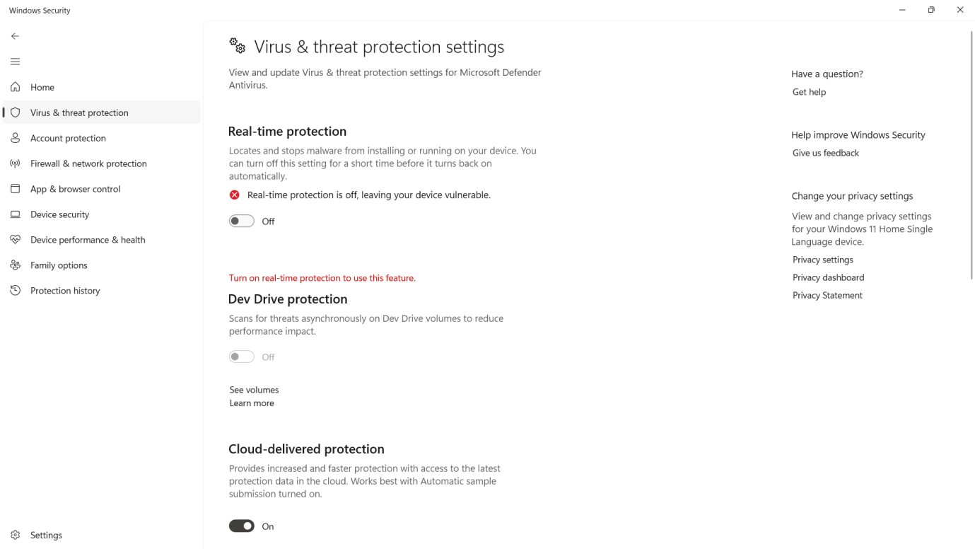

Step-2:Go -> <https://ngrok.com> and signup by giving your name ,email and password of atleast 10 charcaters

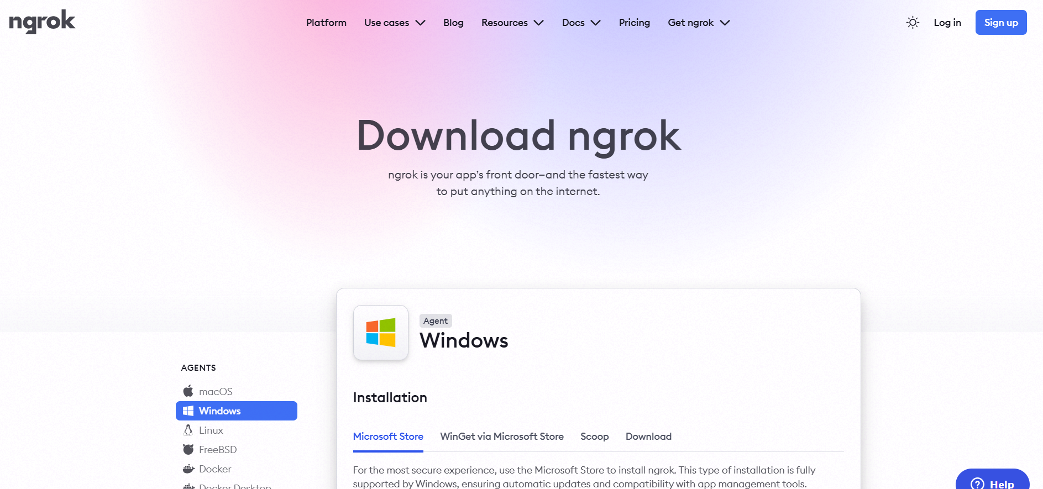

Step-3: After sign in up ,it will show below screen with your name in the top left .now click on download for windows (64Bit) to download ngork

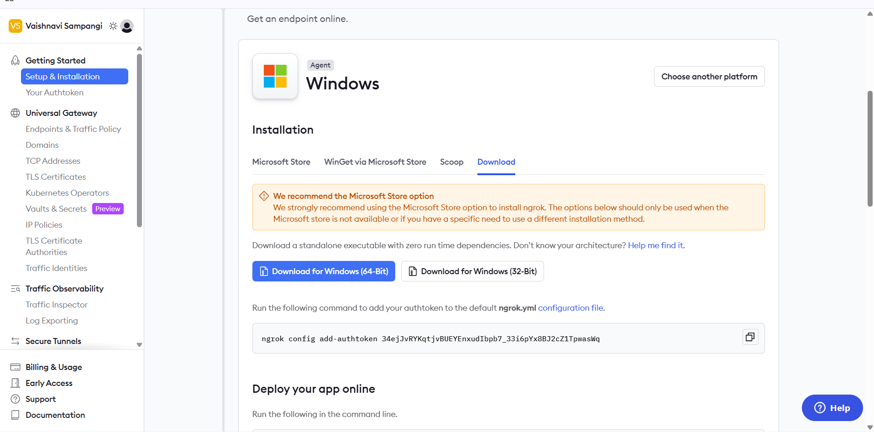

Step4:After downloading ,Extract the file and click on ngrok.exe

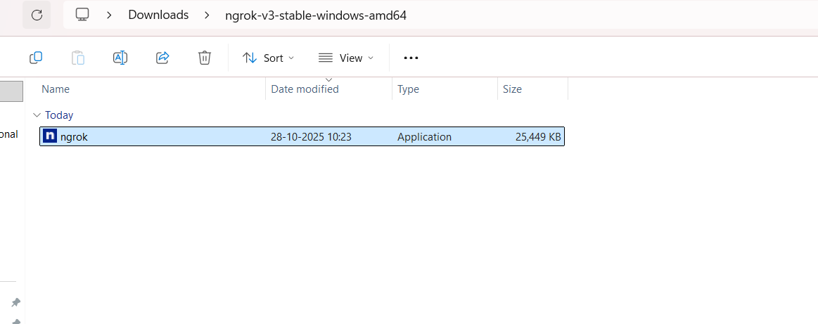

Ngrok command prompt appears as below

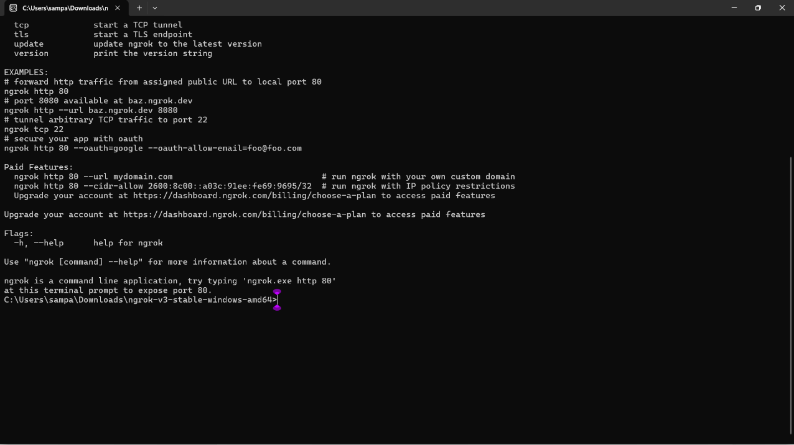

**Step-5:Connect Your ngrok Account (optional but useful)**

* Go to ngrok gives you an auth token.
* Then go to your Authtoken click here
* Copy your Authtoken

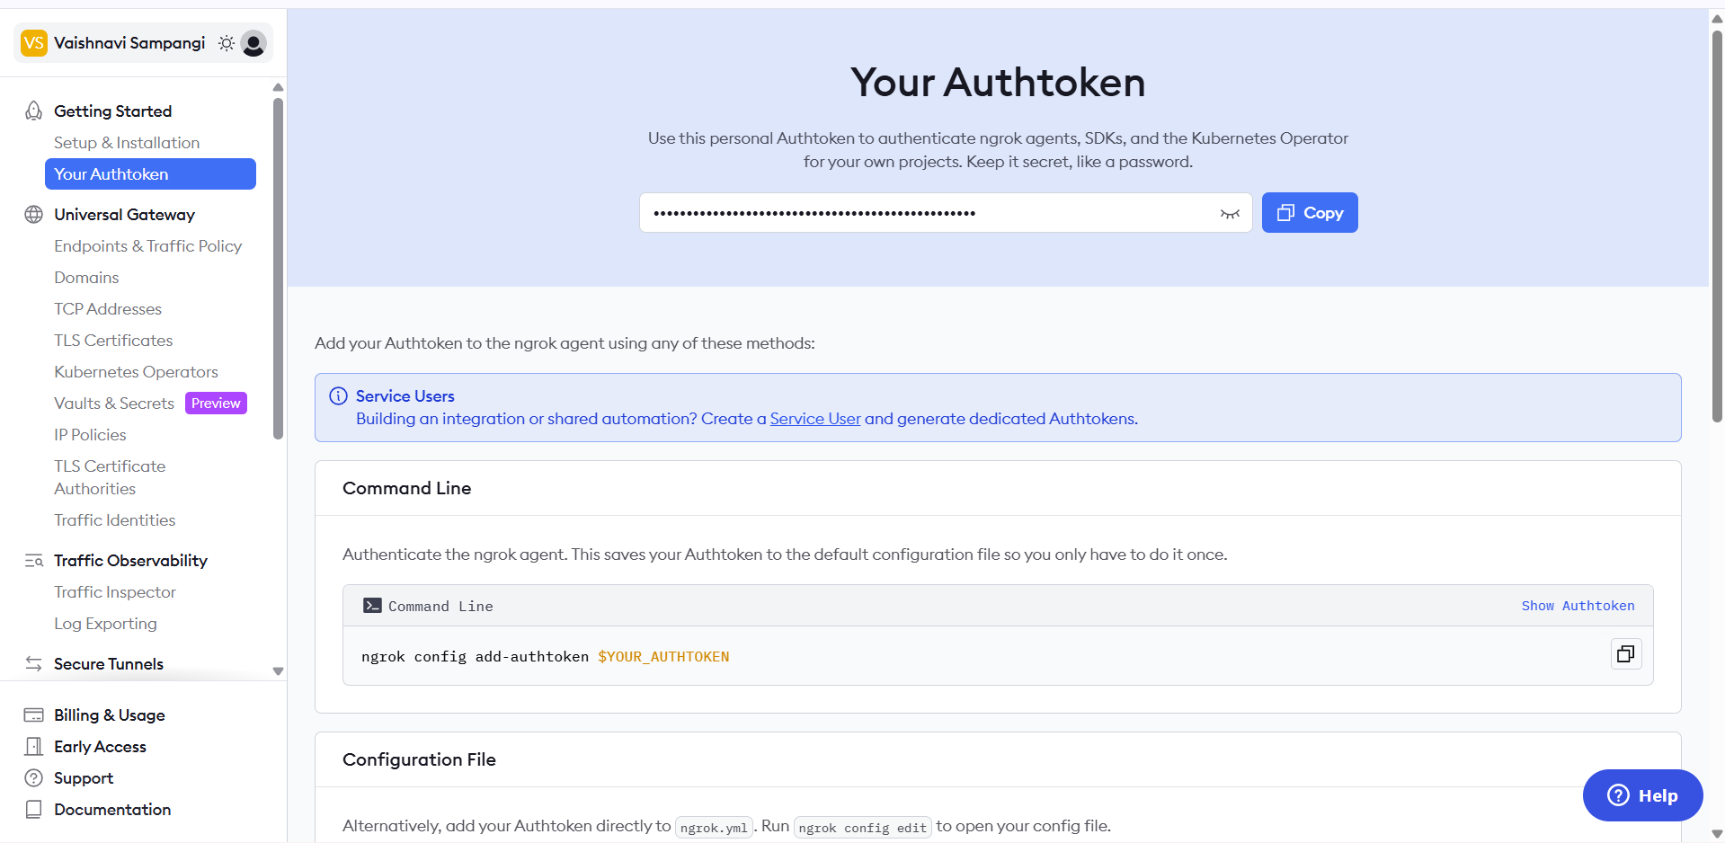

CREATE AUTHENTICATOR [https://dashboard.ngrok.com/get-started/your-authtoken]  
Run this command in ngrok command prompt:(replace <your_token> with yours):

**ngrok config add-authtoken <your_token> // syntax:**

**Example command**

**ngrok config add-authtoken 34ejJvRYKqtjvBUEYEnxudIbpb7_33i6pYx8BJ2cZ1TpwasWq**



**Step-6**

**Start a Tunnel for Jenkins**

* Check on which port is your Jenkins running . for this give in browers or url localhost:8081

For me Jenkins is running on 8081

* Go to ngrok command prompt and type below command
* ngork http 8081 //Always use this command to start a tunnel for jenkins .

Type in ngrok command prompt:



Next it shows this public jenkins URL generated by ngrok that can be pasted into github repo for Webhooks.

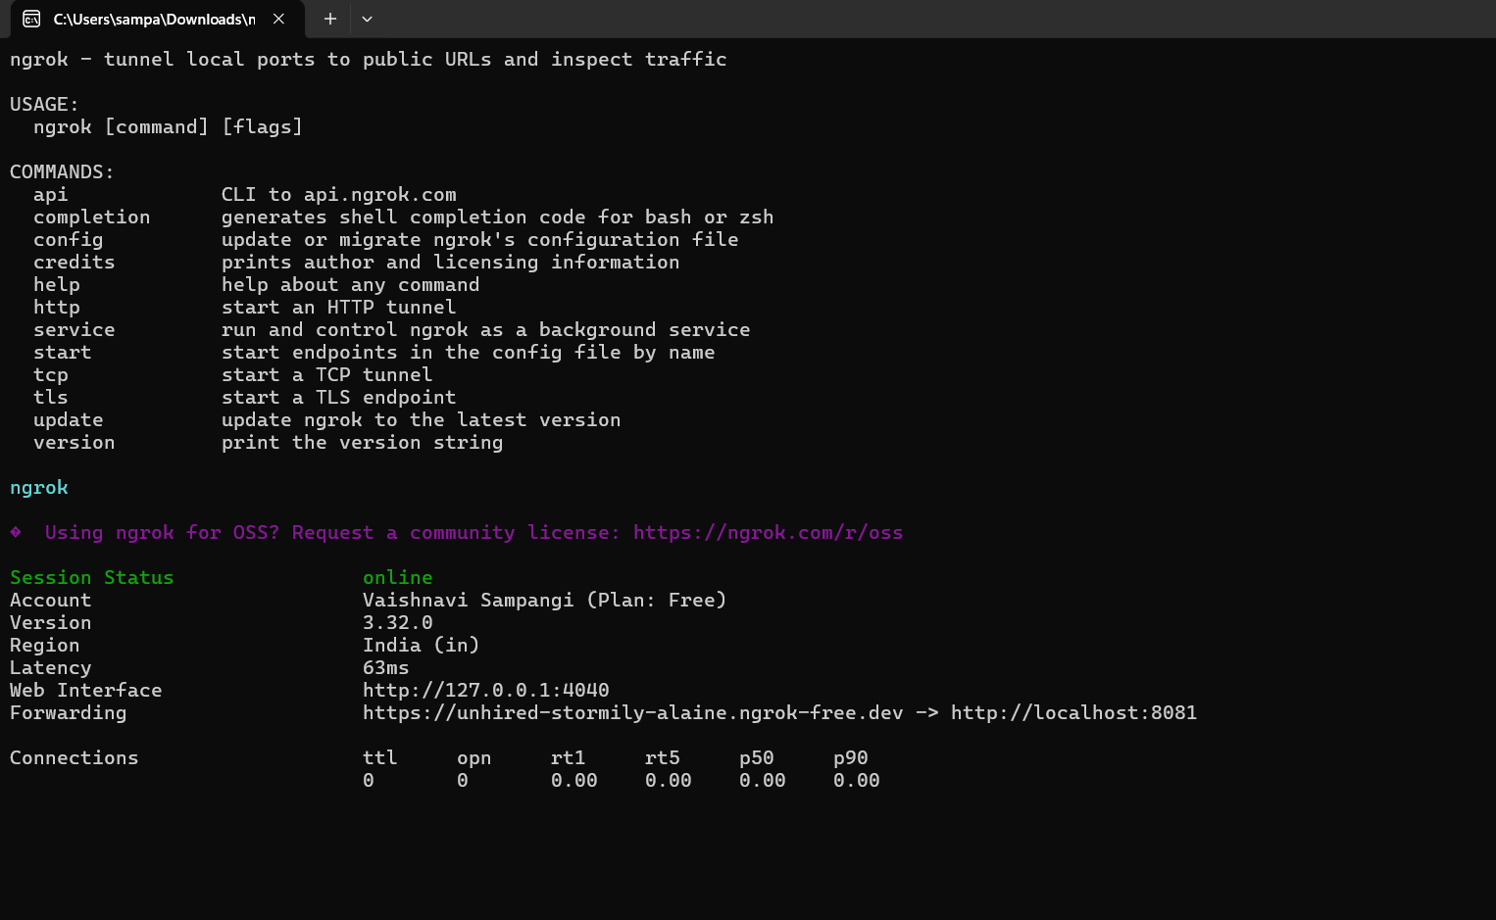

Copy this URL only highlighted part

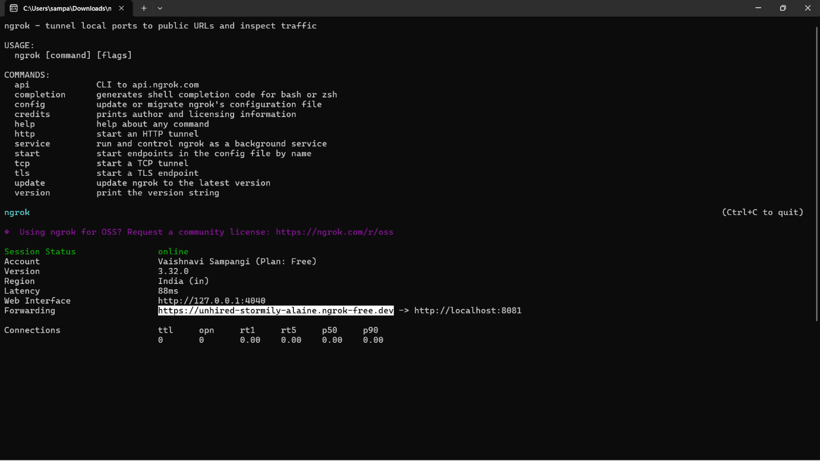

Step-7: **Configure Webhook in GitHub**

1. Go to your GitHub repository.
2. Navigate to Settings → **Webhooks.**
3. Click “**Add webhook**”.
4. In the Payload URL field:
   * Enter the Jenkins webhook URL in the format:  
     http://<**jenkins-server-url**>/github-webhook/

Ex: **https://unhired-stormily-alaine.ngrok-free.dev**/github-webhook/

Note: If Jenkins is running on localhost, GitHub cannot access it directly

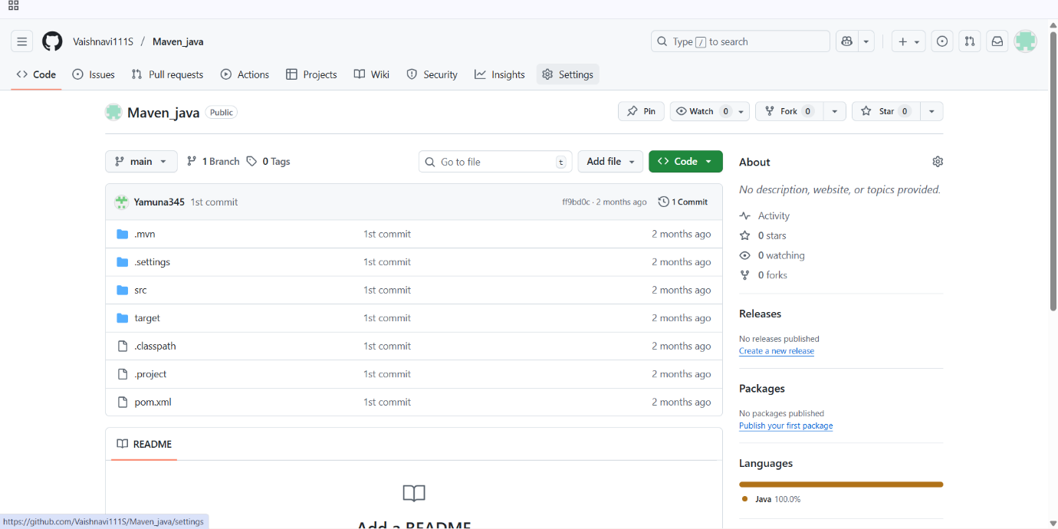

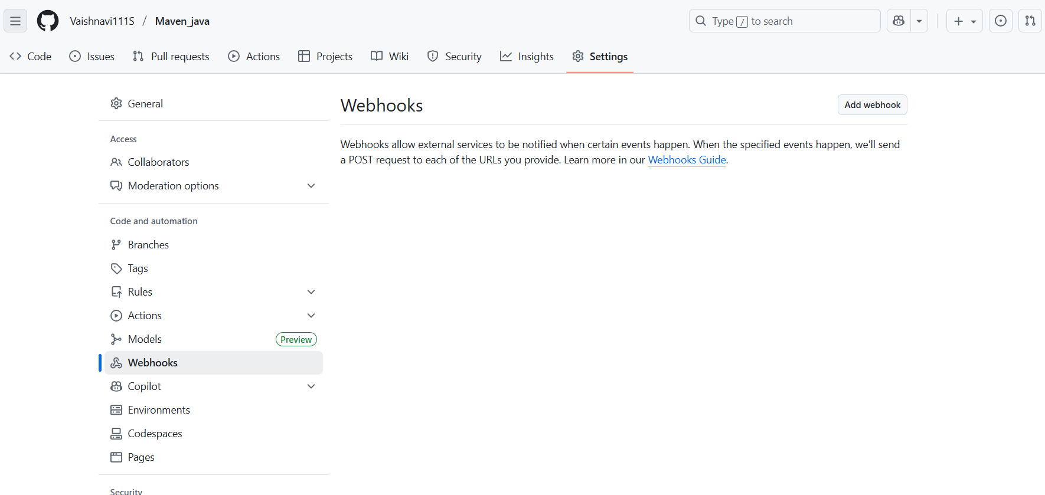

Step-8:

* + - Add url [**https://unhired-stormily-alaine.ngrok-free.dev**/github-webhook/](https://unhired-stormily-alaine.ngrok-free.dev/github-webhook/)
    - Set content Type to application/json
    - Under “Which events would you like to trigger this webhook?”, select:

Just the push event.

* Click “Add webhook” to save.

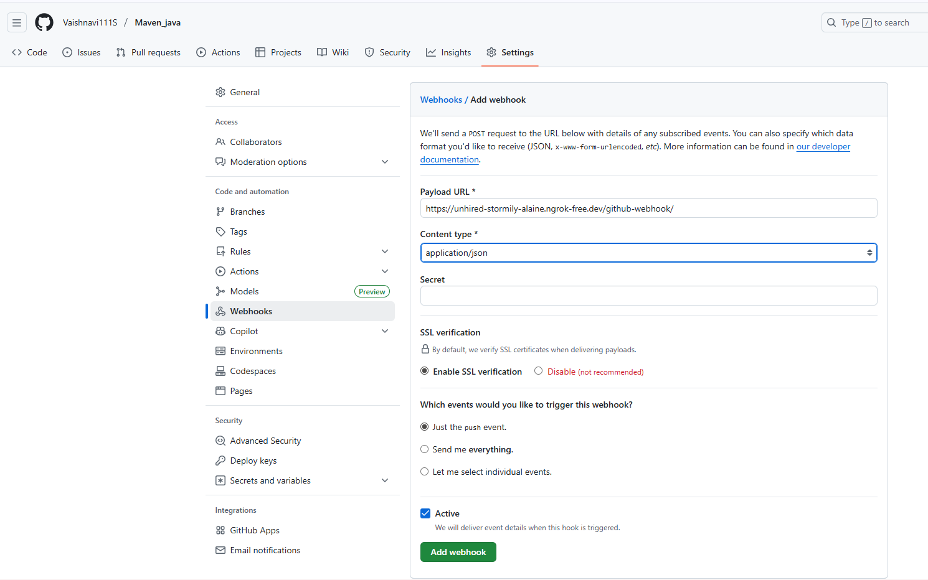

**Step 10: Configure Jenkins to Accept GitHub Webhooks**

1. Open Jenkins Dashboard.
2. Select the job (freestyle or pipeline) you’ve already created.

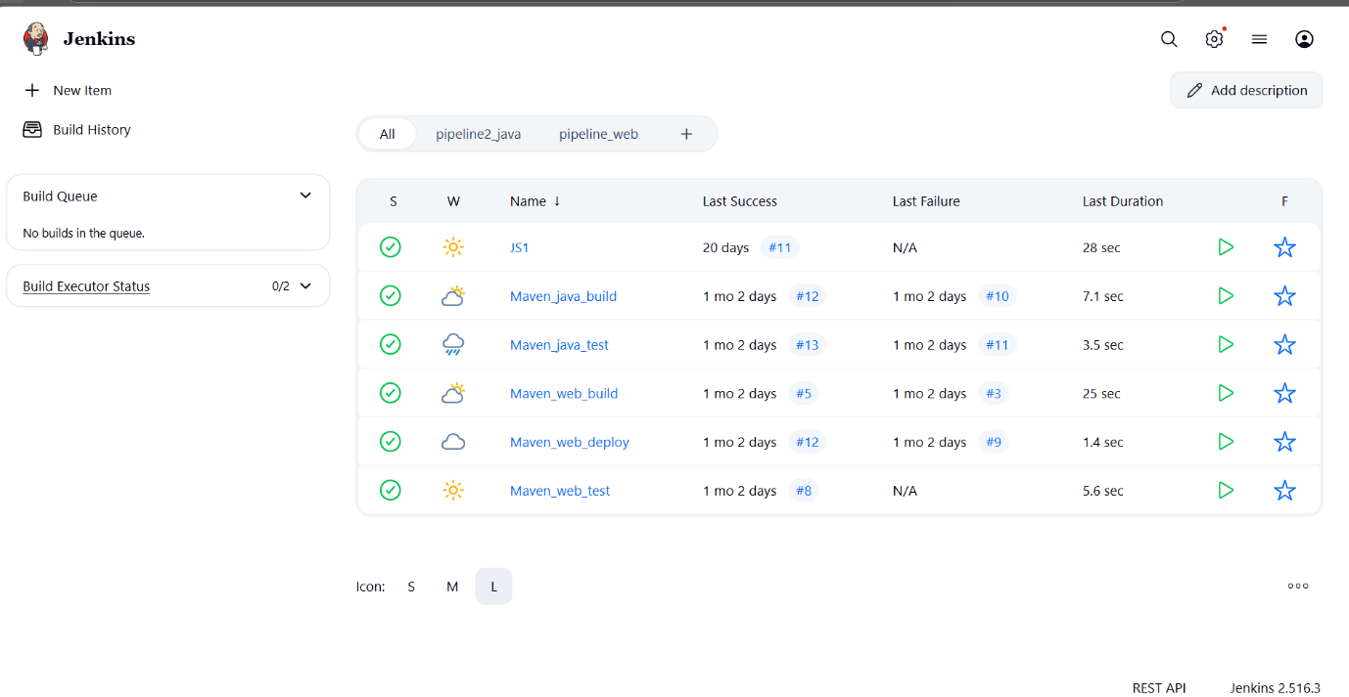

1. Click Configure.
2. Scroll down to the Build Triggers section.
3. Check the box: ✅GitHub hook trigger for GITScm polling

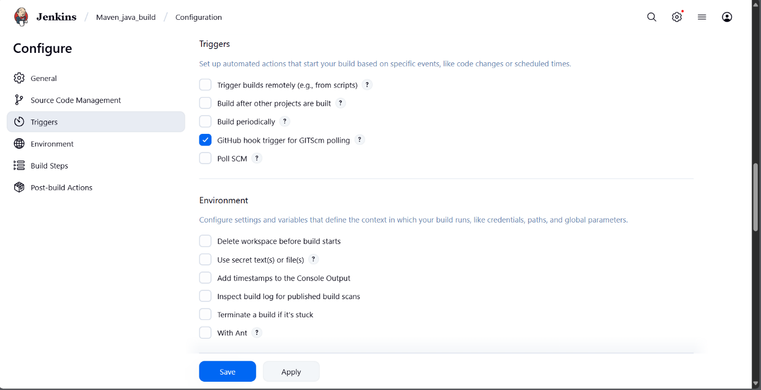

1. Click Save**.**

**Step 11: Test the Setup**

1. Make any code update in your local repo and push it to GitHub.
2. Once pushed, GitHub will trigger the webhook.
3. Jenkins will automatically detect the change and start the build pipeline**.**

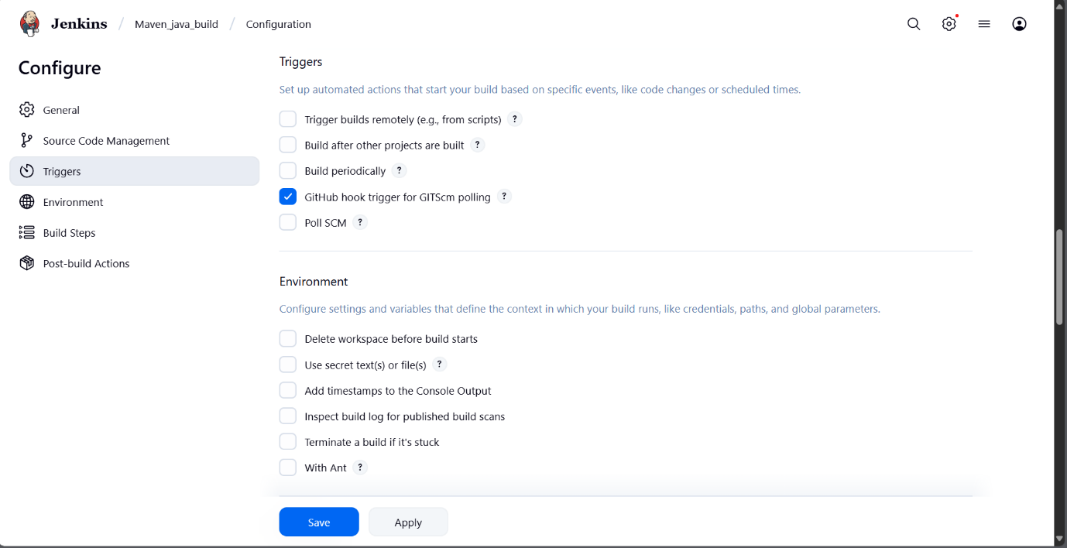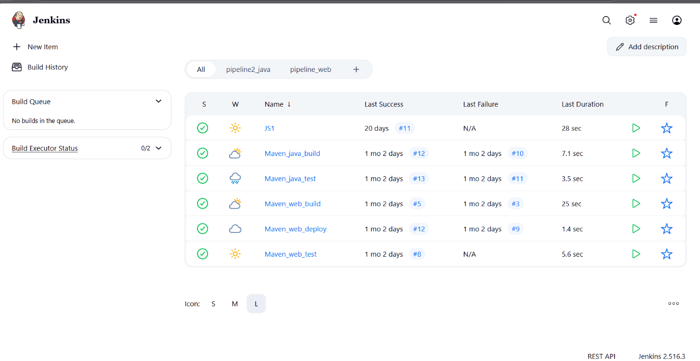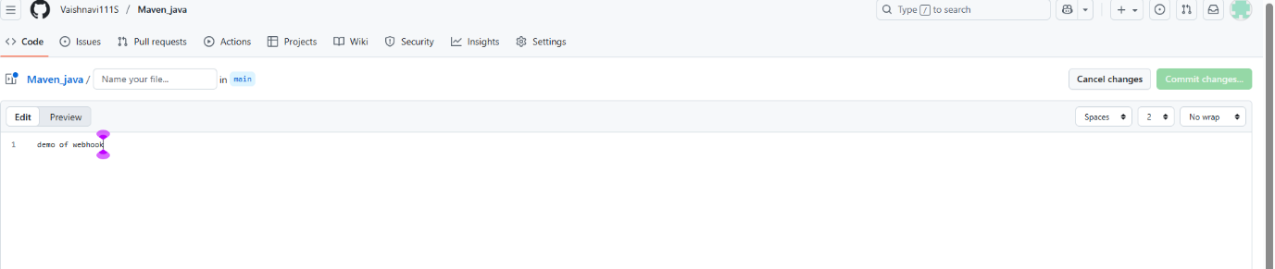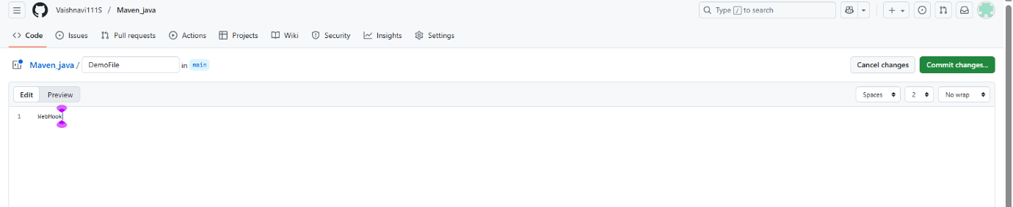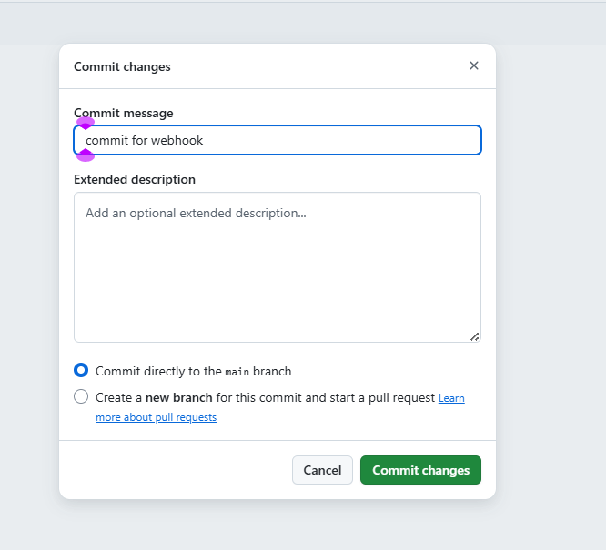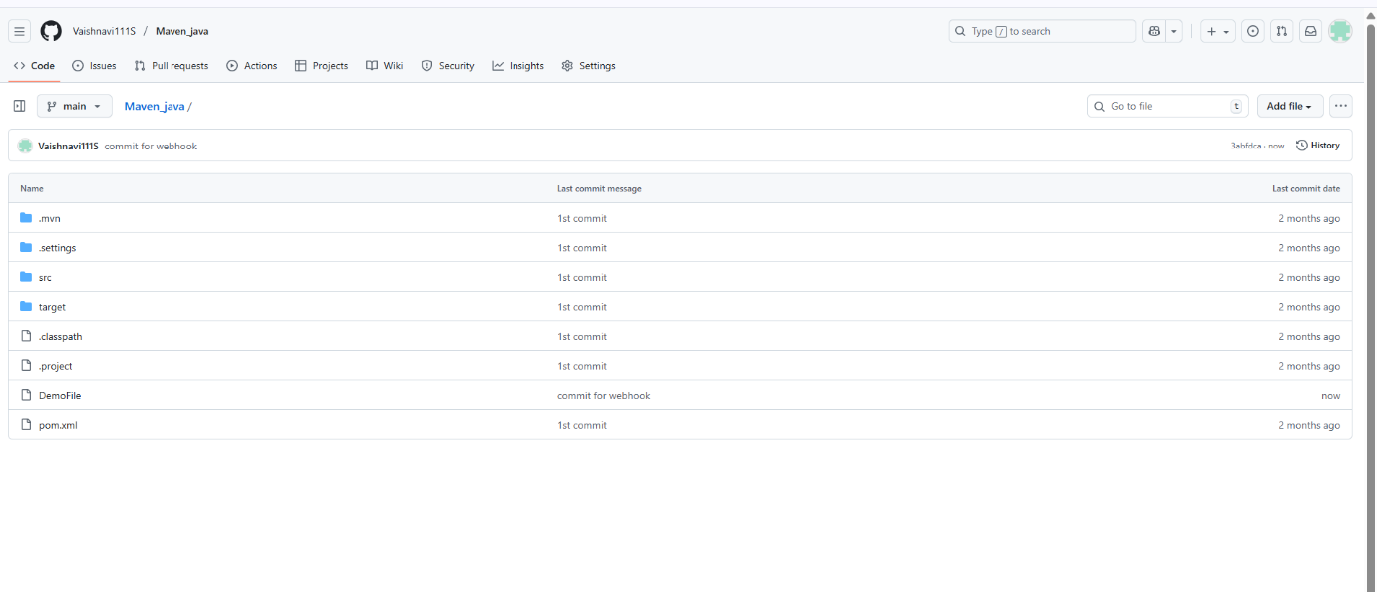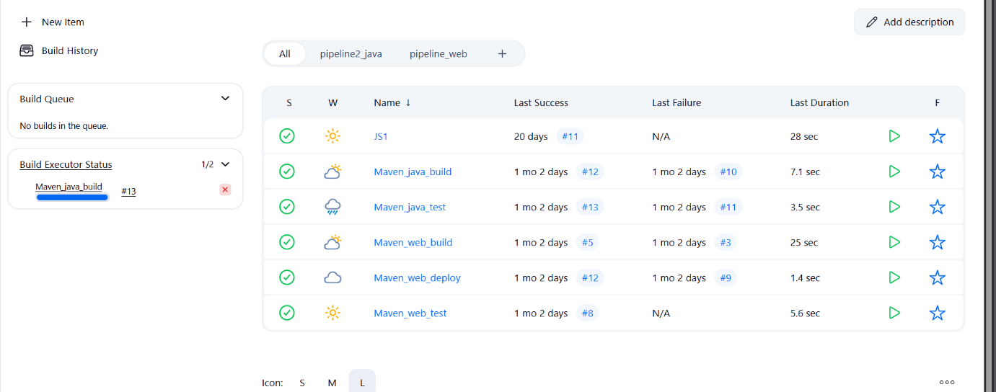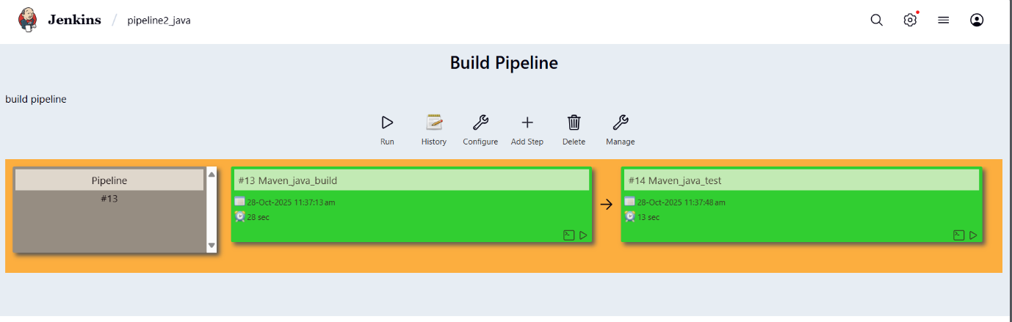

**outcome**

* You’ve successfully connected GitHub and Jenkins using webhooks.
* Every time you push code to GitHub, Jenkins will automatically start building your project without manual intervention.

EXCERCISE-2

**Setting Up Jenkins Email Notification Setup (Using Gmail with App Password)**

**Creation of app password**

**1. Gmail: Enable App Password (for 2-Step Verification)**

**i. Go to:** [**https://myaccount.google.com**](https://myaccount.google.com/)

**ii. Enable 2-Step Verification**

* Navigate to:
  + Security → 2-Step Verification
  + Turn it **ON**
  + Complete the OTP verification process (via phone/email)

**iii. Generate App Password for Jenkins**

* Go to:
  + Security → App passwords
* Select:
  + **App**: Other (Custom name)
  + **Name**: Jenkins-Demo
* Click **Generate**
* Copy the **16-digit app password**
  + Save it in a secure location (e.g., Notepad)

**2. Jenkins Plugin Installation**

**i. Open Jenkins Dashboard**

**ii. Navigate to:**

* Manage Jenkins → Manage Plugins

**iii. Install Plugin:**

* Search for and install:
  + Email Extension Plugin

**3. Configure Jenkins Global Email Settings**

**i. Go to:**

* Manage Jenkins → Configure System

**A. E-mail Notification Section**

| **Field** | **Value** |
| --- | --- |
| **SMTP Server** | smtp.gmail.com |
| **Use SMTP Auth** | ✅ Enabled |
| **User Name** | Your Gmail ID (e.g., archanareddykmit@gmail.com) |
| **Password** | Paste the 16-digit App Password |
| **Use SSL** | ✅ Enabled |
| **SMTP Port** | 465 |
| **Reply-To Address** | Your Gmail ID (same as above) |

**➤ Test Configuration**

* Click: Test configuration by sending test e-mail
* Provide a valid email address to receive a test mail
* ✅ Should receive email from Jenkins

**B. Extended E-mail Notification Section**

| **Field** | **Value** |
| --- | --- |
| **SMTP Server** | smtp.gmail.com |
| **SMTP Port** | 465 |
| **Use SSL** | ✅ Enabled |
| **Credentials** | Add Gmail ID and App Password as Jenkins credentials |
| **Default Content Type** | text/html or leave default |
| **Default Recipients** | Leave empty or provide default emails |
| **Triggers** | Select as per needs (e.g., Failure) |

**4. Configure Email Notifications for a Jenkins Job**

**i. Go to:**

* Jenkins → Select a Job → Configure

**ii. In the Post-build Actions section:**

* Click: Add post-build action → **Editable Email Notification**

**A. Fill in the fields:**

| **Field** | **Value** |
| --- | --- |
| **Project Recipient List** | Add recipient email addresses (comma-separated) |
| **Content Type** | Default (text/plain) or text/html |
| **Triggers** | Select events (e.g., Failure, Success, etc.) |
| **Attachments** | (Optional) Add logs, reports, etc. |

**iii. Click Save**

**Now your Jenkins job is set up to send email notifications based on the build status!**

**✅ WEEK 11 — CI/CD Using Jenkins + Webhook + Email Notification**

**(Full Practical Execution Steps)**

**🚦 Before You Start (Prerequisite Check)**

| **Requirement** | **Should You Do It?** |
| --- | --- |
| **Jenkins Installed** | **YES (already done)** |
| **Maven Project in GitHub** | **YES (week 7 repo)** |
| **Internet Access** | **YES (you have)** |
| **Gmail logged in for App password** | **optional (only needed for email part)** |
| **Ngrok installed** | **if not, download now** |

**🟢 PART 1 — Configure Webhook CI (Auto Build When Code Pushes)**

**STEP 1 — Start Jenkins**

1. **Open browser → enter:**

**http://localhost:8080**

**(or 8081, whichever yours is)**

**📸 Screenshot: Jenkins Dashboard.**

**STEP 2 — Start ngrok Tunnel**

**Open Command Prompt, go to folder where ngrok.exe is, then run:**

**ngrok http 8080**

**(or replace 8080 with your Jenkins port number)**

**Output will show lines like:**

**Forwarding: https://dfw2-33-11-222-xyz.ngrok-free.app -> http://localhost:8080**

**📸 Screenshot: The forwarding URL visible.**

**STEP 3 — Add Webhook in GitHub**

1. **Open your GitHub Maven project.**
2. **Go to:**

**Settings → Webhooks → Add Webhook**

1. **In Payload URL, paste:**

**https://YOUR-NGROK-URL/github-webhook/**

**(Include /github-webhook/ — mandatory)**

1. **Set:**

**👉 Content Type → application/json  
👉 Event → Just the push event**

1. **Click Add webhook**

**If successful → it shows green ✔ checkmark.**

**📸 Screenshot: Webhook page showing green tick.**

**STEP 4 — Configure Jenkins Job to Respond**

1. **Go to Jenkins → Click your Maven project → Configure**
2. **Scroll to Build Triggers**
3. **Tick:**

**☑ GitHub hook trigger for GITScm polling**

1. **Click Save**

**📸 Screenshot: Build Trigger settings page.**

**STEP 5 — Test CI/CD Trigger**

**Now test automation:**

1. **Go to GitHub repository → click README.md**
2. **Click edit**
3. **Add any line:**

**# Testing CI Hook - <your name>**

1. **Commit.**

**📌 DO NOT manually click build in Jenkins.**

**→ Within 5–20 seconds, Jenkins should automatically start build.**

**📸 Screenshots required:**

* **Jenkins showing "Started by GitHub push"**
* **Build in progress**
* **Console output ending with BUILD SUCCESS**

**🟣 PART 2 — Configure Email Notification (If time permits)**

**STEP 1 — Set Gmail App Password (One-time only)**

1. **Open:** [**https://myaccount.google.com**](https://myaccount.google.com)
2. **Go:**

**Security → 2-Step Verification → Turn ON**

1. **Then go to:**

**App Passwords → Generate → Name: Jenkins**

1. **Copy the 16-digit password.**

**STEP 2 — Configure Email in Jenkins**

**Go:**

**Manage Jenkins → Configure System**

**Scroll to:**

**📍 E-Mail Notification Section**

| **Field** | **Value** |
| --- | --- |
| **SMTP Server** | **smtp.gmail.com** |
| **SMTP Port** | **465** |
| **Use SMTP Authentication** | **✔ Yes** |
| **Username** | **your Gmail** |
| **Password** | **your generated app password** |
| **Use SSL** | **✔ Yes** |

**Click Test Configuration.**

**📸 Screenshot: Email test successful message.**

**STEP 3 — Add Email Notification to Job**

**Open your Jenkins Job → Configure**

**Scroll → Post-build Actions → Add → Editable Email Notification**

| Field | Value |
| --- | --- |
| Recipients | your Gmail |
| Trigger | Failure + Success |

Save.

📸 Screenshot: Email notification settings.

STEP 4 — Run a Build to Receive Email

1. Push another commit OR click Build Now
2. Check your email.

📸 Screenshot of Jenkins mail received (“Build Success” or “Build Failed”).

🎯 EXPECTED FINAL OUTPUTS FOR DOCUMENT:

✔ Jenkins dashboard  
✔ ngrok terminal showing forwarded URL  
✔ GitHub webhook config page  
✔ Jenkins triggered automatically (“Started by GitHub push”)  
✔ Console log with BUILD SUCCESS  
✔ (Optional) Email Notification screenshot  
✔ Short reflection line:

"Week 11 implemented CI/CD using Jenkins, GitHub webhook and notification system."

WEEK-12

1 DEPLOYMENT OF INDEX.HTML USING EC2 INSTANCE in AWS

**Step 1: Login to AWS /canvas account**

* Go to course invitation mail and click on start
* Opens the aws academy, select the student login and enter the email and password details
* Click on Modules
* Scroll down and select Lunch AWS Academy Lab-
* Click on start Lab and wait AWS becomes from red to green AWS

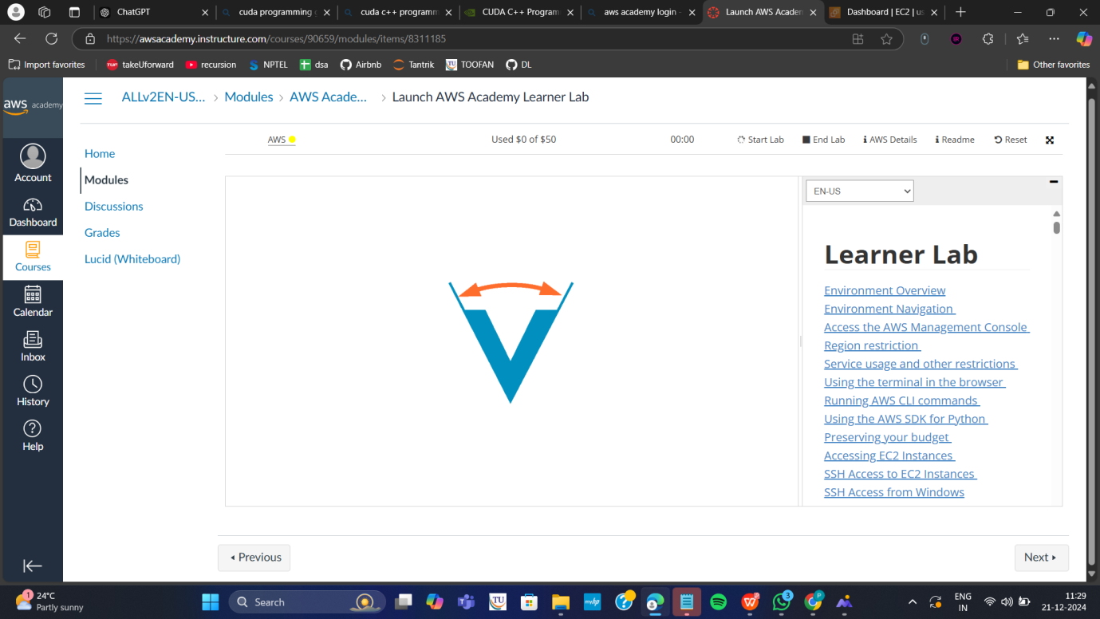

**Click on AWS**

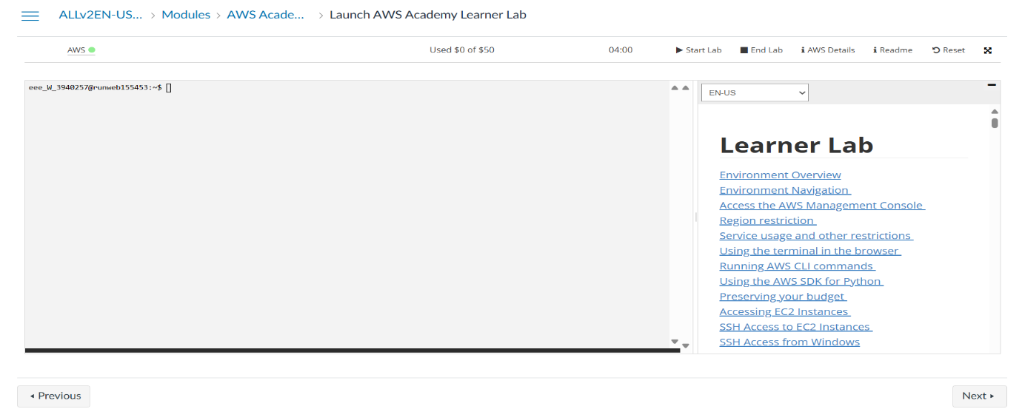

**Step 2:** **Click on EC2 to create instance**

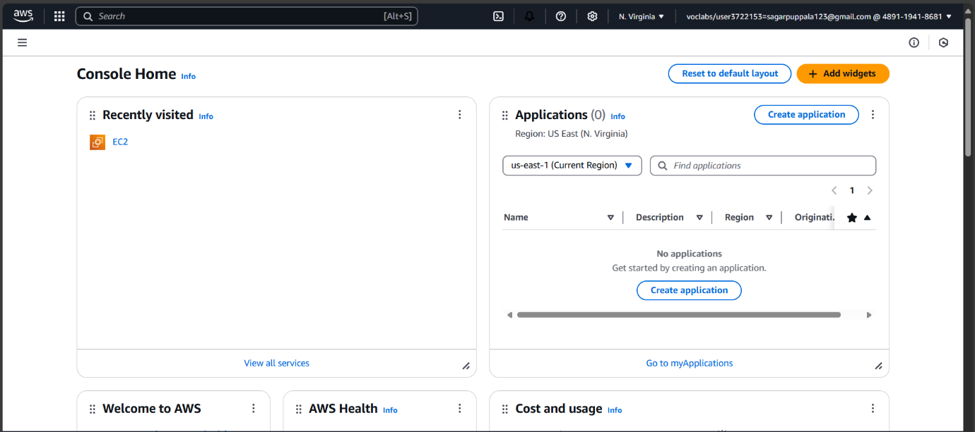

**Click on Launch Instance**

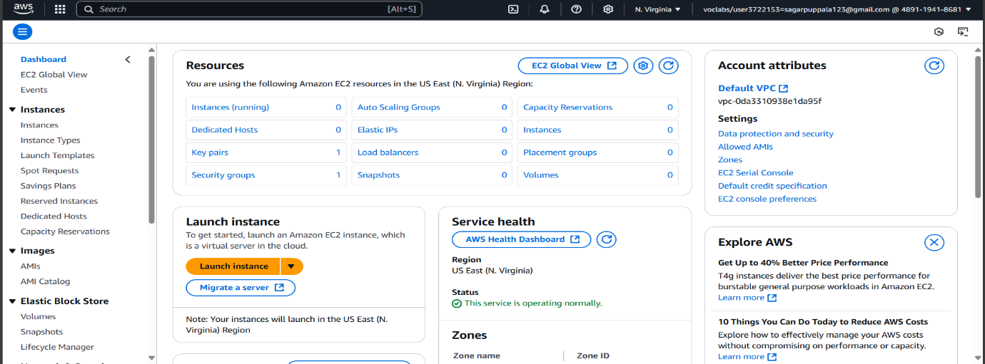

Stage 1 --Name (Giving name to the machine) ubuntu

Stage 2 -- Select AMI ( Note: Select free tier eligible ) ubuntu server

**Give name and select ubuntu** under application

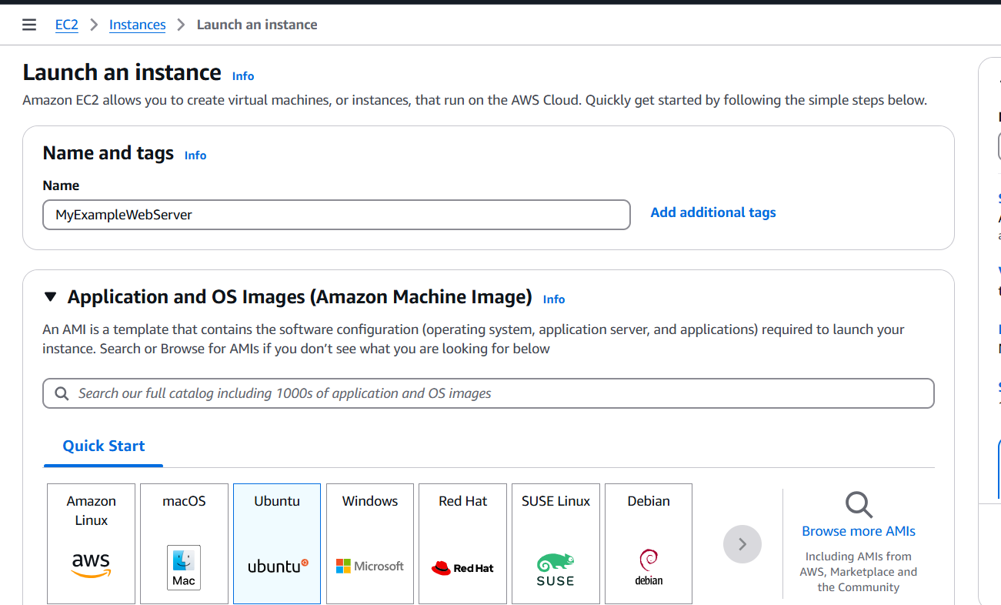

**Select this free tier option of Ubuntu from here**

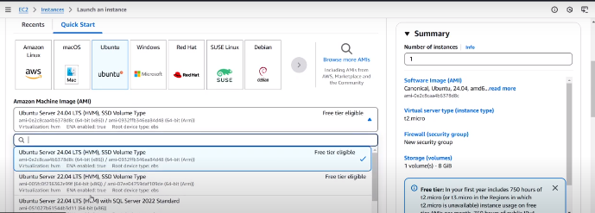

Stage 3 -- Architecture as 64-bit

Make sure AMI and Architecture are there as shown

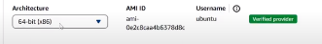

Stage 4 -- **Instance type** ---- t2.micro(default 1 CPU,1 GB RAM)

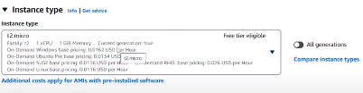

Stage 5 -- Create a new keypair---a keypair will downloaded with extension .pem

Store key in folder AWS

**First Click on create-new key pair**

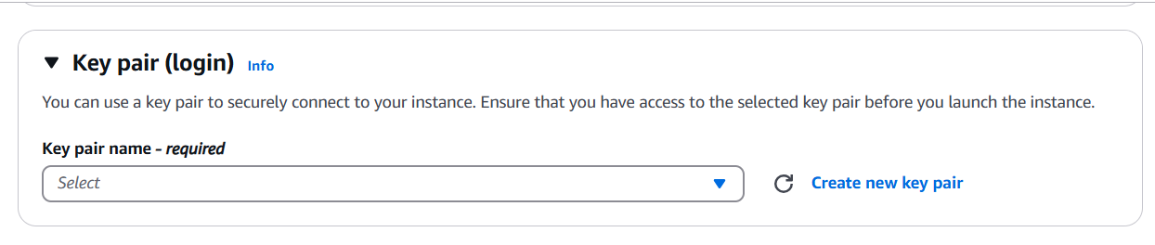

Give KeyPair name and click on create key pair

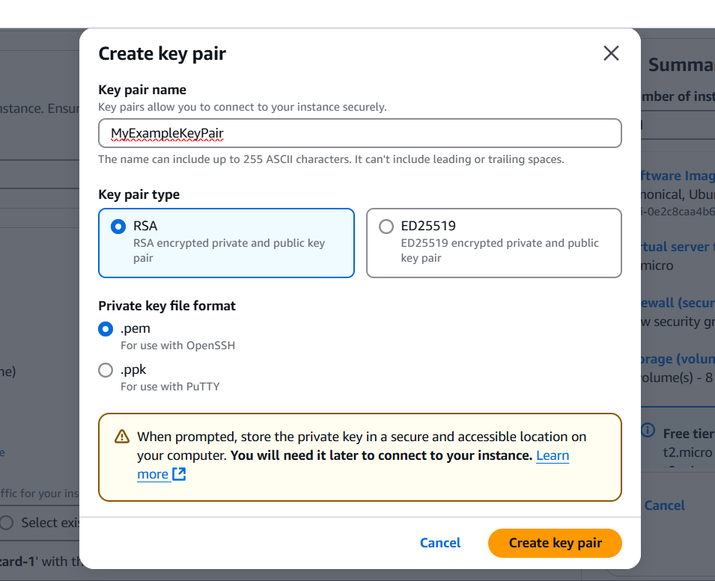

Save the .pem file in folder AWS on desktop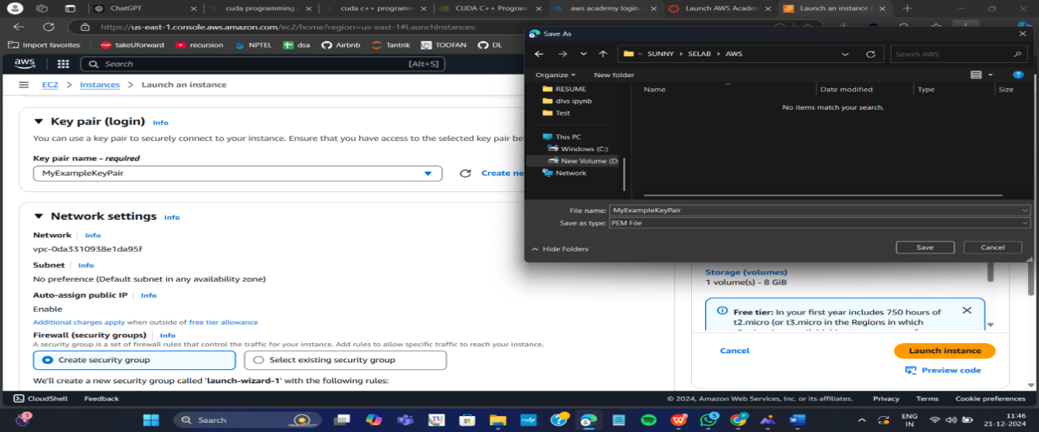

Stage 6 -- Network Setting ----Create Security group -- ( It deals with ports )

(Note for understanding We have 0 to 65535 ports. Every port is dedicated to special purpose)

**HERE select https and http** (which allow to load your web pages while execution)

In network setting check all the checkboxes

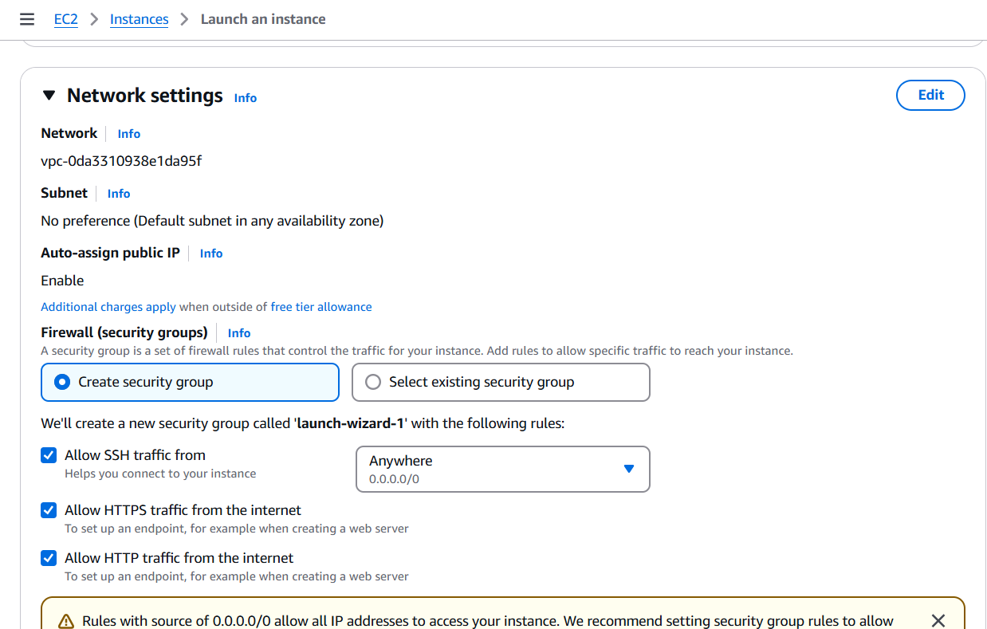

Stage 7 -- Storage - 8GB ( Observation - we have root - it is same as C Drive) it default 8 GB

Stage 8 --- click on launch instance

Now click on the instances

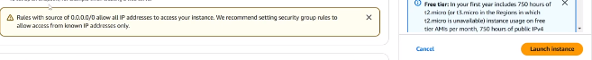

Wait for the Success message to apper in green color

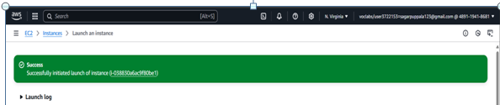

You can see MyExampleWebServer is Running and wait for it to initialize

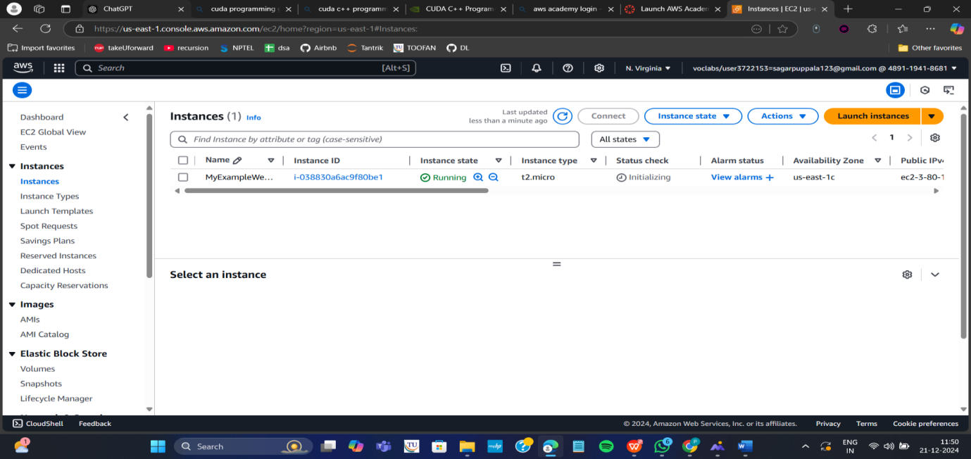

You have to get 2 tests passes.

Important:---- Now check the box and click on connect.

**Do this step:---once it is created select that instance**

**(Tick in checkbox) and click on connect**

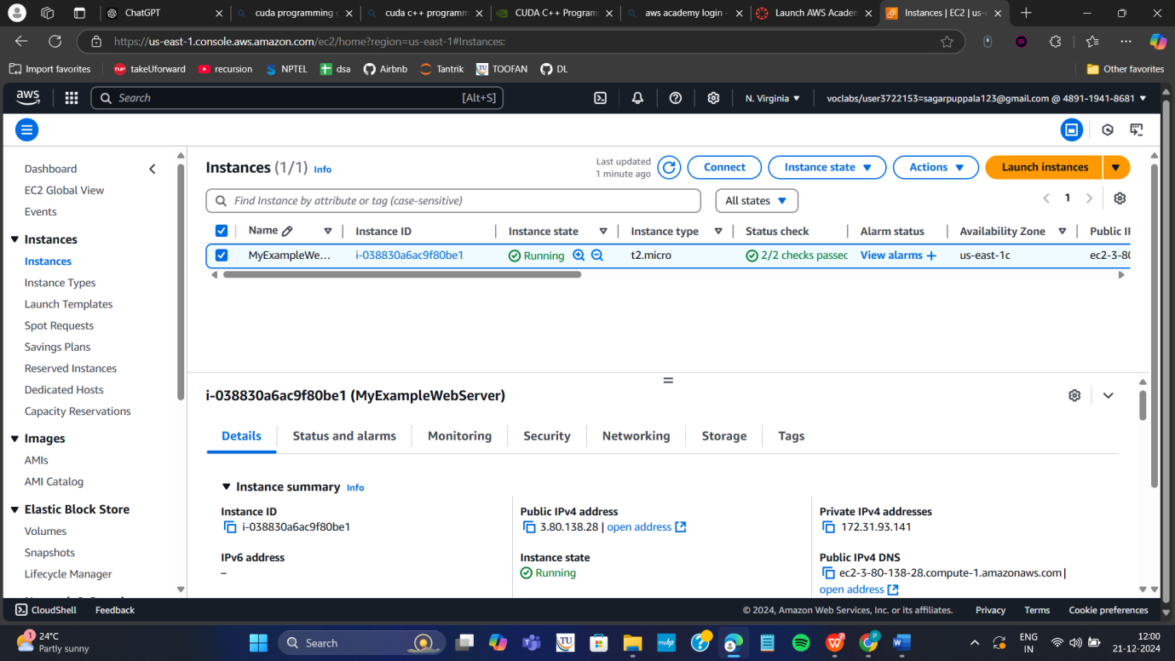

Thus your EC2 instance is running on server.

Step 4: Now you can connect local system to server (EC2 instance) using secure shell SSH.

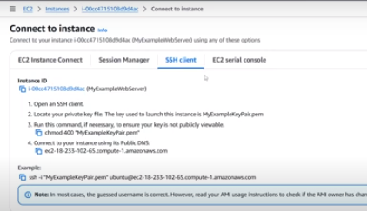

For this, **Here copy the ssh – i command from SSH client connect tab and paste later**

Next We can use powershell /gitbash /webconsole **in administrative mode**, to connect to ubuntu machine.

Step a: Copy the path of .pem file that you saved earlier in folder AWS eg. as here D:\SUNNY\SELABWEB\AWS

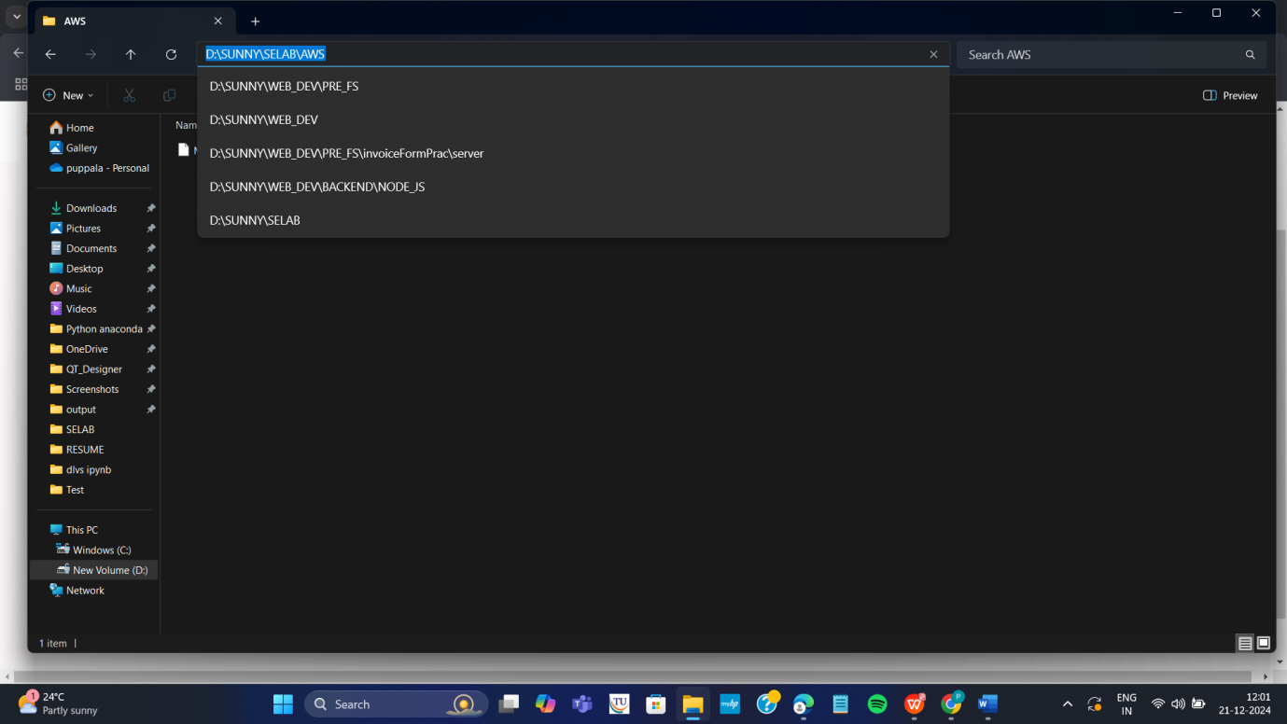

Step b: Open Powershell in administrative mode and navigate to that path.

Type: cd < path>

eg. cd D:\SUNNY\SELABWEB\AWS here specify your .pem path

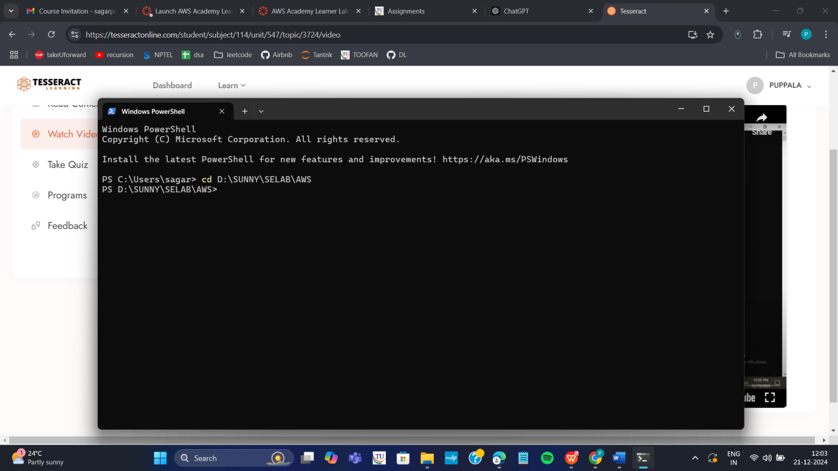

Step c: Go to SSh and copy the command ssh which is present at the below

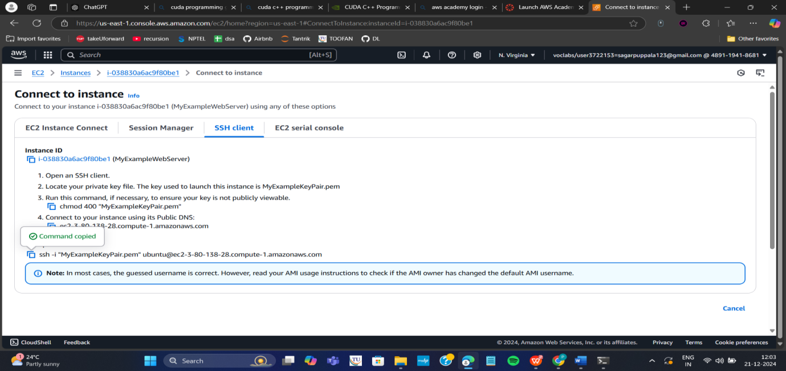

Note: To connect to above terminals we need to go into the path of the keypair.and

paste the ssh -i command from the aws console

Step d: **Run the pasted** ssh -i **command in the terminal**

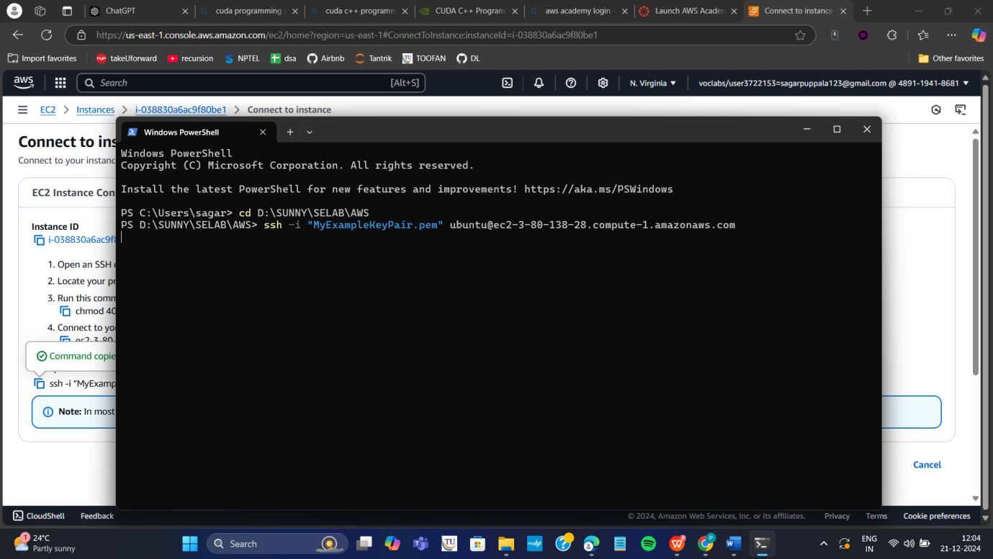

Step 5: Run the following commands to install s/w

1. Update all softwares in Ubuntu by command

**sudo apt update**

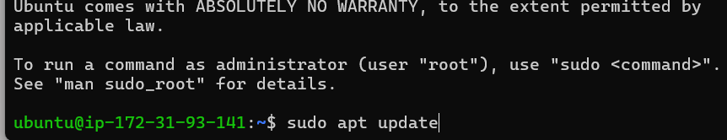

1. Install docker by command

**sudo apt-get install docker.io**

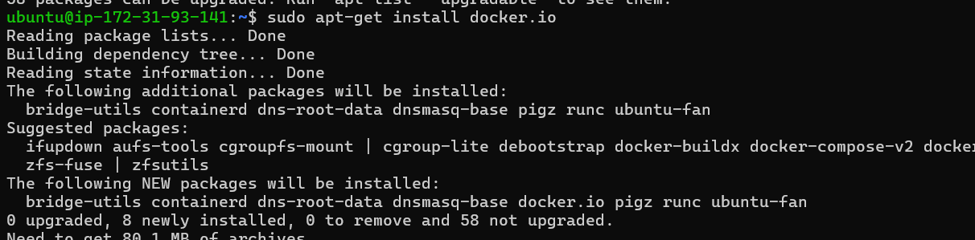

1. Install git by command

**sudo apt install git**

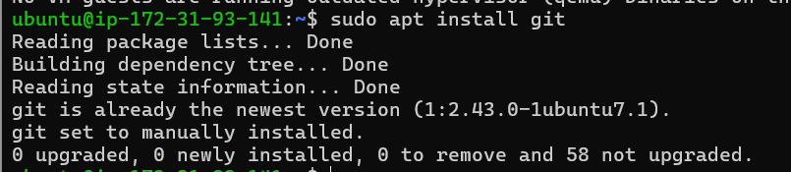

1. Install nano( text editor) by command

**Sudo apt install nano**

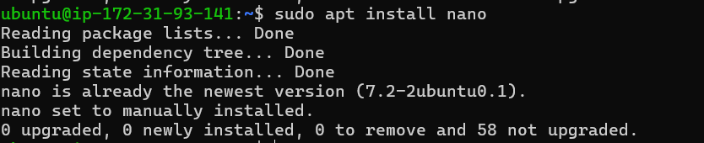

Step 6: Now we want to create an application, push it into git, create docker image of it and run it

**Step a:** Create basic index.html file in folder Example and save it

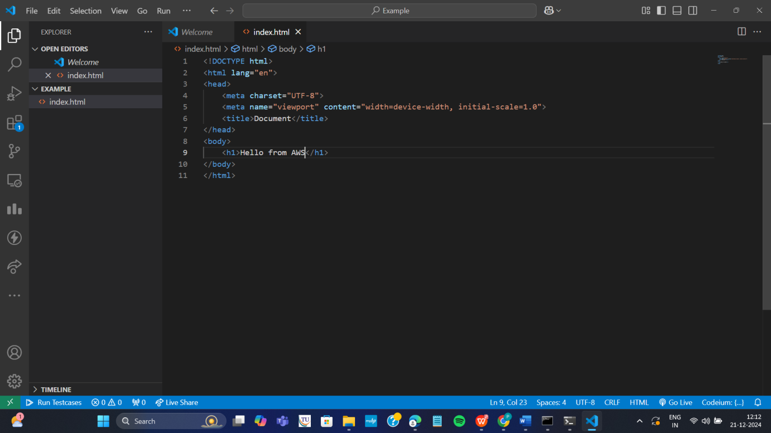

**Step b:** Open git Bash **in folder Example** by right clicking with mouse

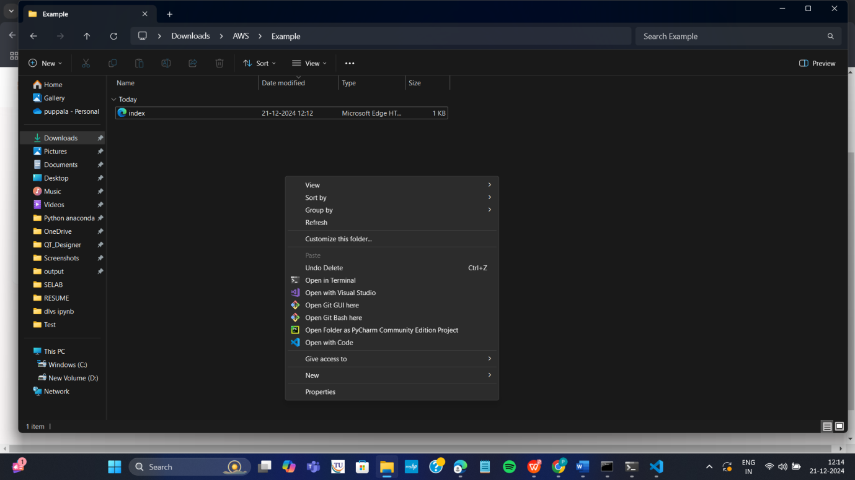

**Step c:** In git bash run the following commands

**git init**

**git add .**

**Git commit –m “first commit”**

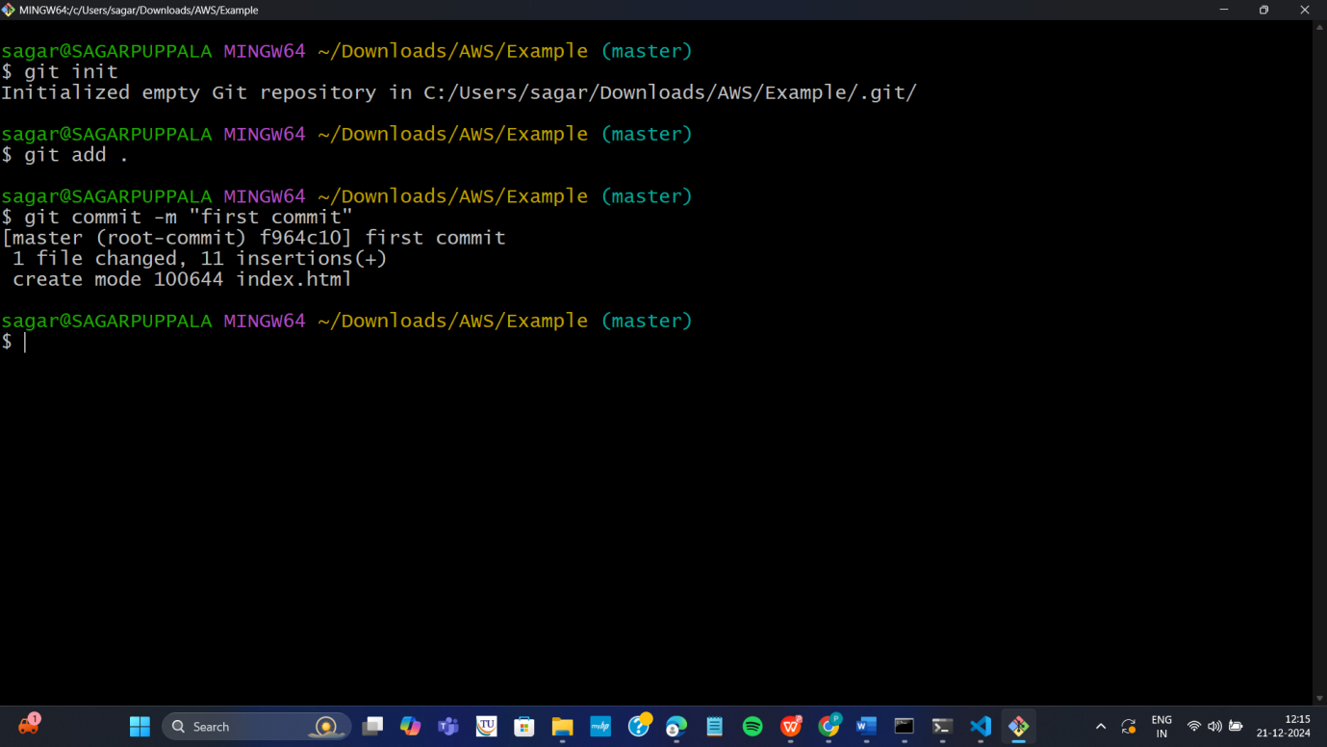

**Step d:** Create git repository (here with name AWS)

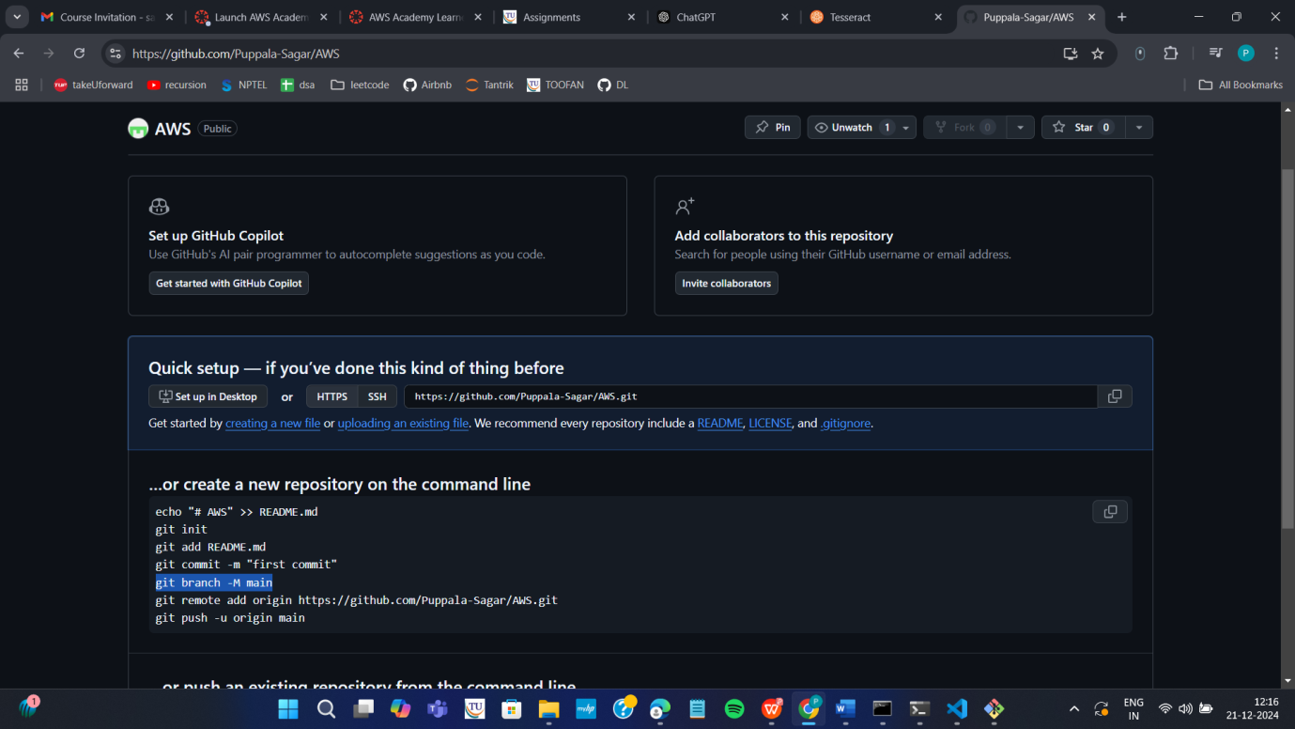

**Step e:** Copy command **one by one** from above repository and run as below

**git branch –M main**

**git remote add origin <https url>**

**git push –u origin main**

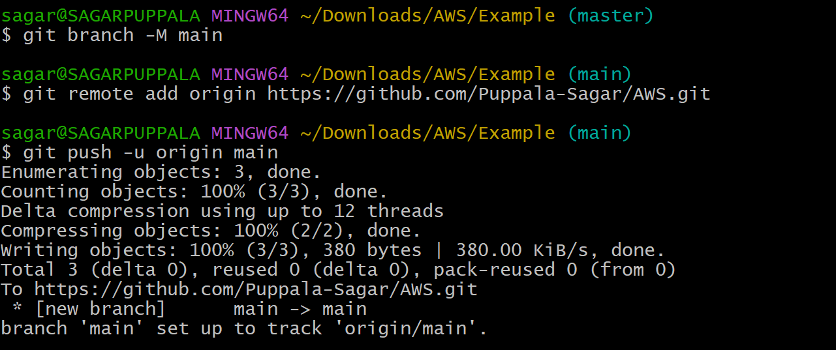

**Step f:** refresh repository and You can now see index.html in github

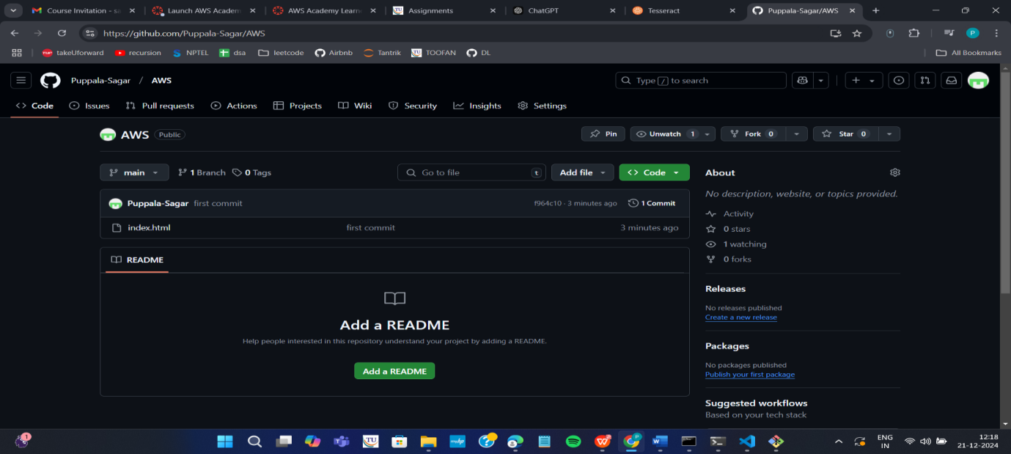

**Step g:** Copy http path

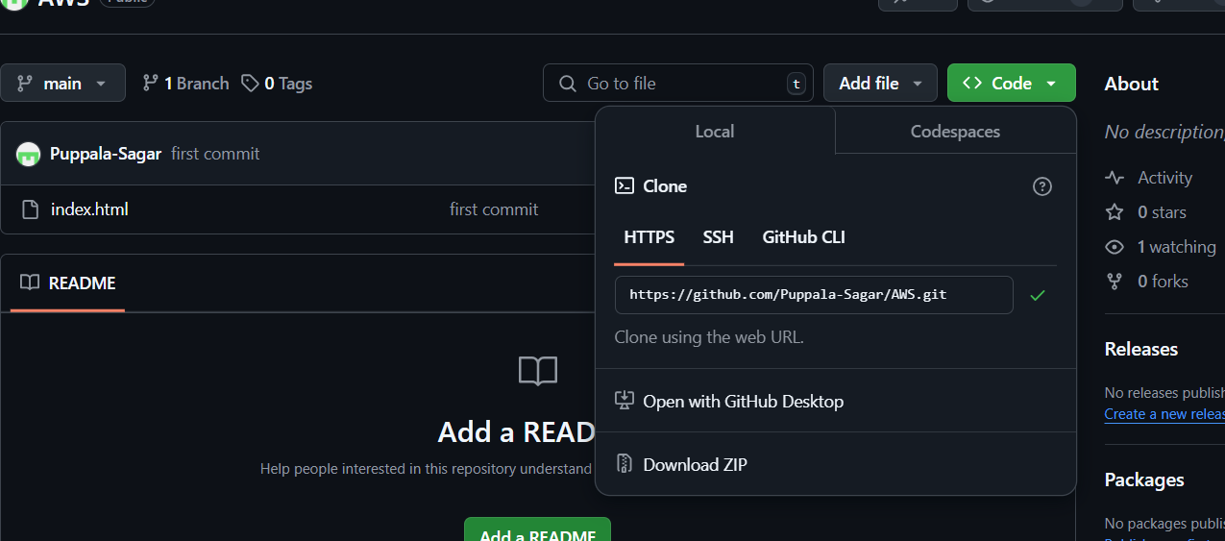

**Step h:** Clone the repository with copied http path by command **in command prompt git clone <copied http url>**

**Step i:** Navigate to the cloned folder. Type **cd AWS** as below, next **ls** to

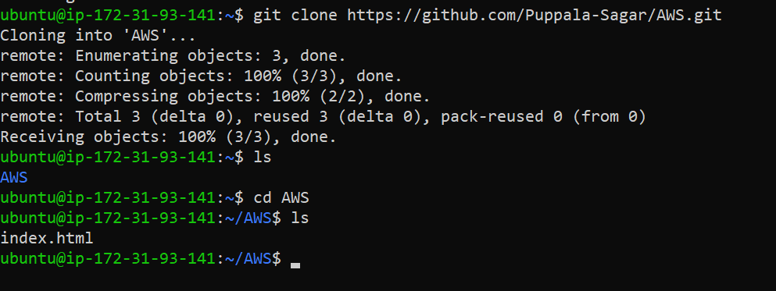

**Step j:** create Dockerfile in above command prompt in ububtu ie in power shell

**Nano Dockerfile**



**Step k:** Write the following data in Dockerfile and click ctrl+o Enter and then ctrl-x

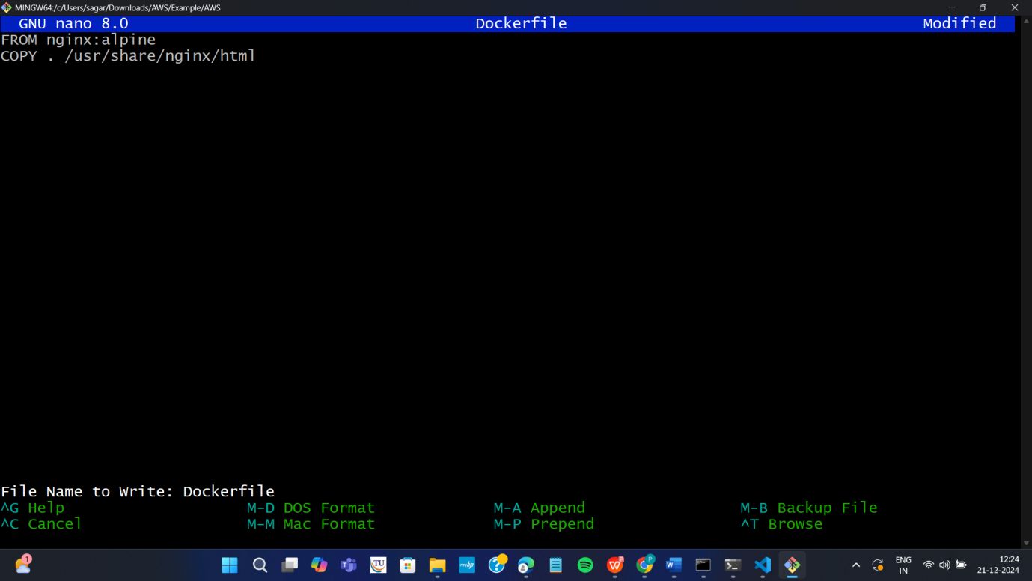

**Step L:** Build docker image by executing the following command

**sudo docker build –t mywebapp .**

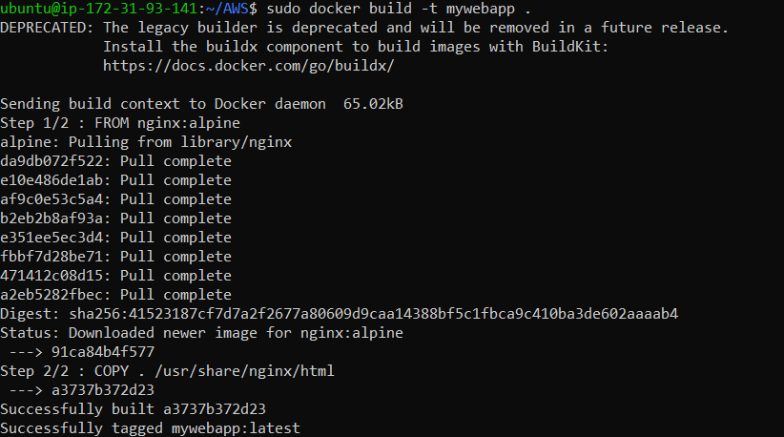

Thus image is created

**Step m:** run the image and map it to port 80

**sudo docker run –**d –p 80:80 mywebapp



**Step n:** Go to instances and click on instance here

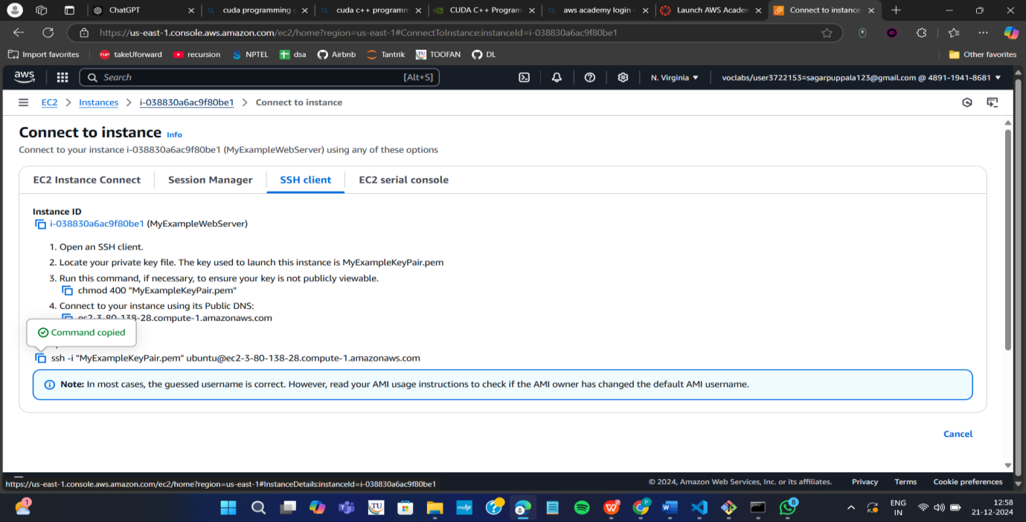



**Step o:** Copy public ipv4 address

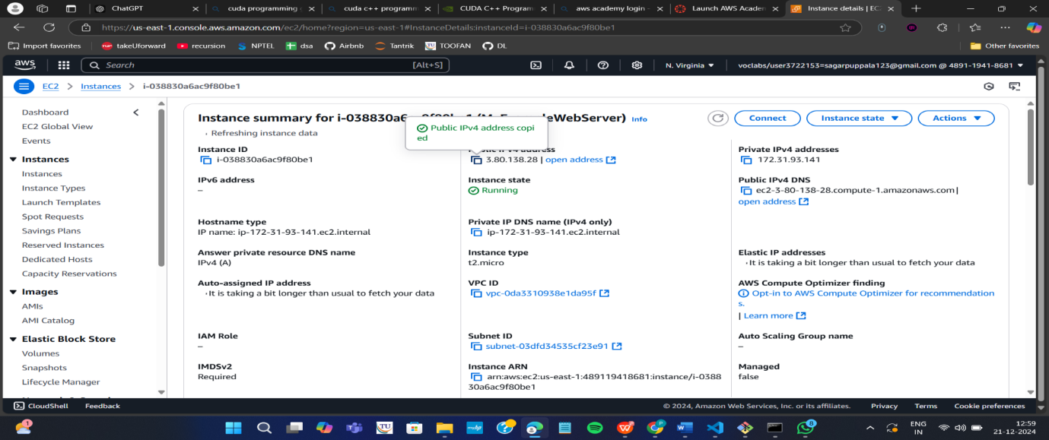

**Step p:** Paste it in the browser to get below output

**Note :** if https :__ won’t work then type just http:___

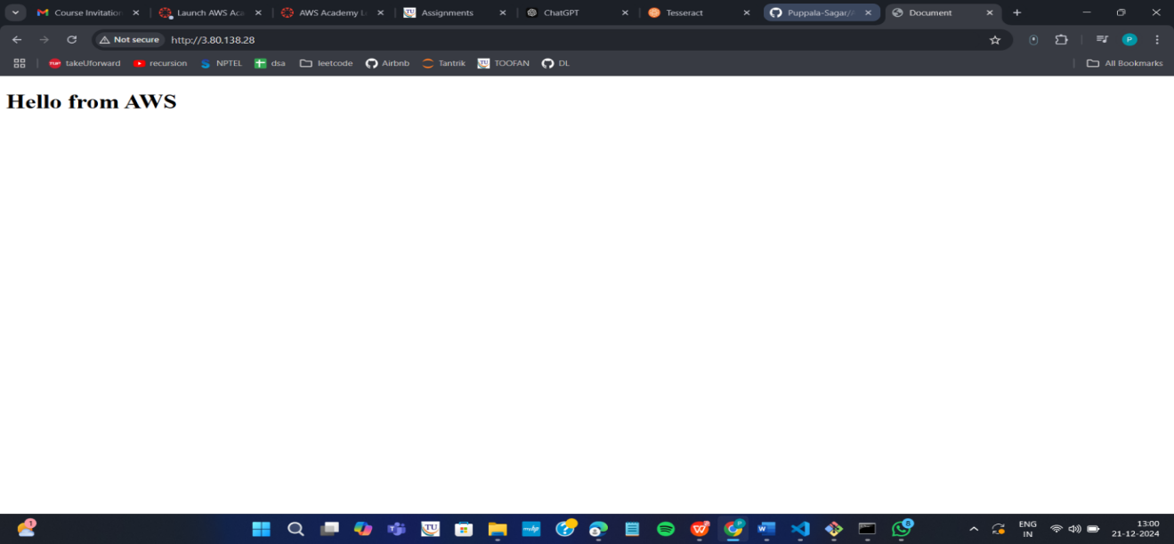

**Important do it without fail. Step Q:** stop container

Run the following command to stop the container

1. sudo docker ps
2. sudo docker stop <container-id>

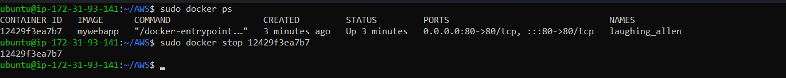

1. Go back to instances and click on option instance. Once load as below, then Click on Instance state and select terminate instances

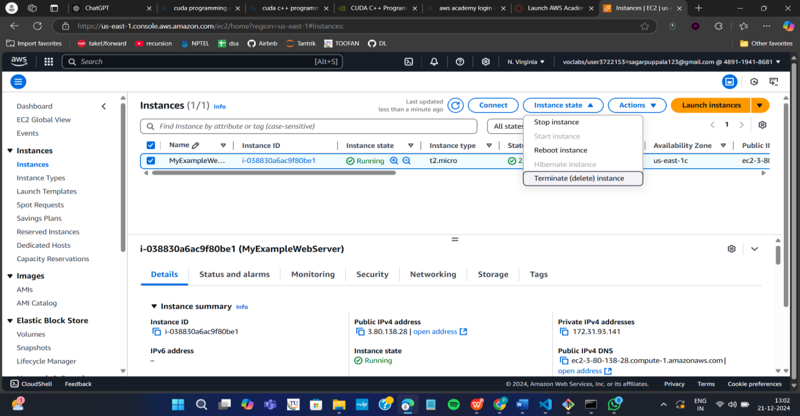

Click on Terminated (deleted)

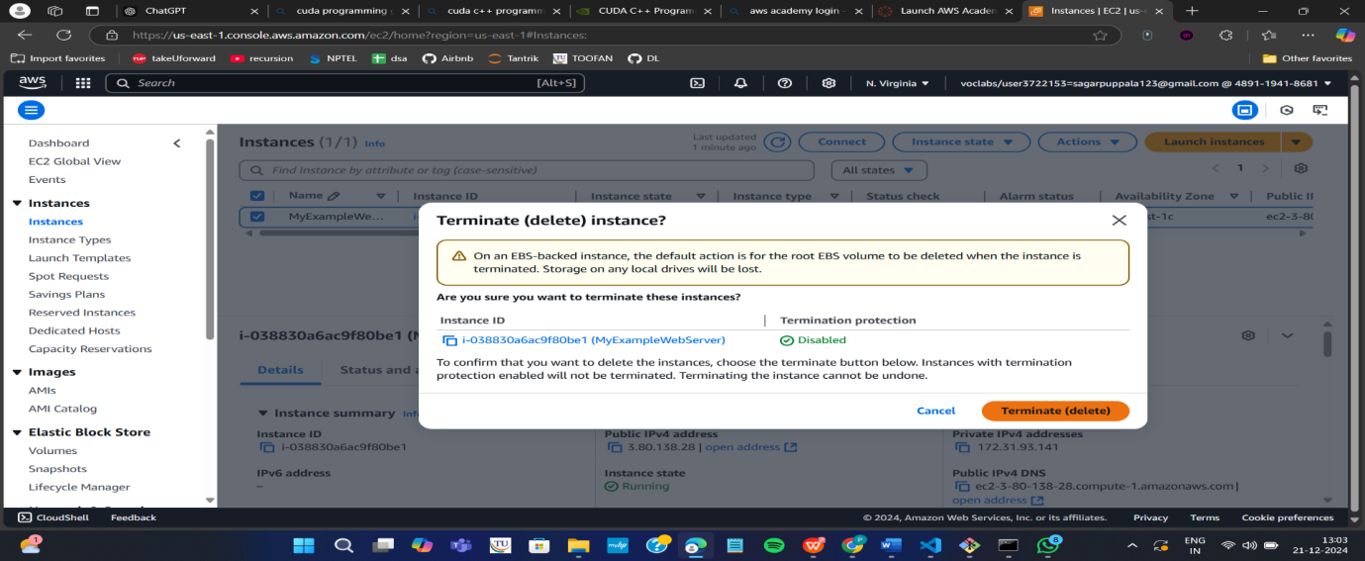

1. Now click on End lab

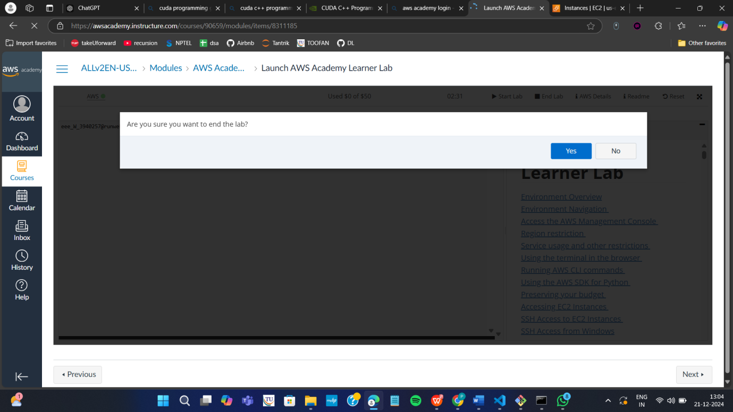

End of exercise 1 (DEPLOYMENT of index.html using EC2 instance in AWS) consisting of:

1. creating EC2 instance to install Ubuntu, docker, git , and nano.
2. creating web application (index.html) using Visual studio
3. Pushing index.html to github and cloning the it
4. Creating Dockerfile to build image for running index.html on nginx server
5. Run it as container using docker command and get the output on browser
6. Terminate the instance
7. End lab

2 MAVEN WEB PROJECT DEPLOYMENT IN AWS

Click on start lab



Click on AWS

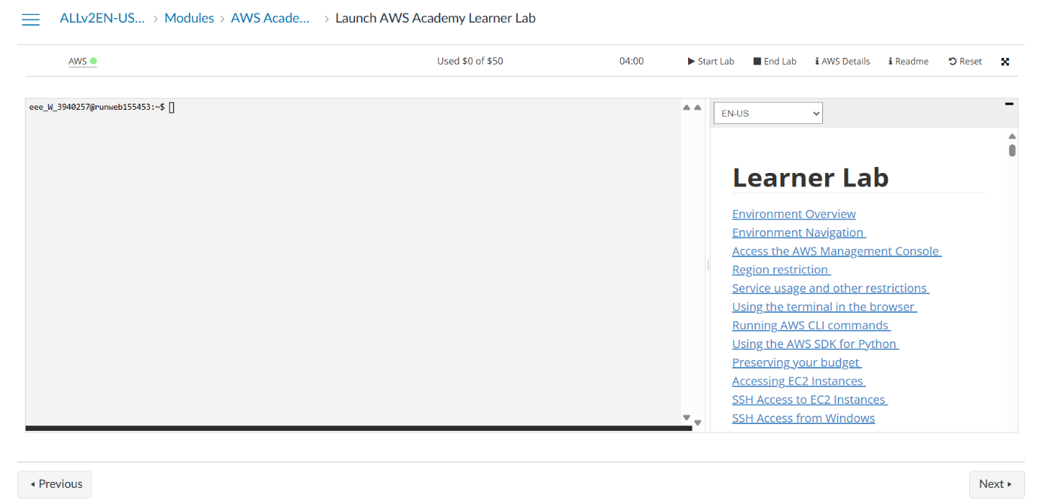

Click on EC2

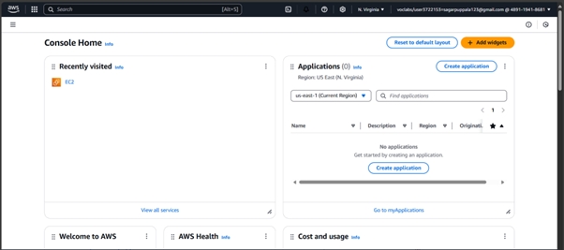

Click on launch instance

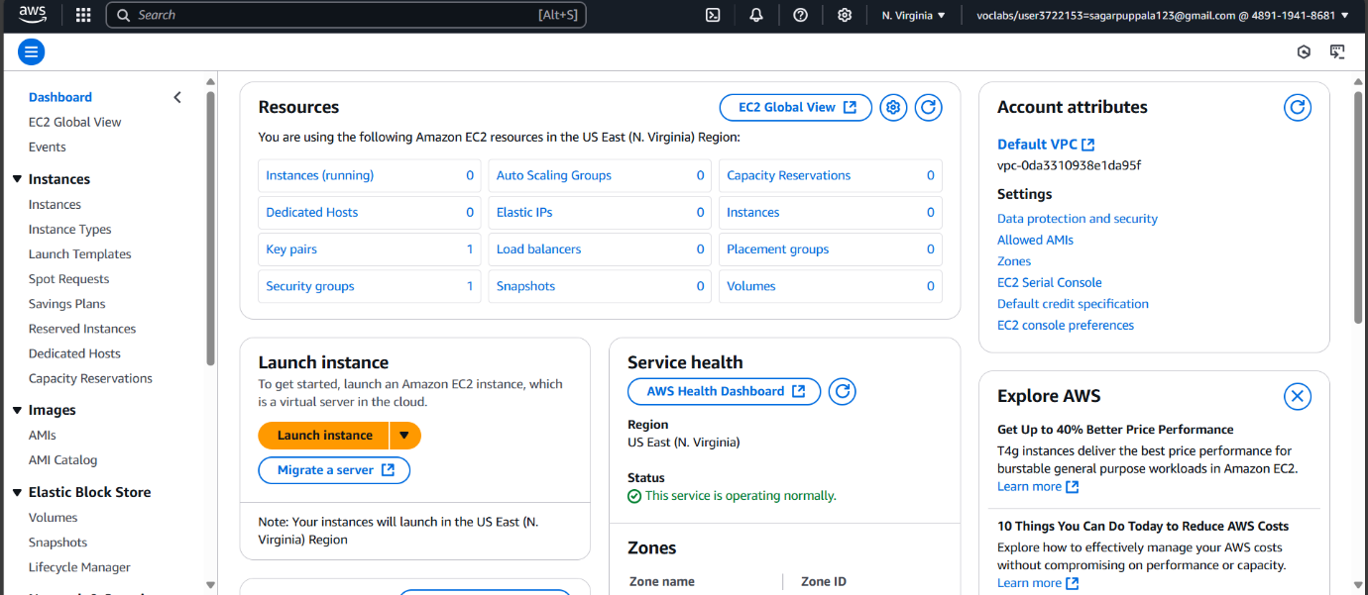

Give name

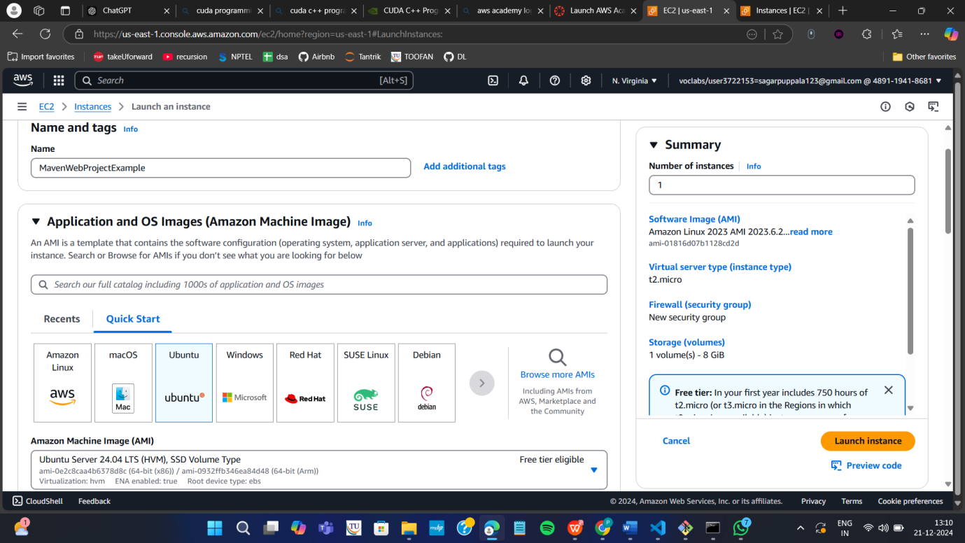

Create new key

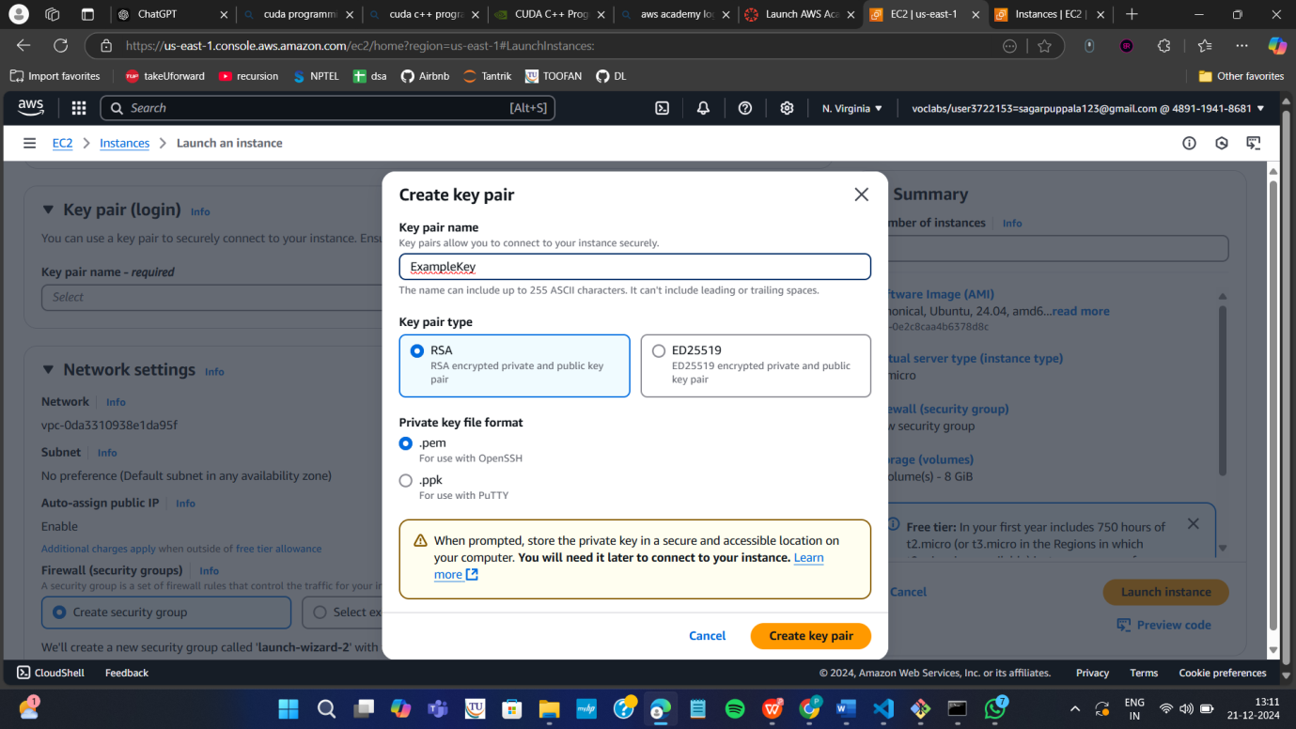

Check all the boxes under network and click on launch instance

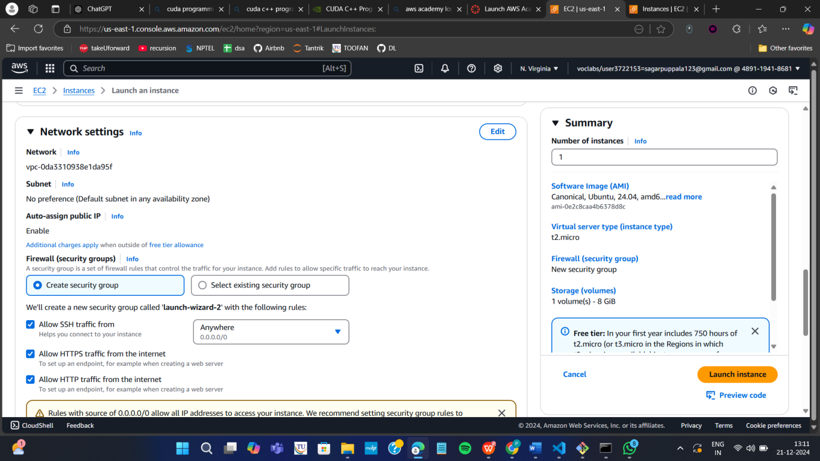

Click on instances

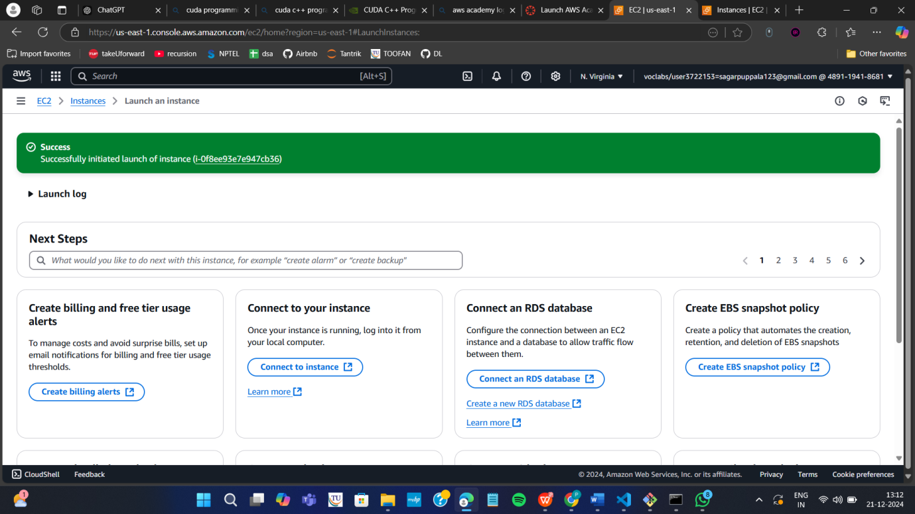

Wait until you get 2 tests passes

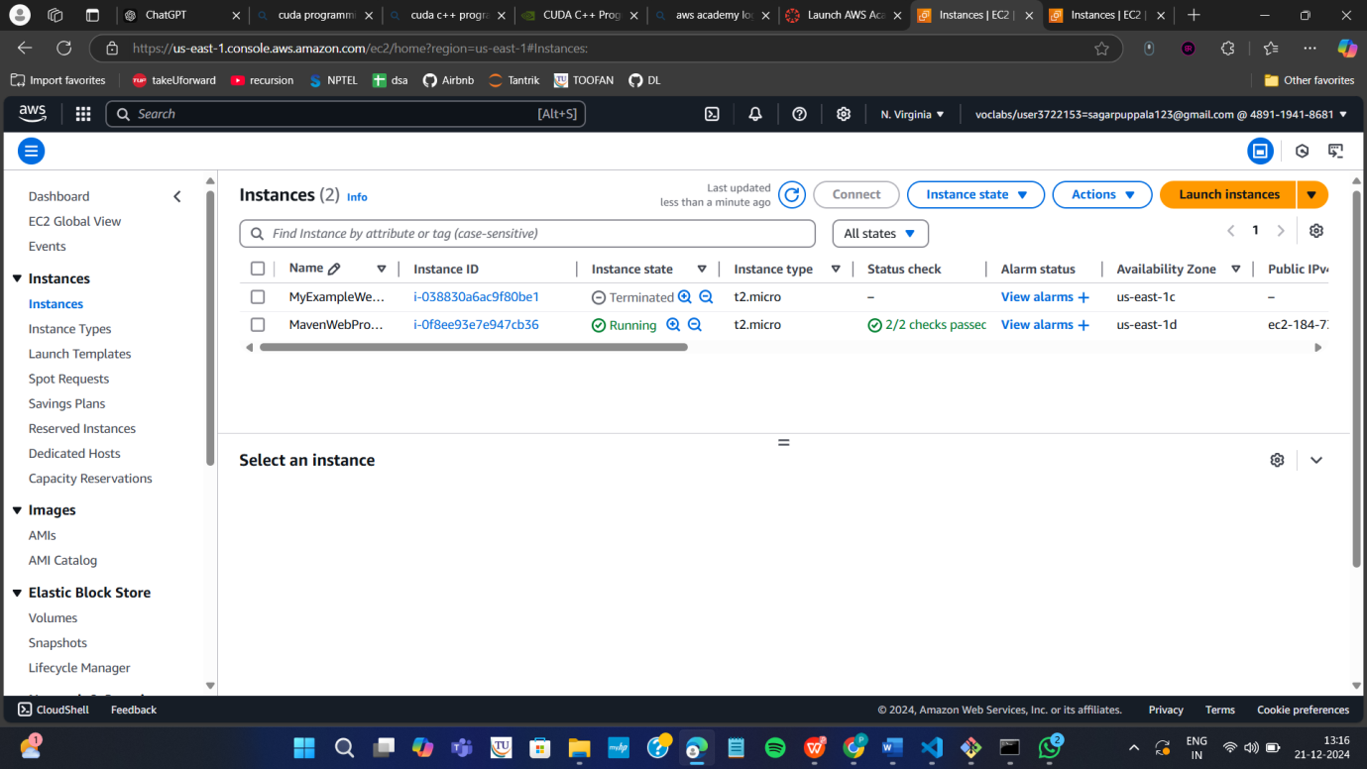

Click on connect after checking the box

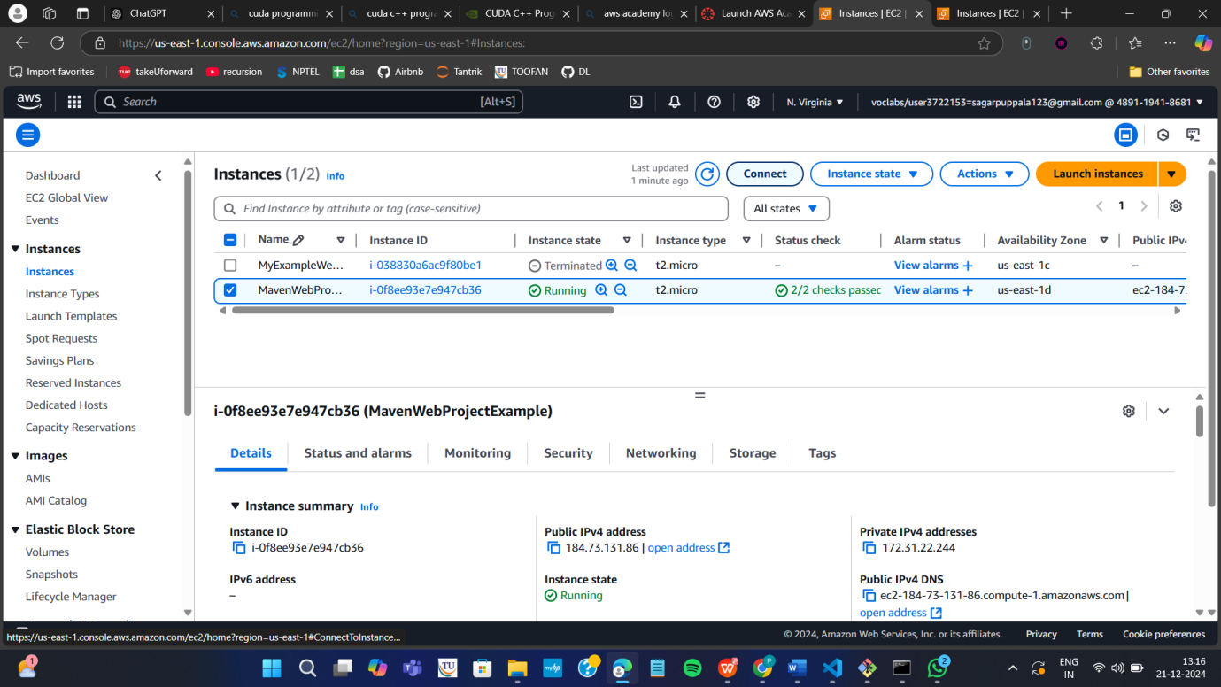

Copy ssh command

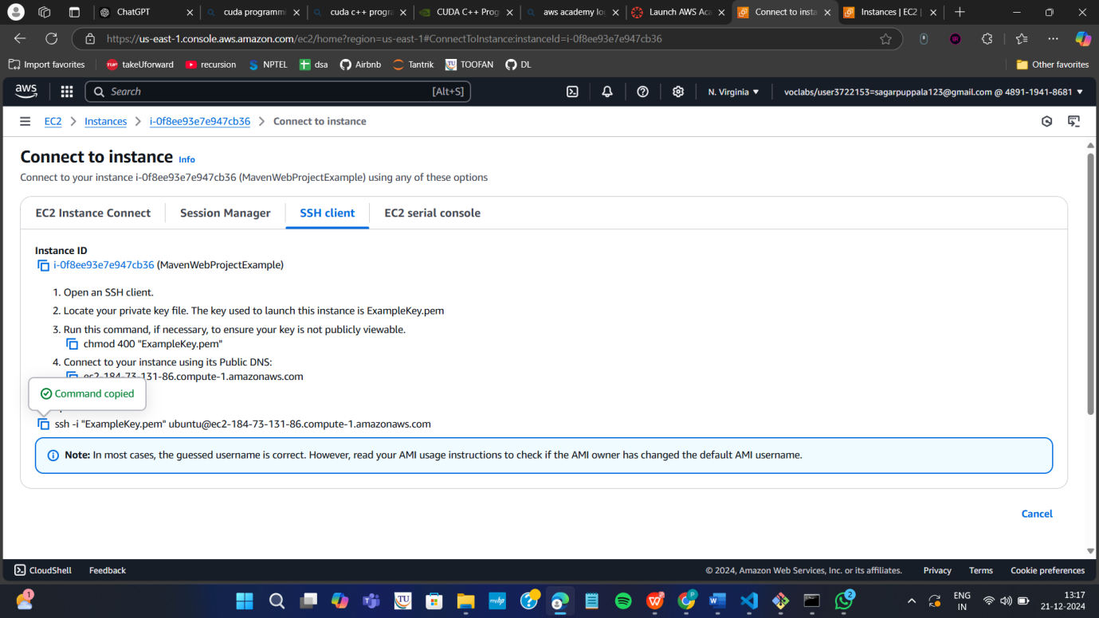

Open the terminal, Navigate to the path

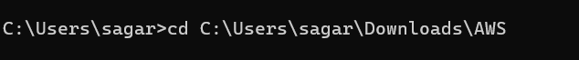

Run the ssh command

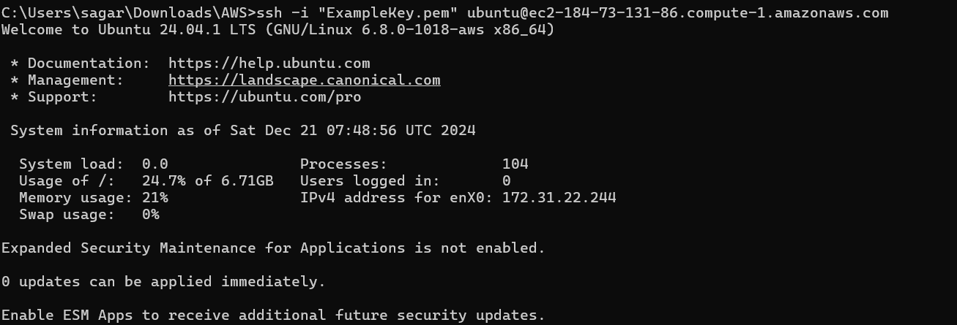

Run the following commands

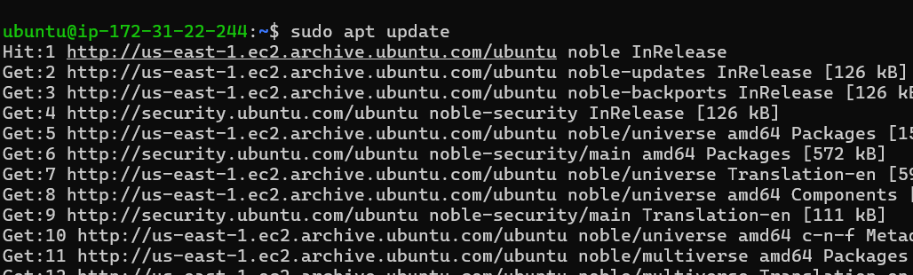

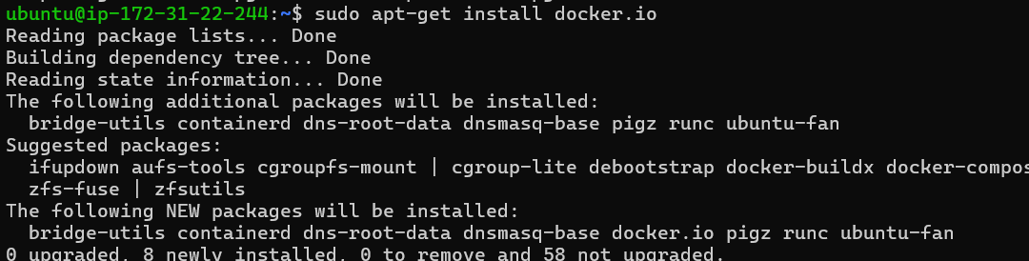

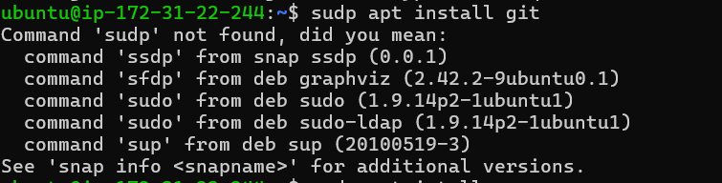

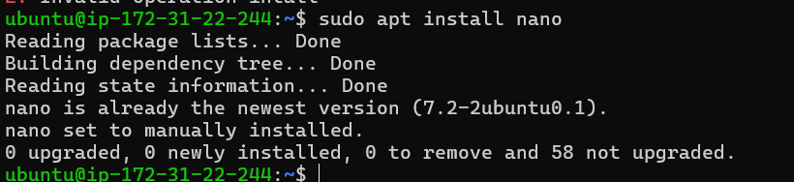

**Open MAVEN WEB PROJECT REPO in github and copy http link**

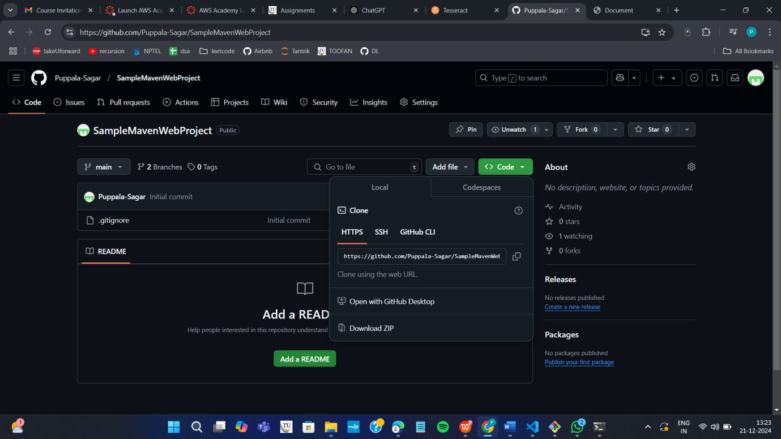

**Clone the repository**

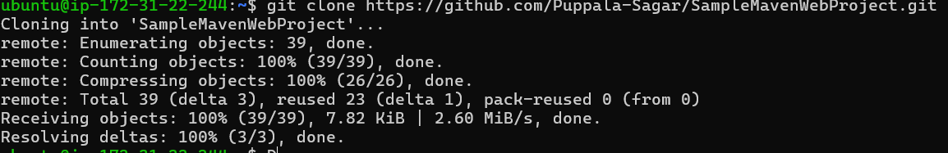

**If your repository is in main run following**

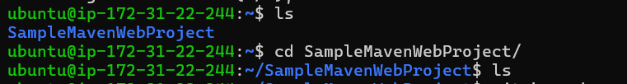

**If not goto your github repo**

**Click on settings**

**Under default branch section click on the icon shown and you’re your master branch as default and execute above commands**

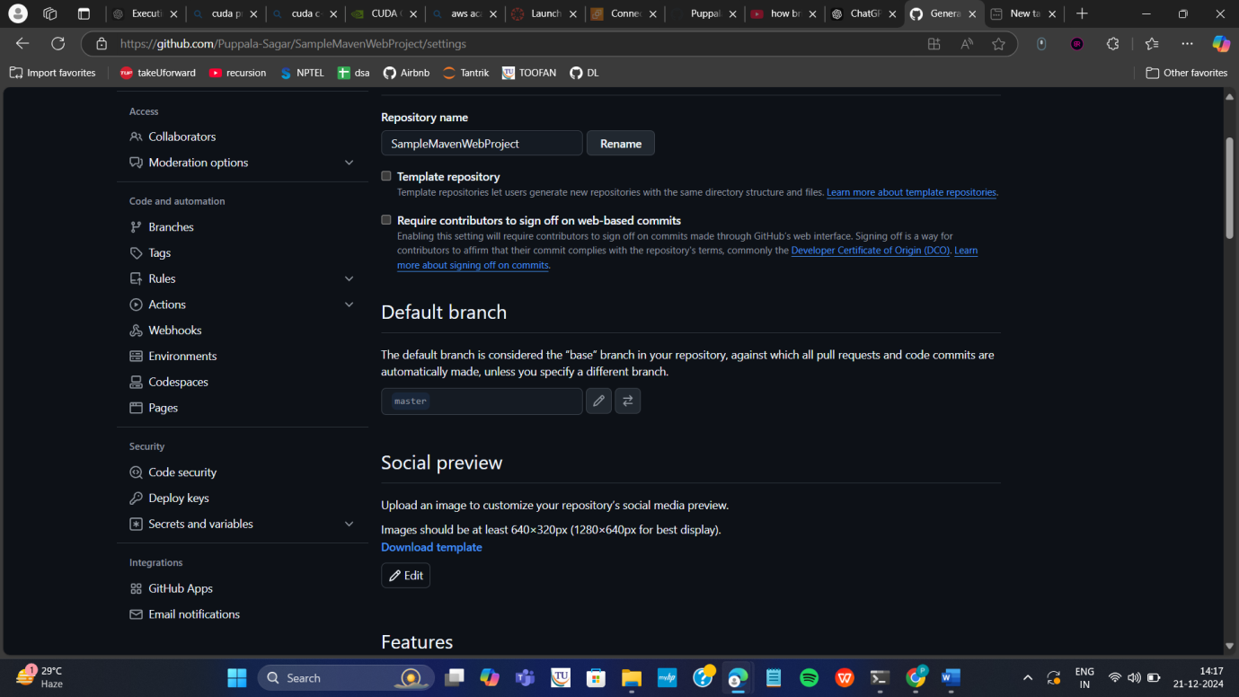





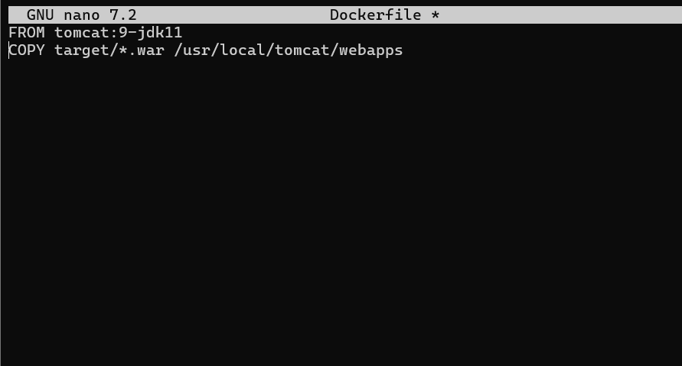

**Build docker image**

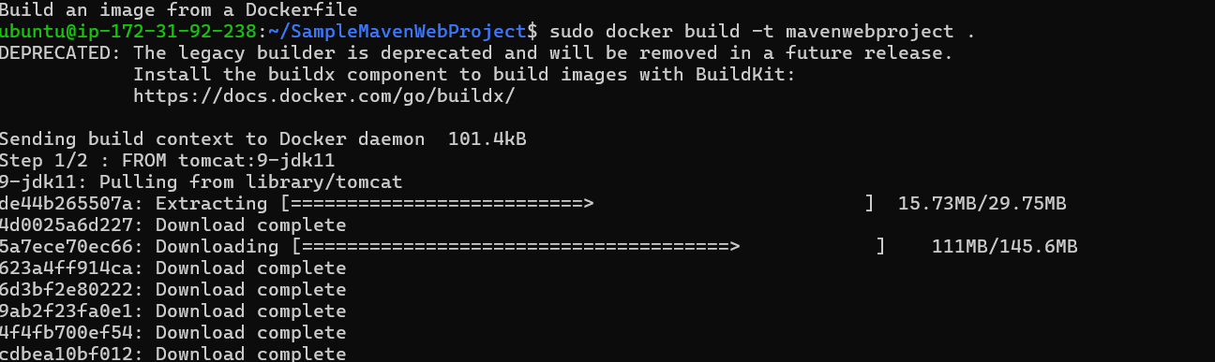

**Run the container**

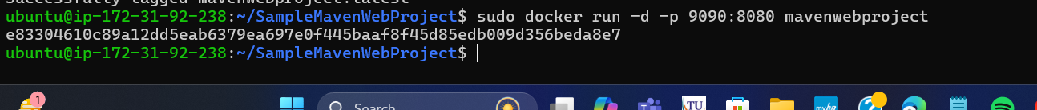

**Copy public ipv4**

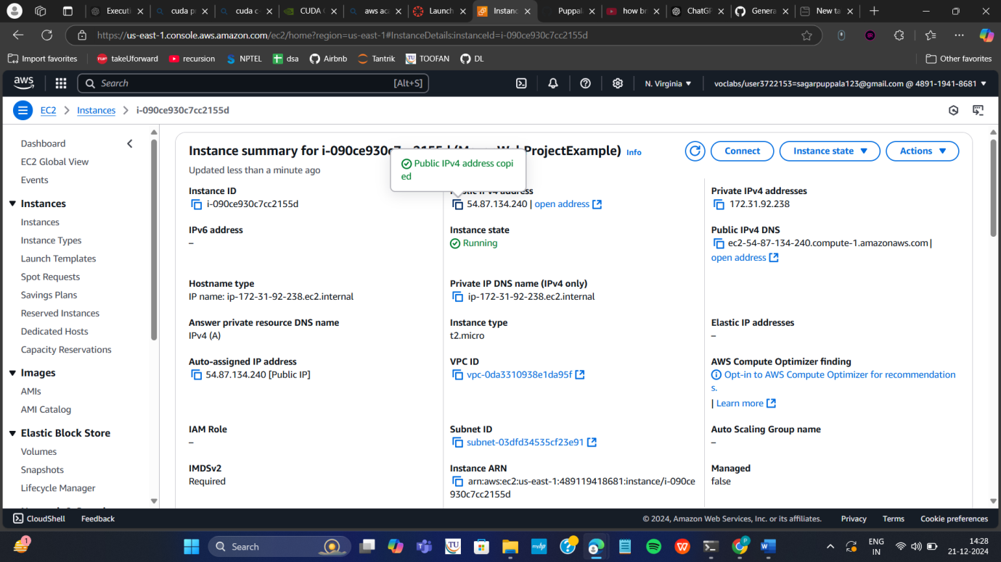

**Enter this url in browser and click enter**

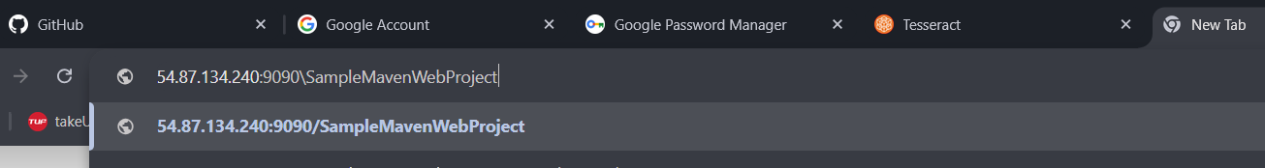

**If your app is not running goto security and Click on security groups**

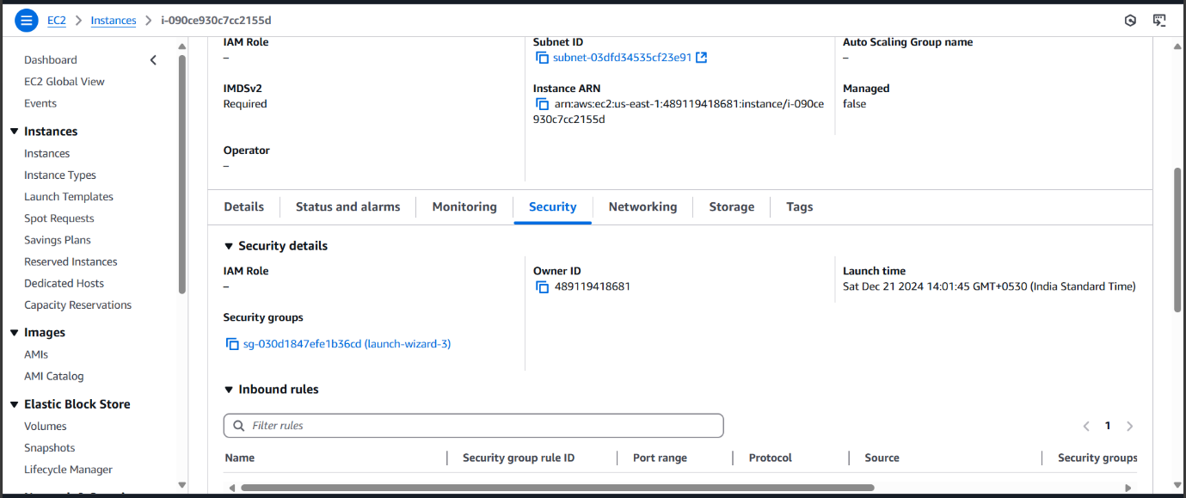

**Click on edit inbound rules**

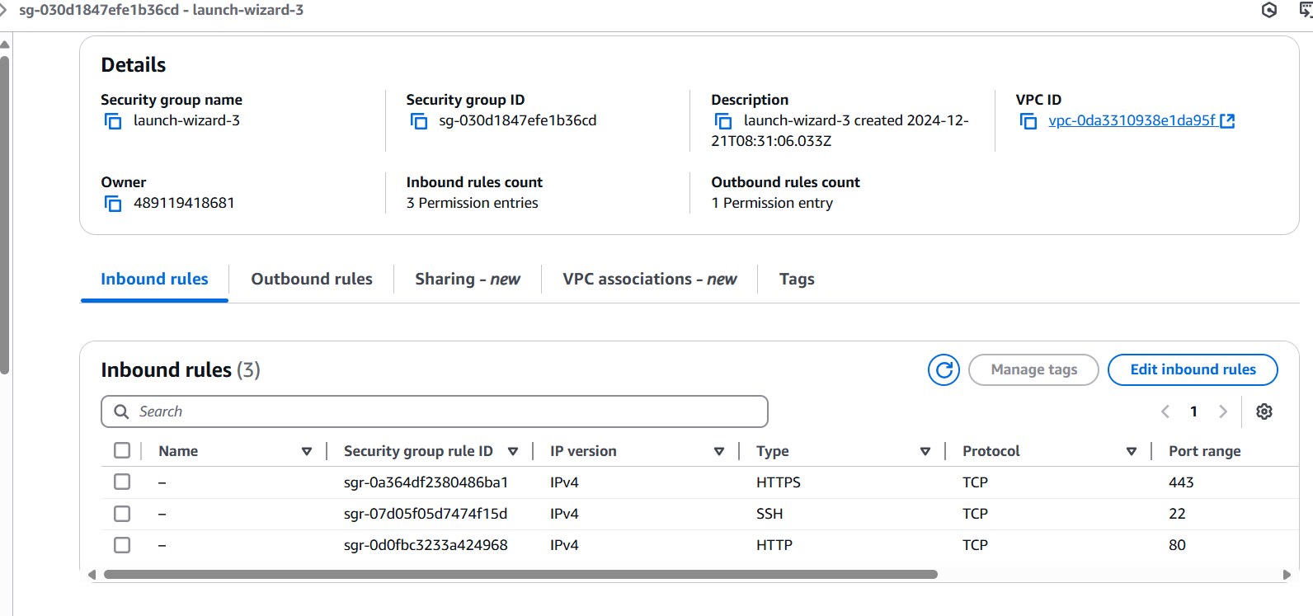

**Click on add rule give port as 9090 and 0.0.0.0/0 click on save**

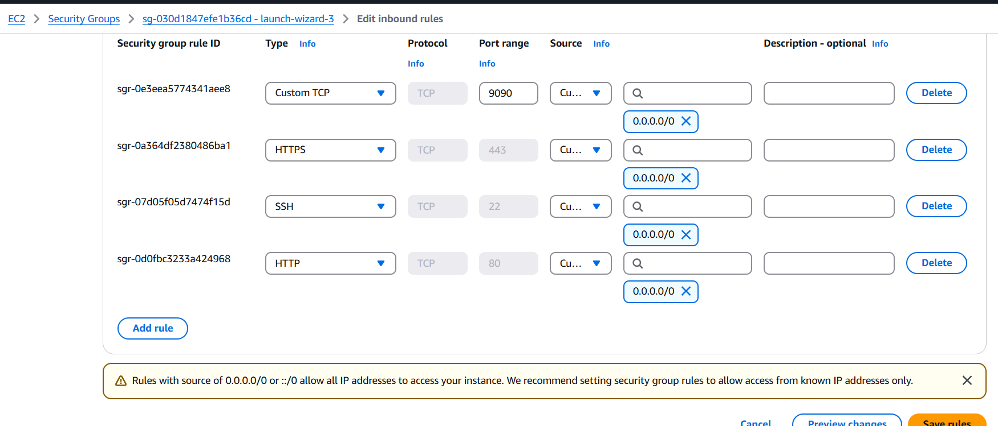

**And refresh the page to check whether the web page has loaded or not**

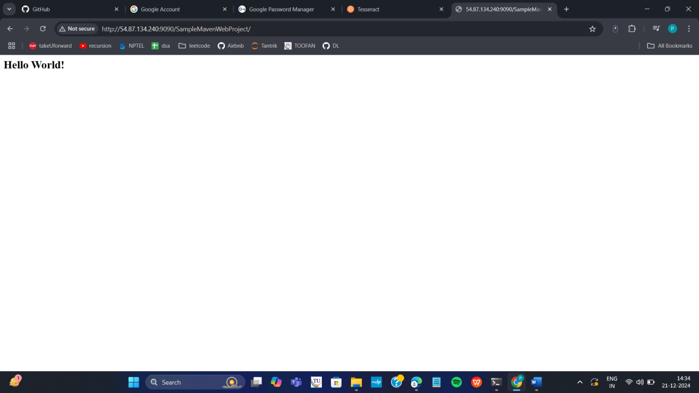

**If it is loaded you have successfully deployed you maven web project In your ec2 instance**

**Run the following commands to stop the container**

**Terminate your instance**

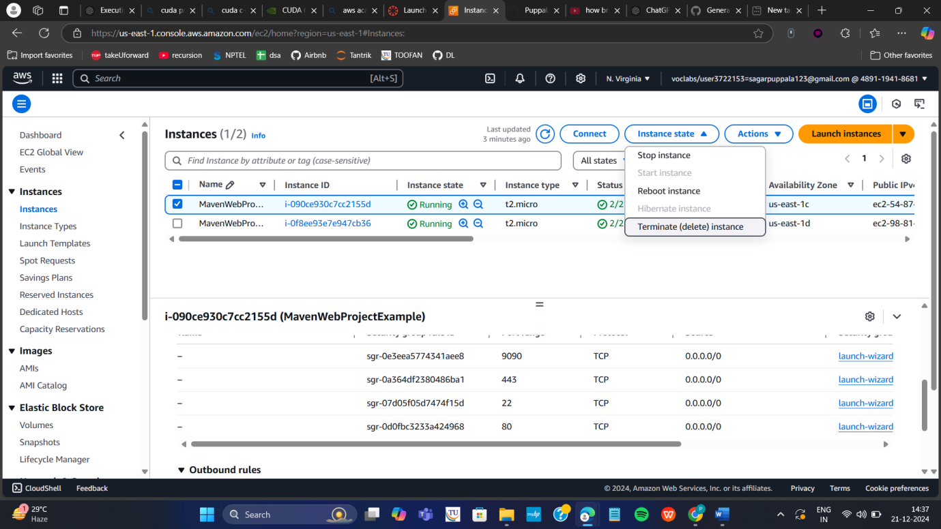

**End your lab**

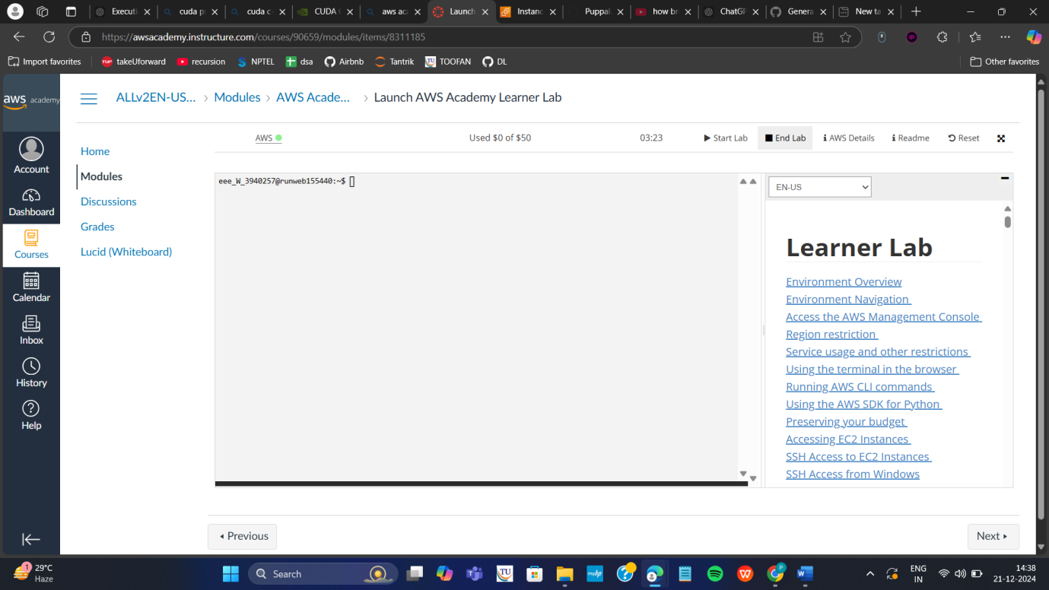

**✅ Q1 — Jenkins Pipeline for a Web Application (Tomcat)**

**1️⃣ Requirements (already installed in the lab ideally):**

* Jenkins running on system (usually on localhost:8080)
* Tomcat server installed (often path: /var/lib/tomcat9/webapps)
* Maven installed (optional if project uses Maven)
* A GitHub repo URL

**2️⃣ Step-by-Step Execution**

**Step 1: Open Jenkins**

1. Open **Google Chrome**.
2. Type in address bar:
3. http://localhost:8080
4. Press **Enter** → Jenkins Dashboard appears.  
   (If login required → username: *admin*, password may be given OR already logged in.)

**Step 2: Create a Pipeline Job**

1. Click **“New Item”** on the left.
2. In the name field, type:
3. WebProjectPipeline
4. Select **Pipeline** option.
5. Click **OK**.

**Step 3: Add GitHub Repository**

1. Scroll to the **Pipeline** section.
2. Set **Definition = Pipeline Script**.
3. In the script box, paste:

pipeline {

agent any

stages {

stage('Clone Repository') {

steps {

git 'https://github.com/username/repo-name.git'

}

}

stage('Build') {

steps {

sh 'mvn clean package'

}

}

stage('Deploy to Tomcat') {

steps {

sh 'cp target/*.war /var/lib/tomcat9/webapps/'

}

}

}

post {

success {

echo "BUILD SUCCESS — Application Deployed"

}

}

}

1. Click **Save**.

**Step 4: Run Pipeline**

1. Click **Build Now** (left side).
2. Click the latest build (#1 or #2 etc.).
3. Click **Console Output**.

**Expected Console Output:**

Cloning repository...

[INFO] BUILD SUCCESS

BUILD SUCCESS — Application Deployed

Finished: SUCCESS

**Step 5: Check Web App in Tomcat**

1. Open new browser tab.
2. Type:
3. http://localhost:8080/your-project-name
4. Press **Enter** → Webpage loads.

**3️⃣ Short Theory to Write**

Jenkins is a CI/CD automation server.

Jenkins Pipeline automates pull → build → deploy process using a Jenkinsfile.

Tomcat is used as deployment server for the web application.

Pipeline stages: Clone → Build → Deploy.

Expected result: Console output shows BUILD SUCCESS and application visible in browser.

**✅ Q2 — Webhooks to Trigger Jenkins Build Automatically**

**1️⃣ Requirement:**

* Jenkins running
* GitHub account
* Working Jenkins project connected to Git

**2️⃣ Step-by-Step Execution**

**Step 1: Enable Webhook Trigger in Jenkins**

1. Open Jenkins:
2. http://localhost:8080
3. Click your project name (**WebProjectPipeline**).
4. Click **Configure**.
5. Scroll to **Build Triggers**.
6. Check:

☑ GitHub hook trigger for GITScm polling

1. Click **Save**.

**Step 2: Configure Webhook in GitHub**

1. Open **github.com** → login.
2. Open your repo.
3. Click **Settings** tab.
4. On left menu → click **Webhooks**.
5. Click **Add Webhook**.
6. Fill the form:

| **Field** | **Value** |
| --- | --- |
| Payload URL | http://localhost:8080/github-webhook/ |
| Content Type | application/json |
| Trigger | Send me everything / Push event only |

1. Click **Add Webhook**.

A green ✓ appears if successful.

**Step 3: Push Change to Repo**

If using GitHub Web editor:

1. Go to any project file.
2. Click the **pencil icon** (edit).
3. Add a line:
4. <!-- webhook test -->
5. Scroll → click **Commit changes**.

**Step 4: Verify Build Trigger**

1. Go back to Jenkins Dashboard.
2. The build should start automatically with message:

Build triggered by GitHub push

**Expected Output:**

Started by GitHub push

Pulling latest code...

BUILD SUCCESS

Finished: SUCCESS

**3️⃣ Short Theory to Write**

A webhook automates Jenkins build when new code is pushed to GitHub.

GitHub sends a POST payload to Jenkins /github-webhook/ endpoint.

This removes manual triggering and supports CI/CD automation.

**✅ Q3 — Deploying an App in AWS EC2 with Docker**

**1️⃣ Requirement:**

* AWS Account
* Internet

**2️⃣ Step-by-Step Execution**

**Step 1: Create EC2 Instance**

1. Open browser → go to:
2. https://console.aws.amazon.com
3. In search bar → type **EC2** → open it.
4. Click **Launch Instance**.
5. Fill:
   * Name: MyAppInstance
   * OS: **Ubuntu**
   * Instance Type: t2.micro
   * Key Pair: select or create
6. Click **Launch Instance**.

**Step 2: Connect to the Instance**

1. Click your instance → copy **Public IPv4**.
2. Open terminal and type:

ssh ubuntu@<public-ip>

Example:

ssh ubuntu@54.201.22.11

**Step 3: Install Docker**

sudo apt update

sudo apt install docker.io -y

**Step 4: Clone Your Application**

git clone https://github.com/username/app.git

cd app

**Step 5: Create Dockerfile**

nano Dockerfile

Paste:

FROM node:alpine

WORKDIR /app

COPY . .

RUN npm install

CMD ["npm","start"]

EXPOSE 3000

Save.

**Step 6: Build & Run App**

sudo docker build -t myapp .

sudo docker run -d -p 80:3000 myapp

**Step 7: Test in Browser**

Open:

http://<public-ip>

**Expected Output:**

✔ App home page visible.

**3️⃣ Short Theory to Write**

EC2 is a cloud virtual machine.

Docker creates lightweight containers.

Steps: Launch EC2 → Install Docker → Clone code → Build Docker image → Run container → Access using Public IP.

**✅ Q4 — Minikube Nginx Deployment**

**1️⃣ Requirement Installed:**

* Minikube
* kubectl
* Docker (driver)

**2️⃣ Step-by-Step Execution**

**Step 1: Start Minikube**

minikube start

**Step 2: Create Deployment**

kubectl create deployment nginx-deploy --image=nginx

**Step 3: Expose Service**

kubectl expose deployment nginx-deploy --type=NodePort --port=80

**Step 4: Get Access URL**

minikube service nginx-deploy

Browser opens:

http://localhost:8090

**Step 5: Verify Pods and Services**

kubectl get pods

kubectl get svc

**Expected Output:**

NAME READY STATUS RUNNING

nginx-deploy 1/1 Running

Service accessible at: http://127.0.0.1:xxxxx

**3️⃣ Short Theory**

Minikube runs Kubernetes locally.

Deployment creates a replica of containers.

Service exposes it externally.

**Week 12: Creation of virtual machine for Ubuntu OS and Deploying the web application**

1. Evaluation of previous experiments
2. Creating, running and scaling pods in minikube (eg. nginx)
3. Running Nagios server and Understanding the Monitoring tool using Docker.
4. Creation of virtual machine for Ubuntu OS and deploying an web server

(i.e. DEPLOYMENT of index.html using EC2 instance in AWS)

1. Deploying an Maven web project application into cloud
2. Creation of virtual machine
3. Deploying the web application
4. Accessing it publicly

**Deploying an application into cloud**

**Steps for Deploying application into the cloud**

1. Create application and Push into github
2. Create the virtual machine and connect to it.
3. Clone the application from github, Write the Dockerfile
4. Create the image
5. Run the image and access it public ip of virtual machine
6. **Create Maven-web-java project in eclipse & push into github**
7. **Create the virtual machine (EC2--instance) in aws and connect to**

Using Amazon EC2 eliminates your need to invest in hardware up front, so you can develop and deploy applications faster.

Ex : **Launch ubuntu instnace**

Step 1: Login to AWS /canvas account

Step 2: Services -- EC2

Step 3: Choose region which is near ?

**Services -- EC2 --- Launch Instance**

Stage 1 --Name (Giving name to the machine) ubuntu

Stage 2 -- Select AMI ( Note: Select free tier eligible ) ubuntu server

Stage 3 -- Architecture as 64-bit

Stage 4 -- **Instance type** ---- t2.micro(default 1 CPU,1 GB RAM)

Stage 5 -- Create a new keypair---a keypair will downloaded with extension .pem

Store key in folder AWS

Stage 6 -- Network Setting ----Create Security group -- ( It deals with ports )

(Note for understanding We have 0 to 65535 ports. Every port is dedicated to special purpose)

**Do this step :** **HERE select http and https**

Stage 7 -- Storage - 8GB ( Observation - we have root - it is same as C Drive)

Stage 8 --- click on launch instance

Stage 9: Number of instances ---1

+++++++++++++++++++++++++++++++

Observation - One machines created

**Do this step:---once it is created select that instance and click on connect**

**Here copy the ssh – i command from SSH client connect tab**

We can use powershell /gitbash /webconsole , to connect to ubuntu machine.

**NOTE:- cd path of AWS folder // change path**

To connect to above terminals we need to go into the path of the keypair.and

paste the

ssh -i command from the aws console

**IV .Clone the application from github, Write the Dockerfile**

once connected to instance

Step 1:- install the docker

**install docker ---apt-get update**

* **apt-get install docker.io**

**apt-get install nano**

step 2:- git clone <**paste the github link of maven-web-java project**>

**step 3:- navigate to the maven-web-java project**

1. **Create the image**

Step 4:- nano Dockerfile

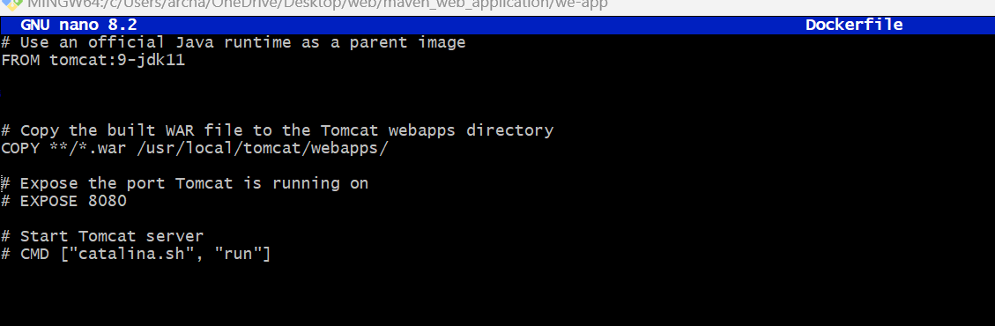

**V. Run the image and access it with public ip of virtual machine**

Step 1:- build your image

docker build –t <imagename> .(dot)

Step 2:- check for images

Step 3:- run image

docker run –d --name app-demo –p 6060:8080 <image name>

Step:-4 **Accessing the app by public ip of virtual machine**

**Note:-if your are not able to connect change the inbound rules..**

**SOLUTION:**

**✅ 📌 Week 12 — Final Execution Steps (Easy + Exam Ready)**

**🟢 BEFORE EXAM (DO AT HOME)**

✔ Push your Maven Web Project to GitHub (you already did or will do).  
✔ Have AWS account created (done).  
✔ Keep your .pem key downloaded and saved in email/Drive in case lab PC is different.

**🏁 START IN THE LAB (Exam Execution)**

**STEP 1 — Login to AWS**

1. Open browser
2. Go to 👉 https://aws.amazon.com/console/
3. Sign in as **Root user**
4. Choose a region close to India:  
   👉 **Mumbai (ap-south-1)**

**STEP 2 — Create an EC2 Ubuntu Virtual Machine**

1. Go to: **Services → EC2**
2. Click **Launch Instance**
3. Fill settings:

| **Setting** | **Value** |
| --- | --- |
| Name | Ubuntu-Web-Server |
| AMI | Ubuntu Server 22.04 LTS (Free Tier Eligible) |
| Architecture | 64-bit |
| Instance Type | t2.micro |
| Key Pair | Create New → download .pem |
| Security Group | Allow: SSH (22), HTTP (80), Custom TCP (8080) |
| Storage | 8GB |

1. Click **Launch Instance**
2. Wait until status = **Running** and **2/2 status checks passed**

**STEP 3 — Connect to the Instance**

1. Select the instance → click **Connect**
2. Go to **SSH Client Tab**
3. Copy the command shown (example):

ssh -i "ubuntu.pem" ubuntu@3.111.24.200

1. On lab PC → Open **Git Bash**
2. Navigate to folder where .pem is stored:

cd Downloads

chmod 400 ubuntu.pem

1. Connect:

ssh -i ubuntu.pem ubuntu@YOUR_PUBLIC_IP

**STEP 4 — Install Required Software in EC2**

Run these commands one by one:

sudo apt update

sudo apt install docker.io -y

sudo apt install git -y

sudo apt install maven -y

sudo apt install nano -y

To verify:

docker --version

git --version

mvn -version

**STEP 5 — Clone Your Maven Web Project From GitHub**

git clone https://github.com/YOURUSERNAME/maven-web-project.git

cd maven-web-project

**STEP 6 — Build the WAR File**

mvn clean package

Check build output:

ls target

You must see:

something-0.0.1-SNAPSHOT.war

**STEP 7 — Create Dockerfile**

nano Dockerfile

Paste:

FROM tomcat:9-jdk11

COPY target/*.war /usr/local/tomcat/webapps/

Save: **CTRL + O → Enter → CTRL + X**

**STEP 8 — Build Docker Image**

sudo docker build -t mywebapp .

Check:

docker images

**STEP 9 — Run the Container**

sudo docker run -d --name appdemo -p 8080:8080 mywebapp

Check container running:

docker ps

**STEP 10 — Allow EC2 Access (IMPORTANT)**

If the app doesn’t open, edit inbound rules:

✔ Go to: **EC2 → Security → Security Group → Edit inbound rules**  
Add:

| **Type** | **Port** | **Source** |
| --- | --- | --- |
| Custom TCP | 8080 | 0.0.0.0/0 |

Save.

**STEP 11 — Access Application Publicly**

Open browser:

http://PUBLIC-IP:8080/

or

http://PUBLIC-IP:8080/your-project-name

🎉 If the Tomcat page or your web app appears → **SUCCESS**

**📸 What Screenshots to Take for Submission**

| **Screenshot** | **Required 📌** |
| --- | --- |
| AWS EC2 instance running | ✔ |
| Git clone command output | ✔ |
| Maven build success (BUILD SUCCESS) | ✔ |
| Docker image build success | ✔ |
| docker ps showing container running | ✔ |
| Browser showing deployment using public IP | ⭐ REQUIRED |
| WEEK-12  1 DEPLOYMENT OF INDEX.HTML USING EC2 INSTANCE in AWS  **Step 1: Login to AWS /canvas account**   * Go to course invitation mail and click on start * Opens the aws academy, select the student login and enter the email and password details * Click on Modules * Scroll down and select Lunch AWS Academy Lab- * Click on start Lab and wait AWS becomes from red to green AWS     **Click on AWS**    **Step 2:** **Click on EC2 to create instance**    **Click on Launch Instance**    Stage 1 --Name (Giving name to the machine) ubuntu  Stage 2 -- Select AMI ( Note: Select free tier eligible ) ubuntu server  **Give name and select ubuntu** under application    **Select this free tier option of Ubuntu from here**    Stage 3 -- Architecture as 64-bit  Make sure AMI and Architecture are there as shown    Stage 4 -- **Instance type** ---- t2.micro(default 1 CPU,1 GB RAM)    Stage 5 -- Create a new keypair---a keypair will downloaded with extension .pem  Store key in folder AWS  **First Click on create-new key pair**    Give KeyPair name and click on create key pair    Save the .pem file in folder AWS on desktop  Stage 6 -- Network Setting ----Create Security group -- ( It deals with ports )  (Note for understanding We have 0 to 65535 ports. Every port is dedicated to special purpose)  **HERE select https and http** (which allow to load your web pages while execution)  In network setting check all the checkboxes    Stage 7 -- Storage - 8GB ( Observation - we have root - it is same as C Drive) it default 8 GB  Stage 8 --- click on launch instance  Now click on the instances    Wait for the Success message to apper in green color    You can see MyExampleWebServer is Running and wait for it to initialize    You have to get 2 tests passes.  Important:---- Now check the box and click on connect.  **Do this step:---once it is created select that instance**  **(Tick in checkbox) and click on connect**    Thus your EC2 instance is running on server.  Step 4: Now you can connect local system to server (EC2 instance) using secure shell SSH.    For this, **Here copy the ssh – i command from SSH client connect tab and paste later**  Next We can use powershell /gitbash /webconsole **in administrative mode**, to connect to ubuntu machine.  Step a: Copy the path of .pem file that you saved earlier in folder AWS eg. as here D:\SUNNY\SELABWEB\AWS    Step b: Open Powershell in administrative mode and navigate to that path.  Type: cd < path>  eg. cd D:\SUNNY\SELABWEB\AWS here specify your .pem path    Step c: Go to SSh and copy the command ssh which is present at the below    Note: To connect to above terminals we need to go into the path of the keypair.and  paste the ssh -i command from the aws console  Step d: **Run the pasted** ssh -i **command in the terminal**    Step 5: Run the following commands to install s/w   1. Update all softwares in Ubuntu by command   **sudo apt update**     1. Install docker by command   **sudo apt-get install docker.io**     1. Install git by command   **sudo apt install git**     1. Install nano( text editor) by command   **Sudo apt install nano**    Step 6: Now we want to create an application, push it into git, create docker image of it and run it  **Step a:** Create basic index.html file in folder Example and save it    **Step b:** Open git Bash **in folder Example** by right clicking with mouse    **Step c:** In git bash run the following commands  **git init**  **git add .**  **Git commit –m “first commit”**    **Step d:** Create git repository (here with name AWS)    **Step e:** Copy command **one by one** from above repository and run as below  **git branch –M main**  **git remote add origin <https url>**  **git push –u origin main**    **Step f:** refresh repository and You can now see index.html in github    **Step g:** Copy http path    **Step h:** Clone the repository with copied http path by command **in command prompt git clone <copied http url>**  **Step i:** Navigate to the cloned folder. Type **cd AWS** as below, next **ls** to    **Step j:** create Dockerfile in above command prompt in ububtu ie in power shell  **Nano Dockerfile**    **Step k:** Write the following data in Dockerfile and click ctrl+o Enter and then ctrl-x    **Step L:** Build docker image by executing the following command  **sudo docker build –t mywebapp .**    Thus image is created  **Step m:** run the image and map it to port 80  **sudo docker run –**d –p 80:80 mywebapp    **Step n:** Go to instances and click on instance here    **Step o:** Copy public ipv4 address    **Step p:** Paste it in the browser to get below output  **Note :** if https :__ won’t work then type just http:___    **Important do it without fail. Step Q:** stop container  Run the following command to stop the container   1. sudo docker ps 2. sudo docker stop <container-id>      1. Go back to instances and click on option instance. Once load as below, then Click on Instance state and select terminate instances     Click on Terminated (deleted)     1. Now click on End lab     End of exercise 1 (DEPLOYMENT of index.html using EC2 instance in AWS) consisting of:   1. creating EC2 instance to install Ubuntu, docker, git , and nano. 2. creating web application (index.html) using Visual studio 3. Pushing index.html to github and cloning the it 4. Creating Dockerfile to build image for running index.html on nginx server 5. Run it as container using docker command and get the output on browser 6. Terminate the instance 7. End lab   2 MAVEN WEB PROJECT DEPLOYMENT IN AWS  Click on start lab    Click on AWS    Click on EC2    Click on launch instance    Give name    Create new key    Check all the boxes under network and click on launch instance    Click on instances    Wait until you get 2 tests passes    Click on connect after checking the box    Copy ssh command    Open the terminal, Navigate to the path    Run the ssh command    Run the following commands          **Open MAVEN WEB PROJECT REPO in github and copy http link**    **Clone the repository**    **If your repository is in main run following**    **If not goto your github repo**  **Click on settings**  **Under default branch section click on the icon shown and you’re your master branch as default and execute above commands**        **Build docker image**    **Run the container**    **Copy public ipv4**    **Enter this url in browser and click enter**    **If your app is not running goto security and Click on security groups**      **Click on edit inbound rules**    **Click on add rule give port as 9090 and 0.0.0.0/0 click on save**    **And refresh the page to check whether the web page has loaded or not**    **If it is loaded you have successfully deployed you maven web project In your ec2 instance**  **Run the following commands to stop the container**  **Terminate your instance**    **End your lab** |  |

**I’ll give you exactly what to do from the moment you sit at the lab PC *if they give Week-12 (AWS EC2 deployment) as the question*.**

**You already have:**

* **AWS free-tier account ✅**
* **Maven web project in GitHub ✅ (I’ll assume yes – if not, still same idea)**

**🧭 Overall flow (what examiner expects)**

1. **Login to AWS**
2. **Create Ubuntu EC2 instance**
3. **SSH into it**
4. **Install Docker + Git (+ Maven/JDK if needed)**
5. **Clone your Maven web app from GitHub**
6. **Build WAR with Maven**
7. **Write Dockerfile**
8. **Build Docker image**
9. **Run container mapping port → 6060**
10. **Open app in browser using public IP**

**Screenshots: EC2, SSH, Docker, Browser.**

**🖥️ FROM THE MOMENT YOU SWITCH ON LAB PC**

**0. Open needed tools**

1. **Open browser (Chrome/Edge).**
2. **Open Git Bash (or PowerShell) – but you’ll only need it later *if* you decide to SSH from PC instead of browser.**
   * **We’ll primarily use browser-based SSH (EC2 Instance Connect) if available (easiest).**

**1️⃣ Login to AWS & go to EC2**

1. **In browser: go to https://aws.amazon.com/console/**
2. **Click Sign in to the Console**
3. **Choose Root user, enter your AWS email + password.**
4. **Once you see AWS Console:**
   * **At top-right, set Region to something near you:  
     e.g. Asia Pacific (Mumbai) ap-south-1 (or whatever you used before).**
5. **In the search bar at the top, type EC2 → Click EC2.**

**📸 *Screenshot 1*: AWS Console → EC2 Dashboard.**

**2️⃣ Launch Ubuntu EC2 Instance**

**On EC2 Dashboard:**

1. **Click "Launch instance".**
2. **Fill details:**

**a. Name and tags**

* **Name: ubuntu-devops (or anything)**

**b. Application and OS Images (AMI)**

* **Choose: Ubuntu Server 22.04 LTS (Free tier eligible)**
* **Architecture: 64-bit (x86) (default)**

**c. Instance type**

* **t2.micro (Free tier eligible)**

**d. Key pair (login)**

* **Key pair name: devops-key**
* **Type: RSA**
* **Format: .pem**
* **Click Create key pair**
* **Browser will download devops-key.pem to Downloads.**

**(You may NOT even need this if you use browser-based connect, but it’s fine.)**

**e. Network settings**

* **Keep default VPC**
* **Security group → Create new  
  Add inbound rules:**
  1. **Rule 1:**
     + **Type: SSH**
     + **Port: 22**
     + **Source: My IP (default)**
  2. **Rule 2:**
     + **Type: HTTP**
     + **Port: 80**
     + **Source: Anywhere 0.0.0.0/0**
  3. **Rule 3: (for our app port)**
     + **Type: Custom TCP**
     + **Port: 6060**
     + **Source: Anywhere 0.0.0.0/0**

**f. Storage**

* **Leave default: 8 GiB gp3 (or gp2)**

1. **Scroll → Click Launch instance.**
2. **Click View all instances.**

**Wait until:**

* **Instance state = running**
* **Status checks = 2/2 checks passed**

**📸 *Screenshot 2*: EC2 instance list showing running.**

**3️⃣ Connect to Instance (Browser-based SSH – easiest)**

1. **Select your ubuntu-devops instance (tick on left).**
2. **Click Connect (top).**
3. **In the dialog, choose EC2 Instance Connect tab (if available):**

* **User name: ubuntu**
* **Click Connect.**

**👉 A new browser tab opens with a terminal, logged into your Ubuntu VM.**

**📸 *Screenshot 3*: Black terminal screen with prompt like ubuntu@ip-...:~$**

**If EC2 Instance Connect is not available, then:**

* **Click SSH client tab**
* **Copy the ssh -i "devops-key.pem" ubuntu@ec2-xx-xx-xx-xx.compute.amazonaws.com command**
* **Open Git Bash → cd to Downloads → chmod 400 devops-key.pem → paste SSH command.  
  But usually EC2 Instance Connect works and is easier.**

**4️⃣ Install required tools on Ubuntu**

**In the EC2 terminal (browser):**

**# Update package list**

**sudo apt update**

**# Install Docker, Git, Maven, Java**

**sudo apt install -y docker.io git maven openjdk-17-jdk**

**Enable + check Docker:**

**sudo systemctl enable --now docker**

**sudo docker ps # just to test (should show no containers, no error)**

**📸 *Screenshot 4*: Terminal after sudo apt install ... (some lines + cursor).**

**5️⃣ Clone your Maven Web Project from GitHub**

**Still in EC2 terminal:**

**# go to home**

**cd ~**

**# clone your repo (CHANGE this URL to your repo)**

**git clone https://github.com/YOUR_USERNAME/YOUR_MAVEN_WEB_REPO.git**

**# move into project folder**

**cd YOUR_MAVEN_WEB_REPO**

**Replace with your actual repo URL and folder name.**

**📸 *Screenshot 5*: git clone + cd commands.**

**6️⃣ Build the WAR file using Maven**

**Inside project folder (where pom.xml is):**

**mvn clean package**

**Wait for:**

**BUILD SUCCESS at the bottom.**

**This will create target/yourapp.war.**

**📸 *Screenshot 6*: BUILD SUCCESS line.**

**7️⃣ Create Dockerfile**

**In the same project folder:**

**nano Dockerfile**

**Paste this content into nano:**

**FROM tomcat:9.0-jdk17-temurin**

**# copy the built WAR into tomcat's webapps**

**COPY target/*.war /usr/local/tomcat/webapps/**

**EXPOSE 8080**

**CMD ["catalina.sh", "run"]**

**Then:**

* **Press Ctrl + O → Enter (save)**
* **Press Ctrl + X (exit)**

**📸 *Screenshot 7*: Dockerfile opened in nano (before exit, or reopen with cat Dockerfile to show content).**

**8️⃣ Build Docker Image**

**In terminal, still in project folder:**

**sudo docker build -t mywebapp .**

**(There is a dot at the end!)**

**Wait for it to finish. Last lines will show:**

**Successfully tagged mywebapp:latest**

**Check images:**

**sudo docker images**

**📸 *Screenshot 8*: docker images showing mywebapp.**

**9️⃣ Run Container, Map to Port 6060**

**Run:**

**sudo docker run -d --name webapp-container -p 6060:8080 mywebapp**

**Verify:**

**sudo docker ps**

**You should see a container webapp-container UP and PORTS 0.0.0.0:6060->8080/tcp.**

**📸 *Screenshot 9*: docker ps output.**

**🔟 Access Application from Browser (Public)**

1. **Go back to EC2 console tab.**
2. **Select your instance → On top right, note Public IPv4 address, e.g.:**

**3.110.25.78**

1. **In browser (lab PC), open:**

**http://<Public-IP>:6060/**

**If your WAR has a context name, e.g. mymavenweb.war, use:**

**http://<Public-IP>:6060/mymavenweb**

**You should see either:**

* **Your web app page, or**
* **Tomcat welcome page.**

**📸 *Screenshot 10*: Browser showing your app (or Tomcat).**

**If it doesn’t open:**

* **Re-check security group inbound rule for port 6060 (must be 0.0.0.0/0).**
* **Make sure container is running (docker ps).**
* **Make sure you typed http:// not https://.**

**🔚 Cleanup (Optional, for safety)**

**On EC2 terminal:**

**sudo docker stop webapp-container**

**sudo docker rm webapp-container**

**On AWS console, after exam (from home):**

* **Stop or Terminate the instance to avoid accidental charges.**

**🧾 What to show examiner / put in Word doc**

**For Week 12, make sure you have these key outputs:**

1. **EC2 instance list (running Ubuntu)**
2. **Terminal connected to instance (SSH)**
3. **Packages installed (docker, git, maven, openjdk)**
4. **git clone + mvn package (BUILD SUCCESS)**
5. **Dockerfile content**
6. **docker build & docker images**
7. **docker ps with port mapping 6060->8080**
8. **Browser with http://PublicIP:6060/... page**

**→ That clearly proves "Creation of virtual machine & deployment of Maven web app in cloud" ✅**

**“Creation of Virtual Machine for Ubuntu OS and Deploying a Web Application using Docker & AWS EC2”**

**and**

**✔ “Deploying a Maven web project application into the Cloud.”**

**It covers these points from the question:**

| **Item in Question** | **Does the steps match?** |
| --- | --- |
| **Creating Virtual Machine (EC2)** | **✅ Yes** |
| **Connecting using SSH & configuring environment** | **✅ Yes** |
| **Deploying a simple web server (index.html / Tomcat WAR)** | **✅ Yes** |
| **Deploying Maven web application in cloud using Docker** | **✅ Yes** |
| **Making the app accessible publicly using public IP** | **✅ Yes** |

**Solution:**

**📌 PART 2 — What To Do in EXAM (Week-12 Task Execution Plan)**

**When you sit and turn on the lab PC:**

**STEP 0 — Login to AWS Console**

**Go to https://aws.amazon.com/console**

**Sign in as Root user**

**Enter your email + password**

**STEP 1 — Create EC2 Ubuntu Instance**

**Go to Services → EC2**

**Click Launch Instance**

**Name: ubuntu-web-server**

**Select OS: Ubuntu 22.04 LTS (Free tier)**

**Instance Type: t2.micro**

**Key Pair:**

**If new computer: Create new → Download .pem file**

**Name it: ec2key.pem**

**Security Group:**

**Allow SSH (22)**

**Allow HTTP (80)**

**Allow Custom → 8080 (for Tomcat/Docker)**

**Click Launch**

**✔ Wait until instance status = Running + 2/2 checks passed**

**STEP 2 — Connect to EC2 using Git Bash**

**Open Git Bash where your .pem file is saved and run:**

**chmod 400 ec2key.pem**

**Then connect:**

**ssh -i ec2key.pem ubuntu@PUBLIC_IP_ADDRESS**

**(Replace IP with your instance IP.)**

**STEP 3 — Install Docker**

**Inside EC2 terminal:**

**sudo apt update**

**sudo apt install docker.io -y**

**sudo systemctl start docker**

**sudo systemctl enable docker**

**Check:**

**docker --version**

**STEP 4 — Install Git & Clone Your Maven Project**

**sudo apt install git -y**

**git clone https://github.com/YOURUSERNAME/maven-web-project.git**

**cd maven-web-project**

**STEP 5 — Install Maven**

**sudo apt install maven -y**

**Check Maven:**

**mvn -version**

**STEP 6 — Build the WAR File**

**mvn clean package**

**After build completes, check:**

**ls target**

**You should see something like:**

**mymavenproject-0.0.1-SNAPSHOT.war**

**STEP 7 — Create Dockerfile**

**nano Dockerfile**

**Paste:**

**FROM tomcat:9-jdk11**

**COPY target/*.war /usr/local/tomcat/webapps/**

**Save: CTRL + O, Enter → CTRL + X**

**STEP 8 — Build Docker Image**

**sudo docker build -t mywebapp .**

**STEP 9 — Run Container**

**sudo docker run -d --name webapp -p 8080:8080 mywebapp**

**Check running containers:**

**docker ps**

**STEP 10 — ACCESS THE APPLICATION**

**Open browser in lab PC:**

**http://PUBLIC_IP:8080/mymavenproject**

**(Or whatever your WAR name is.)**